
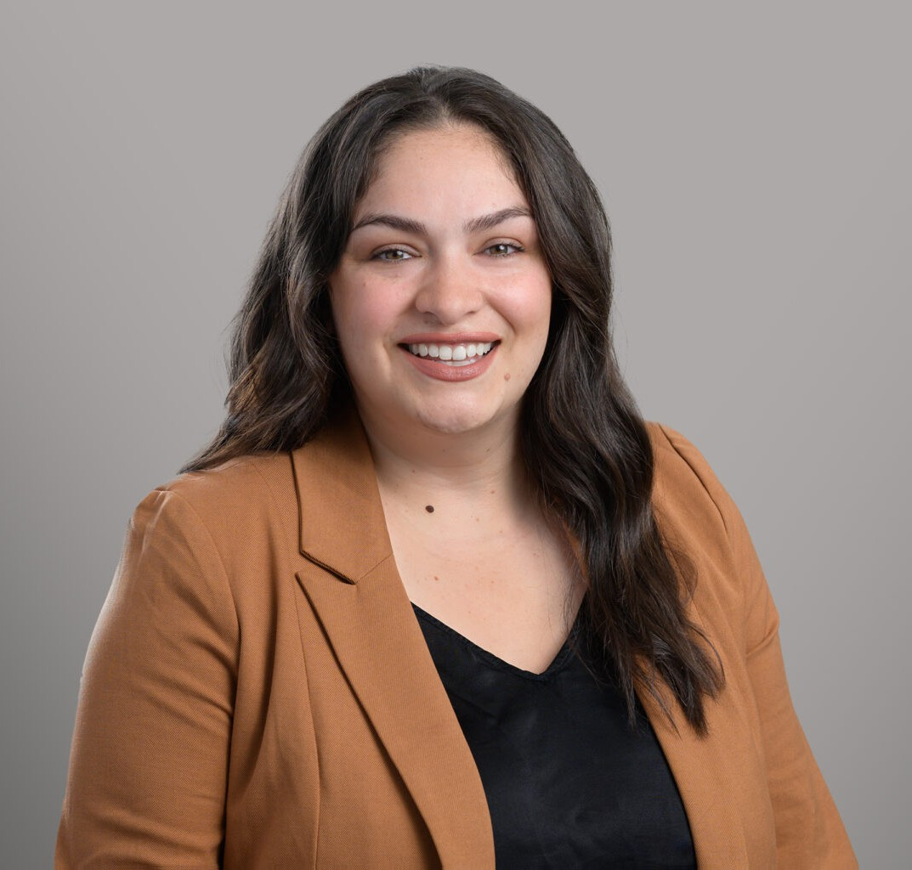
SABRINA HERNANDEZ
Associate
Business Litigation
San Diego
P: 619.595.3219
F: 619.231.4372
shernandez@fennemorelaw.com

SABRINA HERNANDEZ
Sabrina Hernandez is an associate attorney in Fennemore’s business litigation group. She helps clients with commercial disputes, contract and construction law, insurance defense, and trust litigation matters.
Sabrina has extensive experience drafting and arguing dispositive motions, including summary judgment and motions to dismiss, and has also served as lead counsel in jury trials involving
personal injury and property damage. She has handled over 50 depositions and played key roles in both state and federal court trials, as well as arbitrations and mediations.
Sabrina earned her law degree from the University of New Mexico School of Law, where she was a Manuscript Editor for the New Mexico Law Review and an active member of the Mexican American Law Student Association. During law school, she interned with Judge Jimmie V. Reyna at the U.S. Court of Appeals for the Federal Circuit, gaining experience in federal appellate matters involving patent law and international trade.
Sabrina speaks Spanish and brings a global perspective to her work, having studied international business transactions and European Union law in Madrid.

EDUCATION
J.D., University of New Mexico School of Law, magna cum laude

Manuscript Editor, New Mexico Law Review

AREAS OF PRACTICE
Business Litigation

ADMISSIONS
California Kansas

LANGUAGES

Spanish

