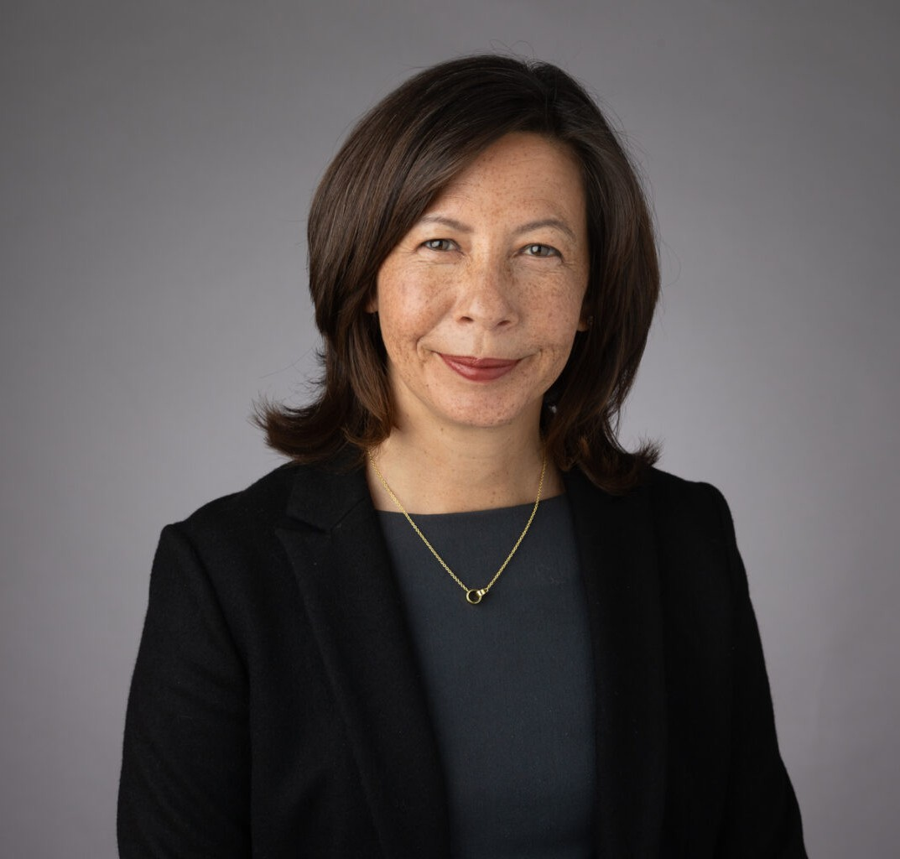

SANDI M.

COLABIANCHI

Of Counsel

[Business Litigation](https://www.fennemorelaw.com/services/business-litigation/)

[Oakland](https://www.fennemorelaw.com/contact-us/oakland/)

P: 510.622.7529 F: 510.834.1928

[scolabianchi@fennemorelaw.com](mailto:scolabianchi@fennemorelaw.com)

# SANDI M. COLABIANCHI

Sandi Colabianchi is an Of Counsel attorney who works in our Financial Restructuring practice group from our Oakland office with experience in transactional and litigation matters, including contracts, real estate, workouts and bankruptcy matters on behalf of lenders, creditors, debtors and trustees.

Raised in a military family, Sandi left Hawaii for California to attend college. The intellection stimulation of being a lawyer has always been a draw for her and after a clerkship for the Honorable Marilyn Morgan, United States Bankruptcy Judge for the Northern District of California, Sandi’s passion for this sector of the law became cemented.

Her practice includes representation of chapter 7 panel trustees, chapter 11 trustees, as well as creditors and landlords in bankruptcy and litigation matters. She has handled appeals of bankruptcy court decisions to the Bankruptcy Appellate Panel for the Ninth Circuit and the United States District Court. She has also handled foreclosure, litigation and bankruptcy matters for lenders and special servicers for REMIC trusts involving commercial mortgage-backed

securities, conventional real property loans and guarantees. Her work in this area has included complex foreclosure, receivership, bankruptcy matters, workouts, deeds in lieu of foreclosure, and property.

Outside of the office, Sandi unwinds with activities such as golfing and skiing.

# EDUCATION

J.D., Santa Clara University School of Law

Articles Editor, *Santa Clara Computer and High Technology Law Journal*

B.A., Business Administration, Whittier College

# AREAS OF PRACTICE

Business Litigation Financial Restructuring Real Estate

# AWARDS AND HONORS

*Best Lawyers in America®* distinction in Bankruptcy and Creditor Debtor Rights/Insolvency and Reorganization Law, 2015-2026

# PROFESSIONAL AND COMMUNITY ACTIVITIES

Member, Bay Area Bankruptcy Forum

Member, International Women’s Insolvency & Restructuring Confederation Member, Olympic Club

Member, Bench-Bar Liaison Committee, 2019-2022

Member, Executive Committee, Auxiliary for the Edgewood Center for Children and Families, 2013-2017

# ADMISSIONS

California

U.S. District Courts, California

U.S. Court of Appeals, Ninth Circuit