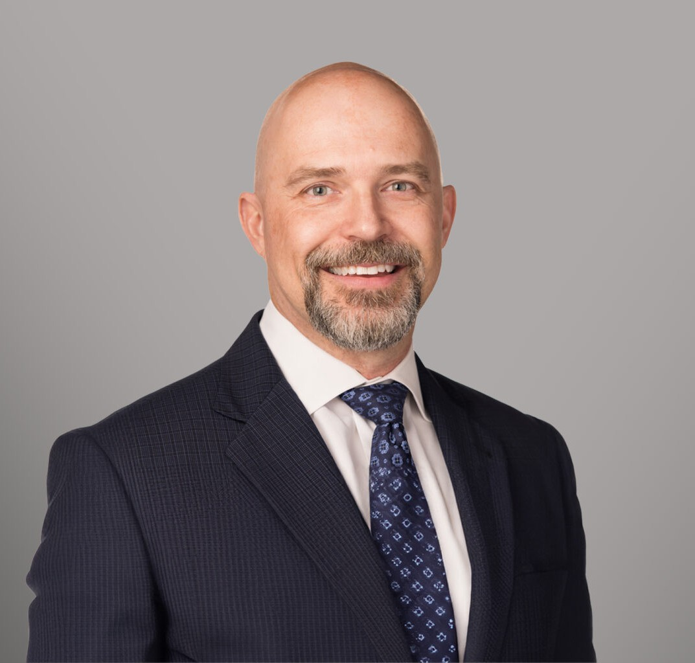

SPENCER A.W. STROMBERG

Director

[Business & Finance](https://www.fennemorelaw.com/services/business-and-finance/)

[Spokane](https://www.fennemorelaw.com/contact-us/spokane/)

P: 509.828.4644 F: 509.455.3718

[sstromberg@fennemorelaw.com](mailto:sstromberg@fennemorelaw.com)

# SPENCER A.W. STROMBERG

Spencer Stromberg is a business and real estate attorney who represents individuals, families, and businesses in all aspects of property and business ownership, including buying or selling residential property; buying, selling, leasing, or developing land or commercial property; new business formation; buying or selling a business; and navigating disputes when they arise.

Spencer also works with his clients to determine the best way to leave their hard-earned assets to their loved ones after death.

Spencer went to law school to become the kind of attorney who could assist his family’s business, which was involved in real estate development, construction, and property

management. He aimed to understand the legal issues facing small companies and sought practical, real-world solutions to help resolve them. Upon graduating and beginning his legal

practice, he discovered that the challenges faced by small business owners are also commonly encountered by individuals and families. He recognized that these clients would eventually need to address the matter of passing their homes, land, investments, and businesses on to family or other loved ones. Spencer is committed to prioritizing client service, with the mission of helping his clients navigate these issues and achieve the best possible outcomes.

A frequent lecturer and author, Spencer has spoken at numerous continuing legal education seminars on key topics such as landlord/tenant law, deed of trust foreclosures, easements, and condominiums. Additionally, he contributes as a co-author to the Washington State Bar Association’s Washington Real Property Deskbook Series, focusing on the ethical issues faced by attorneys in real property matters. Further, Spencer dedicated eight years to serving on the Downtown Spokane Partnership’s Board of Directors and the Business Improvement District Ratepayer Advisory Board. He is a former member of the Executive Committee of the Washington State Bar Association’s Real Property, Probate and Trust Section, demonstrating a broad commitment to advancing the legal profession.

Prior to joining Fennemore, Spencer co-founded Sullivan Stromberg, PLLC, which became

Lucent Law, PLLC. Previously, he worked as in-house counsel, and as a property and project manager for a family-owned real estate development, construction and property management company. Further, he was also a small business owner in the restaurant and brewery industries.

His experiences of running a small business and managing construction projects and commercial

property give him a unique understanding of the issues faced by his clients and the ability to strategically form pragmatic solutions to resolving those issues.

# EDUCATION

J.D., University of Washington School of Law B.A., University of Washington

# AREAS OF PRACTICE

Business & Finance Trusts & Estates Real Estate

General Counsel Services

# ARTICLES AND PRESENTATIONS

Co-Author, “[Transfer on Death Deed in Washington State: What It Is and How It Works,”](https://www.fennemorelaw.com/transfer-on-death-deed-in-washington-state-what-it-is-and-how-it-works/) Firm Publication, July 6, 2023

Co-Author, “[Danger Ahead: Transferring Real Estate into a Trust](https://www.fennemorelaw.com/danger-ahead-transferring-real-estate-trust/),” Firm Publication, June 28, 2023

Co-Author, “[When Should I Use a Quit Claim Deed?”](https://www.fennemorelaw.com/when-should-i-use-a-quit-claim-deed/) Firm Publication, June 28, 2023

Co-Author, “[I Sold My Property on Contract and The Buyer Isn’t Paying. What Can I Do?](https://www.fennemorelaw.com/i-sold-my-property-on-contract-and-the-buyer-isnt-paying-what-can-i-do-exploring-options-for-defaults-on-seller-financing/) [Exploring Options for Defaults on Seller Financing](https://www.fennemorelaw.com/i-sold-my-property-on-contract-and-the-buyer-isnt-paying-what-can-i-do-exploring-options-for-defaults-on-seller-financing/).” Firm Publication, June 3, 2023

Co-Author, “[Navigating Probate in Washington State: A Guide for the Surviving Spouse](https://www.fennemorelaw.com/navigating-probate-in-washington-guide-for-surviving-spouse/),” Firm Publication, May 30, 2023

Co-Author, “[Washington Home Sellers Must Make Required Disclosures](https://www.fennemorelaw.com/washington-home-sellers-must-make-required-disclosures/),” Firm Publication, May 21, 2023

Co-Author, “[Top Five Things to Know About Shared Driveway Easements](https://www.fennemorelaw.com/top-five-things-to-know-about-shared-driveway-easements/),” Firm Publication, December 16, 2022

Co-Author, “[Easements 101: Everything You Need to Know](https://www.fennemorelaw.com/easements-101-everything-you-need-to-know/),” Firm Publication, December 15, 2022

Co-Author, “[Idaho Legislature Acts on Rental Restrictions,”](https://www.fennemorelaw.com/idaho-legislature-acts-on-rental-restrictions/) Firm Publication, October 14, 2022

Co-Author, “[Six Things to Consider Before Putting Your Home On the Market](https://www.fennemorelaw.com/six-things-to-consider-before-putting-your-home-on-the-market/),” Firm Publication, June 22, 2022

Co-Author, “[How Do I Add Someone to My Property’s Title?”](https://www.fennemorelaw.com/how-do-i-add-someone-to-my-propertys-title/) Firm Publication, May 23, 2022 Co-Author, “[Should I Waive the Inspection Contingency?”](https://www.fennemorelaw.com/should-i-waive-the-inspection-contingency/) Firm Publication, February 15, 2022 Co-Author, “([Video) Should I DIY My Real Estate Purchase?”](https://www.fennemorelaw.com/should-i-diy-my-real-estate-purchase-the-quick-answer-is-no/) Firm Publication, June 4, 2021

Co-Author, “[Changes to Washington Real Estate Excise Tax](https://www.fennemorelaw.com/changes-to-washington-real-estate-excise-tax/),” Firm Publication, January 25, 2020

Co-Author, “[Startup Business Law Series: How Do I Protect My Personal Assets?”](https://fennemorelaw.com/startup-business-law-how-do-i-protect-my-personal-assets/) Firm Publication, January 15, 2020

Speaker, “Special Considerations for Commercial and Investment Transactions,” Handling Real Estate Transactions from Start to Finish Seminar, April 2019

Co-Author, “[Changes to LLC and Corporation Filings in Washington](https://www.fennemorelaw.com/changes-llc-corporation-filings-washington/),” Firm Publication, November 14, 2017

Co-Author, “[Service Account Cancellations, Financial Affairs and Powers of Attorney](https://www.fennemorelaw.com/service-account-cancellations-financial-affairs-powers-attorney/),” Firm Publication, November 14, 2016

Co-Author, “[Answers to 3 Common Questions About Digital Assets](https://www.fennemorelaw.com/answers-3-common-questions-digital-assets/),” Firm Publication, January 29, 2016

Speaker, “Terminating or Releasing Easement Options,” Boundary Issues and Easement Law Seminar, December 2016

Speaker, “Creating and Enforcing Easements,” Boundary Issues and Easement Law Seminar, December 2016

Co-Author, “[What is a Durable Power of Attorney](https://www.fennemorelaw.com/what-is-a-durable-power-of-attorney/)?” Firm Publication, December 15, 2015 Co-Author, “[Estate Planning – Who is it Really For](https://www.fennemorelaw.com/estate-planning-who-is-it-really-for/)?” Firm Publication, September 30, 2015 Co-Author, “[HOA Rental Restrictions – Are They Valid](https://www.fennemorelaw.com/hoa-rental-restrictions-are-they-valid/)?” Firm Publication, September 8, 2015

Co-Author, “[CC&R Amendment – Idaho Supreme Court Favors HOA Over Homeowner](https://www.fennemorelaw.com/ccr-amendment-idaho-supreme-court-favors-hoa-over-homeowner/),” Firm Publication, August 31, 2015

Co-Author, “[Subchapter S Election for a Single-Member LLC](https://www.fennemorelaw.com/subchapter-s-election-for-a-single-member-llc/),” Firm Publication, July 23, 2015

Co-Author, “[Estate Planning – Do I Need It If I’m Not Wealthy](https://www.fennemorelaw.com/why-do-i-need-estate-planning/)?” Firm Publication, January 29, 2015

Speaker, “Creating and Enforcing Easements,” Boundary Issues and Easement Law Seminar, December 2014

Speaker, “Terminating or Releasing Easement Options,” Boundary Issues and Easement Law Seminar, December 2014

Co-Author, “[Condominium Resale Certificate – Washington & Idaho](https://www.fennemorelaw.com/condominium-resale-certificate/),” Firm Publication, January 30, 2014

Speaker, “Case Study: Mixed Use Development Projects – A Panel Discussion,” Real Estate Development in Eastern Washington & Idaho Seminar, September 2013

Speaker, “Terminating or Releasing Easement Options,” Boundary Issues and Easement Law Seminar, December 2011

Speaker, “Creating and Enforcing Easements,” Boundary Issues and Easement Law Seminar, December 2011

Speaker, “Commercial Condominiums and Conversions,” Advanced Commercial Leases Seminar, July 2010

Washington State Bar Association, Washington Real Property Deskbook Series: Duties and Responsibilities of the Lawyer (4th Ed., 2009)

Speaker, “Tenant/Borrower Issues in Foreclosure,” Drafting and Foreclosing Deeds of Trust after the Amendments to the Deed of Trust Act Seminar, October 1998

Speaker, “Evictions under the Washington Residential Landlord Tenant Act,” Washington State Bar Association Real Property, Probate and Trust Section Midyear Meeting, June 1995

# PROFESSIONAL AND COMMUNITY AFFILIATIONS

Executive Committee, Washington State Bar Association Real Property, Probate and Trust Section, 2011-2013

Co-Chair, Washington State Bar Association Real Property, Probate and Trust Section Midyear Meeting, 2014

# ADMISSIONS

Washington Idaho

U.S. District Court for Eastern District of Washington

U.S. District Court for Western District of Washington