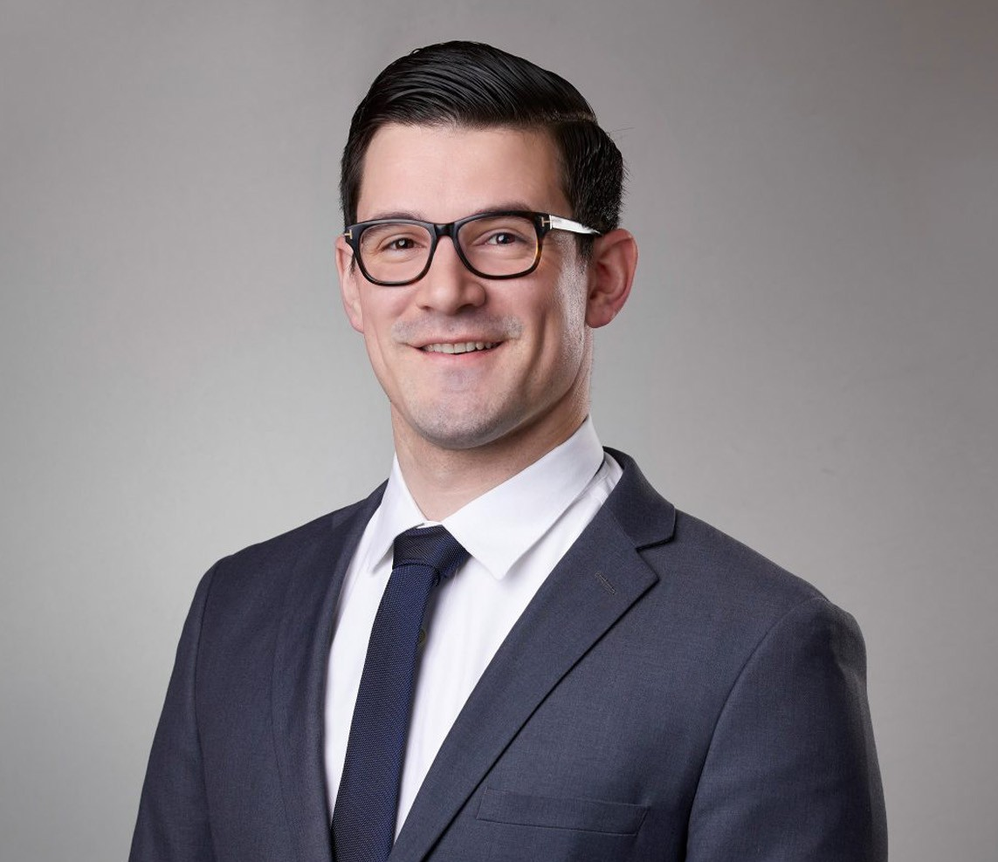

TAIT J. VISKOVICH

Associate

[Real Estate](https://www.fennemorelaw.com/services/real-estate/)

[San Bernardino](https://www.fennemorelaw.com/contact-us/san-bernardino/)

P: 909.890.4499

F: 909.890.9877

[tviskovich@fennemorelaw.com](mailto:tviskovich@fennemorelaw.com)

“

Wise men speak because they have something to say; fools because they

have to say something.

- Plato

”

## TAIT J. VISKOVICH

Tait Viskovich is an associate in the Real Estate practice group in the firm’s San Bernardino office. With a reputation as a forward thinking attorney interested in the intersections of law, business, real estate, and technology, his practice involves all aspects of real estate transactions, including the acquisition, development, construction, leasing, ownership, financing,

management and disposition of industrial, commercial, retail and office properties.

Tait assists clients with various land use matters including strategy, approvals, zoning, amendments, and conditional use permits and variances.

Tait was formerly a construction litigator and understands the complex nature of development from the ground up. This enables him to anticipate issues before they arise to better protect our clients throughout the development process.

Real Estate Advanced Energy

## EDUCATION

J.D., University of Southern California Gould School of Law, Graduate Certificate in Business Law

B.A., Political Science, University of California, Riverside

**AREAS OF PRACTICE**

# OTHER EXPERIENCE

Land Use Real Estate

Advanced Energy

## AWARDS AND HONORS

*Best Lawyers in America®,* Ones to Watch, Land Use and Zoning Law, Real Estate Law, 2026

## PROFESSIONAL AND COMMUNITY ACTIVITIES

Member, State Bar of California

## ADMISSIONS

California