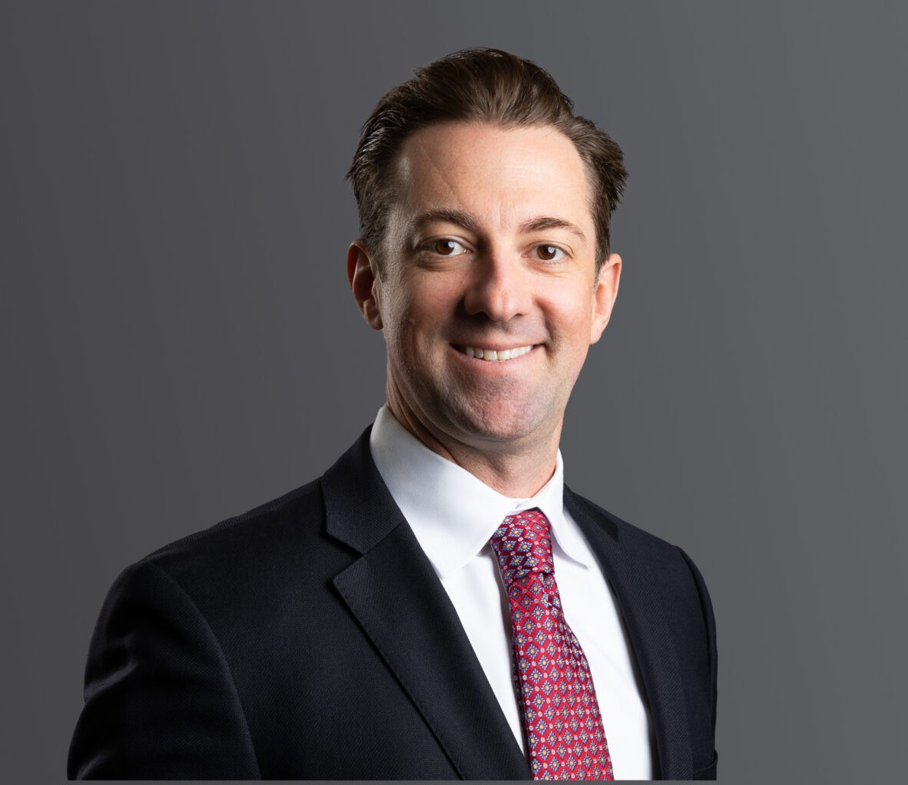

TANNER J. WALLS

Director

[Business Litigation](https://www.fennemorelaw.com/services/business-litigation/)

[Denver](https://www.fennemorelaw.com/contact-us/denver-2/)

P: 303.813.3894

F: 303.291.3201

[twalls@fennemorelaw.com](mailto:twalls@fennemorelaw.com)

# TANNER J. WALLS

Tanner Walls is a trial lawyer who focuses on complex civil litigation. In this capacity, he regularly represents large corporations and small businesses in shareholder disputes, derivative actions,

employment cases, class actions, contract disputes, business torts, trade secret actions, premises liability cases, subrogation matters, and consumer claims. He represented clients on large

employment class actions and multi-district pharmaceutical litigation pending in federal courts as well as statewide coordinated proceedings across the country. Part of his practice involves providing employment law advice to employers and executives in middle market companies and businesses. In this capacity, he provides strategic advice to create proactive solutions for employee management.

Tanner’s versatility as a trial lawyer and breadth of experience provides in-depth insight and knowledge that informs his approach to every case and trial, as well as his role as a trusted advisor to his clients.

Since 2018, Tanner has been a member of the teaching faculty of the National Institute for Trial Advocacy (NITA), where he regularly teaches trial skills to NITA students. He is a frequent lecturer and speaker on the role of trial lawyers in sustaining the legal profession through leadership and mentorship on behalf of the Colorado Supreme Court’s Attorney Mentor Program (CAMP), DRI (f/k/a Defense Research Institute), and the Colorado Defense Lawyers Association. He also presents on issues related to legal malpractice at seminars and continuing legal education

courses.

Tanner also devotes his time to pro bono efforts through his involvement with the Colorado School Expulsion Pilot Project, where he ensures minor school children who have been expelled receive adequate due process. Tanner also volunteers for the Colorado Poverty Law Project and represents indigent clients pro bono in housing-related matters, helping at-risk individuals and families stay in their homes.

When he is not in the courtroom, Tanner is either on his bike or snowboarding somewhere in the mountains of Colorado. He lives in Denver with his wife Alicia, newborn son Wesley, and their two 150lbs. Leonbergers, Murphy and Ralphie.

# EDUCATION

J.D., University of Denver Sturm College of Law

B.A., University of Colorado

# AREAS OF PRACTICE

Business Litigation

Employment & Labor

# REPRESENTATIVE CASES

Lead trial counsel for institutional money manager in breach of contract and fraud action brought by marketing company alleging more than $10 million in damages. Trial resulted in judgment for less than 5% of alleged damages. Bench trial, U.S. Dist. Court for Colo, 2024.

Lead trial counsel for international resort and recreation corporation in alleged race-based discrimination and breach of contract case. Trial resulted in defense verdict for client. Jury trial, U.S. Dist. Court for the Southern Dist. of NY, 2024.

Lead trial counsel for plaintiff in shareholder oppression action involving international garment company. Case resolved on courthouse steps with monetary payment and transfer of foreign real property assets to client. Bench trial, N.J. Court of Chancery, 2023.

Lead trial attorney on breach of contract action for real estate holding company and individual owners against cabinet manufacturer, resulting in judgment for client. Bench trial, Denver Dist. Court, 2021.

Lead trial attorney on multiple arbitrations across the United States resulting from wage and hour class action lawsuit filed against national fast-casual restaurant chain. Every arbitration tried by Tanner resulted in a decision for the restaurant client. JAMS Arbitrations, Chicago, IL; Atlanta, GA; Charleston, SC, 2019-2020

Co-lead trial counsel for medical and commercial real estate brokerage in breach of

contract, theft of trade secret, and reverse veil-piercing case. The trial resulted in six-figure judgment for client. Bench trial, Denver Dist. Court, 2018.

Lead trial counsel for national food brand and manufacturer in jury trial for indemnification with bifurcated bench trial on damages. The trial resulted in jury verdict for client, and Court awarded more than $300,000 in attorney fees and costs. Denver Dist. Court, Colorado, 2017.

Co-lead trial counsel for national mortgage loan servicer and property preservation companies in seven-day jury trial on claims of negligence, respondeat superior, fraud, and civil theft. Jury trial, El Paso County, Colorado, 2016.

Served as co-lead trial counsel for defense in five-day jury trial where plaintiffs requested

$500,000 in damages at trial. Jury trial resulted in a defense verdict for client. Jury trial, Fremont County, Colorado, 2015. Obtained summary judgment for international pharmaceutical company for lack of causation involving diabetes medication and allegations of heart- related injuries. U.S. Dist. Court of Colorado, 2014.

Represented international medical device manufacturer in personal injury suit involving product liability claim on medical device and medical malpractice resulting in dismissal of product liability claims against client following motion for summary judgment; case against co-defendant settled. El Paso County, Colorado, 2013.

Served as second chair for defense in jury trial for legal malpractice case where plaintiffs requested $1.5 million in damages at trial. Jury trial resulted in a defense verdict for client- attorney. Jury trial, Denver, Colorado, 2012.

Served as second chair for defense in jury trial for medical malpractice case resulting from abdominal surgery and placement of synthetic mesh. The case resulted in a directed verdict for the client-physician. Jury trial, Adams County, Colorado, 2011.

# AWARDS AND HONORS

[*Best Lawyers in America®,*](https://www.fennemorelaw.com/people/attorneys/tanner-j-walls/Commercial%20Litigation%20and%20Corporate%20Law)[Corporate Law, 2025, Commercial Litigation, 2025-2026](https://www.fennemorelaw.com/people/attorneys/tanner-j-walls/Commercial%20Litigation%20and%20Corporate%20Law)

[*Best Lawyers in America®,*](https://www.bestlawyers.com/united-states/colorado/denver)[Ones to Watch, Commercial Litigation and Corporate Law, 2024](https://www.bestlawyers.com/united-states/colorado/denver)

# ARTICLES AND PRESENTATIONS

Presenter, “Mastering the Effective Cross Examination,” NITA Trial Skills Semiar, November 1, 2021

Presenter, “Enhance Creative Thinking Among Leadership Team,” DRI Leadership Conference, January 2020

Presenter, “CAMP Pilot Project – Co-Counseling Civil Jury Trials,” CDLA Annual Conference, July 2016

Presenter, “PED Talk,” National Mentoring Conference, May 2016

Presenter, “Do’s and Don’ts of Legal Malpractice,” CDLA CLE, December 2012

# PROFESSIONAL AND COMMUNITY AFFILIATIONS

Colorado Bar Association

Colorado Lawyers Committee, School Expulsion Pilot Project Colorado Poverty Law Project

Denver Bar Association

DRI – Lawyers Representing Business, Regional Director and Board Member National Institute for Trial Advocacy (NITA), Faculty

# ADMISSIONS

Colorado New York Wyoming

U.S. District Court – District of Wyoming

U.S. District Court – District of Colorado

U.S. District Court – Southern District of New York