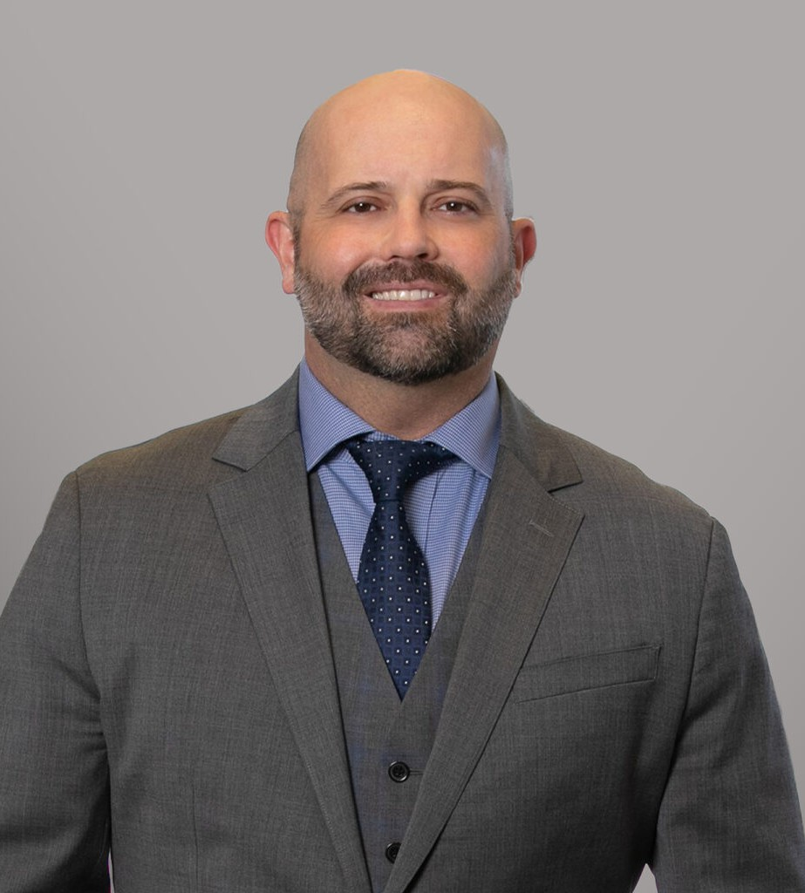

TRAVIS THOMPSON

Director

[Tax Law](https://www.fennemorelaw.com/services/tax/)

[Walnut Creek](https://www.fennemorelaw.com/contact-us/walnut-creek/)

P: 510.622.7561

F: 510.834.1928

[Sacramento](https://www.fennemorelaw.com/contact-us/sacramento/)

P: 510.622.7561

F: 510.834.1928

[tthompson@fennemorelaw.com](mailto:tthompson@fennemorelaw.com)

# TRAVIS THOMPSON

Travis Thompson is a Director in Fennemore’s [Business & Finance](https://www.fennemorelaw.com/services/business-and-finance/) practice group. Travis advises

individual, corporate, and nonprofit clients on a broad spectrum of tax matters, with a particular emphasis on tax litigation, refund claims, voluntary disclosures, and cross-border compliance

issues.

Travis brings deep experience from over a decade of practice, including managing the largest civil FBAR matter in U.S. Department of Justice history. He has represented clients in IRS refund

litigation, FBAR and international tax compliance, cryptocurrency tax matters, and tax-related criminal and civil trials. His work includes negotiating significant tax settlements, defending clients in court, and advising on cutting-edge issues involving AI, digital assets, and data analytics in tax administration.

A prolific thought leader, Travis is widely published and frequently invited to speak at leading industry conferences across the U.S. and internationally. He has authored influential articles on topics ranging from AI in tax enforcement to the ethical implications of big data and cryptocurrency reporting. As founder and chair of the ABA Tax Section’s Tax Practice & Technology Committee, Travis is a key voice at the intersection of tax law and technological

innovation.

Travis holds an LL.M. in Taxation and earned his law degree from Golden Gate University School of Law, and a Certificate in Artificial Intelligence and Business Strategy from MIT Sloan School of Management. He also holds a B.A. in Philosophy from The University of California, Berkeley.

In his free time, Travis enjoys kayaking, hiking, and traveling with his family, singing, and rooting for the California Golden Bears.

# EDUCATION

MIT Sloan School of Management, Certificate in Artificial Intelligence and Implications for Business Strategy

J.D., Golden Gate University School of Law

L.L.M. in Taxation, Golden Gate University

B.A. in Philosophy, University of California, Berkeley

# AREAS OF PRACTICE

Tax Law

Artificial Intelligence (AI) Consulting

# REPRESENTATIVE MATTERS

Authored a petition for writ of certiorari to the United States Supreme Court Negotiated a $150,000 Tax Court settlement in an innocent spouse refund case

Managed all aspects of district court refund litigation for former Major League Baseball team owner

Negotiated an accuracy-related penalty for a client thrown out of voluntary disclosure

Represented individual and corporate clients in negotiations in tax audits, collections cases, tax appeals, and litigation matters before the U.S Department of Justice, Internal Revenue

Service, California Franchise Tax Board, California Department of Tax and Fee Administration, and the Office of Tax Appeals

Successfully represented multiple clients in California property tax appeals Advised U.S. persons on FBAR, Form 3520, and Form 5471 filing obligations.

Managed all aspects of litigation for the largest civil FBAR case in U.S. Department of Justice history, including legal research, strategy, preparing pleadings, and substantive motions.

Secured a major national bank reimbursement for a high-net worth family in a credit card fraud case.

Successfully represented a non-profit in an IRS penalty abatement case. Successfully represented multiple pro bono clients in innocent spouse cases.

Successfully represented clients at trial and on appeal in a civil harassment restraining order matter.

Successfully represented a major technology corporation in a work-place restraining order trial.

Successfully managed all aspects of litigation in a criminal FBAR case, pre-trial through sentencing.

# AWARDS AND HONORS

Super Lawyers, Rising Star, 2020-2025 Best Lawyers, One to Watch, 2024

American Bar Association Section of Taxation Nolan Fellowship, 2019

# ARTICLES AND PRESENTATIONS

Commentary, “White House Plan Could Prompt IRS to Expand Use of AI,” Tax Notes, Tax Analysts, July 2025

Commentary, “Oversight of IRS AI and Data Analytics Faces Setback,” Tax Notes, Tax Analysts, July 2025

Presenter, “The Benefits and Detriments of Using Artificial Intelligence in Tax Practice,” NYU SPS Tax Controversy Forum, June 2025

Contributor, “Proposed Amendments to Real Property Tax Act Withholding Exemption,” Tax Notes, Tax Analysts, June 2025

Commentary, “Artificial Intelligence and the Future of Tax: Insights From Survey Results,” Tax Notes, Tax Analysts, June 2025

Commentary, “California Tax Agency Ramping Up for Generative AI,” Tax Notes, Tax Analysts, May 2025

Commentary, “State Tax Administrators Are Studying the Use of Generative AI,” Tax Notes, Tax Analysts, April 2025

Commentary, “Attorneys Oppose Dismantling of DOJ Tax Division,” Tax Notes, Tax Analysts, April 2025

Co-Chair and Presenter, “What to Do with All the Data?,” Annual ABA and IBA Tax Trends Meeting, Amsterdam, the Netherlands, April 2025

Commentary, “The Tax Angle: ABA Midyear Tax Meeting,” Law360, February 2025

Commentary, “IRS Artificial Intelligence Policy Could See Changes Under Trump,” Tax Notes, Tax Analysts, February 2025

Commentary, “Crypto Industry Seeks to Strike Down DeFi Reporting Regs,” Tax Notes, Tax Analysts, December 2024

Presenter, “Legal Smackdown: AI Versus Tax Practitioner,” California Lawyers Association, Taxation Section, Annual Meeting, Anaheim, CA, November 2024

Author, “Proposed Changes to Improve Refund Claim Processing,” Tax Notes Federal, October 2024

Presenter, “Technological Advancements in Tax Collection,” ABA Tax Section, Virtual Fall Meeting, September 2024

Commentary, “Pig Butchering Theft Losses May Evade TCJA Restrictions,” Tax Notes, Tax Analysts, August 2024

Presenter, “AI and Practical Applications to Tax Practice,” Oregon Tax Institute, June 2024 Presenter, “Ethics – AI and Circular 230,” NYU Tax Controversy Forum, June 2024

Presenter, “The Role of Artificial Intelligence in Tax Controversy,” Agostino BBQ and Seminar, June 2024

Commentary, “Tax Professionals Embrace Generative AI Despite Pitfalls,” Tax Notes, Tax Analysts, May 2024

Presenter, “Ethics of Using Artificial Intelligence in Tax Practice,” FBA Insurance Tax Conference, May 2024

Commentary, “First Purely Tax Crypto Indictment Signals More on Tap,” Lax360, February 2024

Presenter, “The Structure of Revolutions in Taxation and the Law: Paradigm Shifts Caused by A.I.,” Plenary Luncheon, ABA Tax Section, January 2024

Presenter, “Will Artificial Intelligence Take Over Tax Practice?,” NYSSCPA, Taxation of Financial Instruments Conference, January 2024

Presenter, “Ethical Issues in A.I. and Data Security,” ABA National Institute of Criminal Tax Fraud/Tax Controversy, December 2023

Presenter, “Tax, Tax, Revolution: Paradigm Shifts Caused by Generative A.I.,” ABA Tax Section, October 2023

Commentary, “IRS Floats First-Ever Broker Rules for Digital Asset Sales,” Law360, August 2023

Presenter, “Cryptocurrency: Recent Developments & Civil/Criminal Enforcement Update,” Summer Tax Summit, Federal Bar Association, August 2023

Presenter, “The AIvolution of Tax Litigation,” California Lawyers Association, August 2023

Author, “Amusing Inventions Not to Be Thrown Away: ChatGPT and the Future of Tax,” Journal of Tax Practice and Procedure, Wolters Kluwer, Summer 2023

Commentary, “IRS Seeks Outside Help in Applying Big Data,” Tax Notes, Tax Analysts, July 2023 Commentary, “Top Federal Taxes Cases in 1st Half of 2023,” Law360, July 2023

Commentary, “IRS Must Be Aware of Risks of A.I. Use, Tax Professionals Say,” Tax Notes, Tax Analysts, June 2023

Commentary, “Werfel Punts on Racial Audit Report, Says IRS Is Still Digging,” Tax Notes, Tax Analysts, May 2023

Presenter, “Evaluating the IRS’s A.I. and Data Analytics Program in Light of the Stanford Study,” ABA Tax Section, May 2023

Presenter, “IRS Voluntary Disclosure Program Update for Owners of Digital Assets,” CalCPA, International Tax Committee Meeting, February 2023

Presenter, “Taxpayer Data Privacy in the Age of Technological Advancement,” ABA Tax Section, February 2023

Presenter, “Technological Advancements in Tax Practice and the Impact of The Inflation Reduction Act on the IRS’s Capabilities and Service,” ABA Tax Section, October 2022, December 2022

Commentary, “Bankruptcy Plan Confirmation Won’t Life Tax Court Stay,” Tax Notes, Tax Analysts, October 2022

Commentary, “Info Reporting Regime Sets Up IRS Crypto Crackdown,” Tax Notes, Tax Analysts, September 2022

Presenter, “Virtual Currencies – What Are They and How Are They Taxed?,” ABA Tax Section, May 2022

Presenter, “The Metaverse: Ethical Considerations for Tax Practitioners,” ABA Tax Section, May 2022

Commentary, “IRS Crypto Enforcement Success Wave Keeps Breaking,” Tax Notes, Tax Analysts, March 2022

Presenter, “A Fireside Chat with Tax Expert, Travis Thompson,” Blue J Legal Virtual Meeting, March 2022

Commentary, “Tax Pros Burst Overeager Cryptocurrency Community Bubble,” Tax Notes, Tax Analysts, February 2022

Presenter, “Artificial Intelligence in Tax,” California State Bar Tax Section, November 2021 Presenter, “IRS Fraud Enforcement and Cryptocurrency Update,” ABA Tax Section, May 2021

Presenter, “Update on John Doe Summonses to Cryptocurrency Exchanges Kraken and Circle,” ABA Tax Section, March 2021

Presenter, “Updated Cryptocurrency FAQs. Is Trouble on the Horizon?,” ABA Tax Section, March 2021

Presenter, “Big Data and Artificial Intelligence in Audit Selection and Litigation,” ABA Tax Section, October 2020

Commentary, “Inquiry Into CI’s Database Use Raises New Data Questions,” Tax Notes, Tax Analysts, October 2020

Commentary, “Business of Tax: A.I. Brings Uncertainty and Opportunity to Tax Practice,” Tax Notes, Tax Analysts, March 2020

Presenter, “The Risks and Rewards of A.I. for Tax,” University of California, Irvine Law School, Graduate Tax Symposium, February 2020

Presenter, “The Ethical Challenges Posed by the Use of Predictive Data Analytics in Tax,” ABA Tax Section, February 2020

Commentary, “IRS in Early Stages of Appeals Video conference Rollout,” MLEX US Tax Watch, December 2019

Presenter, “Robots, Drones, Self-Driving Cars, Oh My!,” ABA Tax Section, October 2019

Presenter, “New Technologies to Communicate with IRS Examination and Appeals,” ABA Tax Section, May 2019

Presenter, “The Challenges of Social Media for Tax Practitioners,” ABA Tax Section, May 2019

Commentary, “Tax Court Considering Allowing Limited Appearances,” Tax Notes, Tax Analysts, April 2019

Commentary, “The Business of Tax: The Almighty Billable Hour Versus Branding,” Tax Notes, Tax Analysts, April 2019

Presenter, “How Artificial Intelligence and Other Technology Will Shape the Future of Tax Law,” DC Bar Association, April 2019

Author, “Do IRS Computers Dream About Tax Cheats? Artificial Intelligence and Big Data in Tax Enforcement and Compliance,” Journal of Tax Practice and Procedure, Wolters Kluwer, February-March 2019

Presenter, “What Everyone Needs to Know About Cryptocurrency,” ABA National Institute of Criminal Tax Fraud/Tax Controversy, December 2018

Presenter, “The IRS’s Modern Use of Artificial Intelligence and Big Data in Tax Enforcement,” ABA Tax Section, December 2018

Commentary, “The Business of Tax: Big Data is for Practitioners, Too,” Tax Notes, Tax Analysts, December 2018

Commentary, “The IRS’s Use of Big Data and Artificial Intelligence,” Tax Notes, Tax Analysts, December 2018

# PROFESSIONAL AND COMMUNITY ACTIVITIES

Founder and Chair, American Bar Association Tax Section’s Tax Practice & Technology Committee

Current Vice Chair, American Bar Association Tax Section’s Tax Collection, Bankruptcy, and Workouts Committee

Current Vice Chair, American Bar Association Tax Section’s CLE Committee

# ADMISSIONS

California