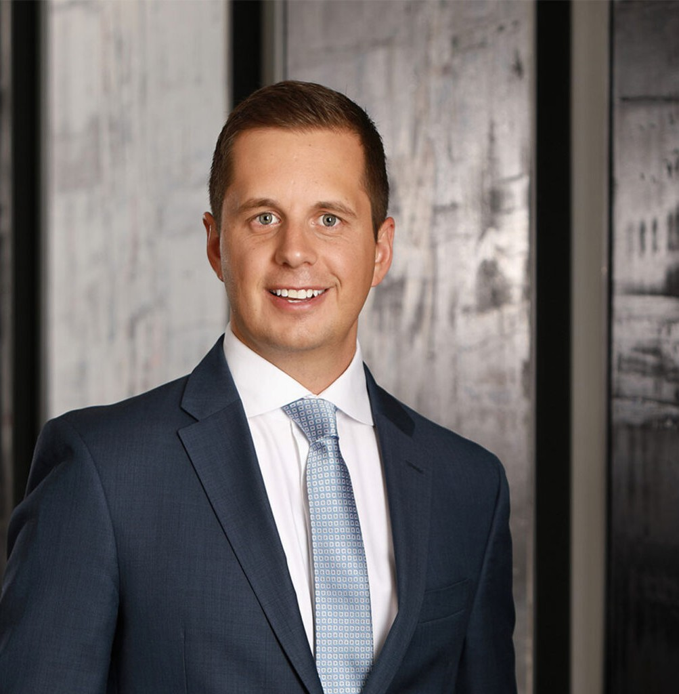

WADE BEAVERS
Director
Business & Finance

Reno
P: 775.788.2208 F: 775.788.2283

Las Vegas
P: 775.788.2208 F: 775.788.2283
wbeavers@fennemorelaw.com
WADE BEAVERS
Wade Beavers advises and represents businesses in regulated industries, including utilities, commercial gaming operators, and financial service providers, as well as related stakeholders, in a wide range of matters, with focus on Nevada state and local licensing and regulatory compliance issues. He has extensive experience representing clients in significant proceedings before the Public Utilities Commission of Nevada, the Nevada Gaming Control Board, the
Nevada Financial Institutions Division, the Nevada Department of Taxation, and various other local, state, and federal regulatory bodies, and has assisted companies of all sizes, as well as individuals, in navigating transactions involving privileged licenses and regulatory approval
components.

Wade has specialized expertise in consumer financial services, with years of experience representing financial institutions and debt collectors in compliance matters as well as in
litigation, including class and individual consumer actions. In addition to his regulatory expertise, Wade has over a decade of experience in complex litigation in state and federal courts across the country in a broad range of matters, including significant corporate governance and intellectual property disputes, construction and mechanics’ lien litigation, mining and water law disputes, and significant trust and estate litigation, and has defended large and small corporations in numerous employment lawsuits and other legal proceedings relating to general commercial liability. Wade relies on his background as a litigator in advocating for his regulated- industry clients in agency disputes and judicial review matters, and in representing his clients in rule-making proceedings.
Prior to joining Fennemore, Wade served as a Deputy Attorney General in the Nevada Attorney General’s Bureau of consumer protection, where he prosecuted antitrust and consumer protection matters and represented the interests of the consumers of the State of Nevada in utilities matters.

EDUCATION
J.D., University of Nevada, Las Vegas, William S. Boyd School of Law B.A., University of Arizona

AREAS OF PRACTICE

OTHER EXPERIENCE

Litigation
Business & Finance Business Litigation Gaming & Hospitality

AWARDS AND HONORS
Best Lawyers in America®, Ones to Watch, Commercial Litigation, Litigation-Construction, Litigation-Real Estate, 2022-2026
2025 Top Rank Attorney List, Nevada Business Magazine “Legal Elite,” Nevada Business Magazine, 2019-2022
Mountain States Super Lawyers Rising Stars®, Business Litigation, 2024

ARTICLES AND PRESENTATIONS
Co-Author, “Disability Accommodations in Post-Pandemic Work-from-Home World,” HR Daily Advisor, June 14, 2022
Author, “5 keys to accommodating remote workers’ disabilities,” HR Laws, April 12, 2022
Co-author, “A refresher on Nevada personnel file rules in wake of COVID-19,” Nevada Employment Law Letter, June 1, 2020
Co-author, “Nevada AG Joins Push to Add ERA to U.S. Constitution,” HR Laws, February 13, 2020

ADMISSIONS
California Colorado Nevada

