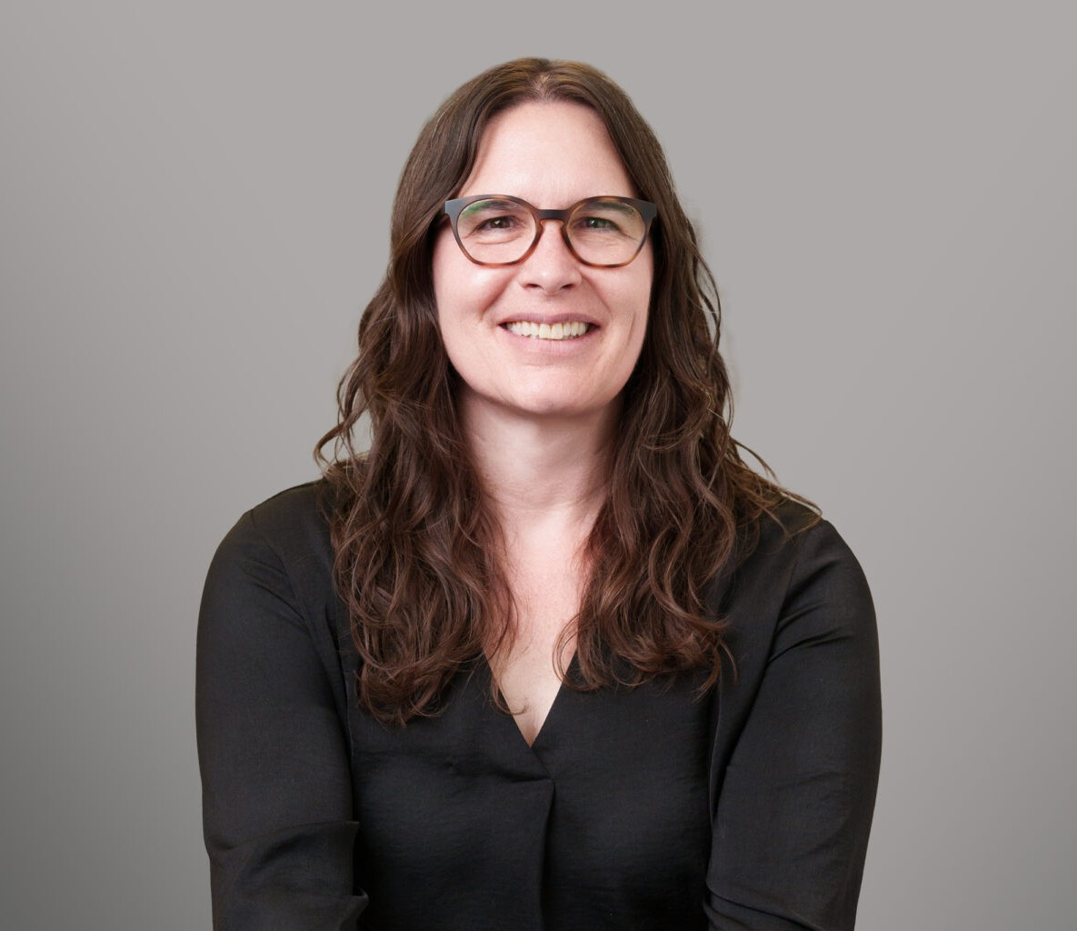

ALYCIA MOSS

Director

[Immigration](https://www.fennemorelaw.com/services/immigration/)

[Coeur d’Alene](https://www.fennemorelaw.com/contact-us/coeur-dalene/)

P: 208.956.0150 F: 208.956.0139

[amoss@fennemorelaw.com](mailto:amoss@fennemorelaw.com)

# ALYCIA MOSS

Alycia Moss is a Director in Fennemore’s Immigration practice group, focusing her practice on guiding businesses, families, and individuals through the complexities of U.S. immigration law. With more than a decade of immigration experience, she has represented clients before the United States Citizenship & Immigration Services (USCIS), Immigration and Customs Enforcement (ICE), Customs and Border Protection (CBP), the Executive Office of Immigration Review (EOIR), the Board of Immigration Appeals (BIA), the Administrative Appeals Office (AAO), the Board of Alien Labor Certification Appeals (BALCA), and federal courts.

Before joining Fennemore, Alycia built and managed a successful immigration practice. She is licensed to practice law in Idaho and Washington, as well as Canada, where she is a Barrister & Solicitor. Her extensive experience includes assisting employers with petitions, visas, immigration compliance, and labor certifications, as well as guiding entrepreneurs and advocating for individuals seeking family- and employment-based immigration solutions.

Alycia earned her law degree from the University of Idaho College of Law, where she was vice president of the student government, a law clerk for the U.S. State Department’s Ambassador for War Crimes Issues, and a published author in the *Michigan State International Law Review*. She graduated magna cum laude from the University of Colorado at Denver with a degree in history, and also studied abroad at St. Petersburg State University in Russia and at Skope Law School in

Macedonia.

A dedicated member of the legal and business communities, Alycia has held leadership roles with the American Immigration Lawyers Association (AILA), including serving as Chair of the Eastern Washington Committee, Chair of the Idaho Chapter, Chair of the Idaho Congressional Liaison Committee, and as a member of the AILA Board of Governors. She is also active in numerous bar associations and civic organizations.

Beyond the office, Alycia enjoys the outdoors and spending time with her daughters. If she were not practicing law, she would happily be leading trips as a backpacking guide.

# EDUCATION

J.D., University of Idaho College of Law

NW Institute for Dispute Resolution, Criminal & Civil Meditation Programs

B.A., University of Colorado, *magna cum laude*

# AREAS OF PRACTICE

Immigration

# AWARDS AND HONORS

Tribute to Women and Industry (TWIN) Award, 2025 Denise O’Donnell Day Pro Bono Award, 2017

Spirit of the Class Award, University of Idaho College of Law, 2005

# ARTICLES AND PRESENTATIONS

Speaker/Contributor, Gonzaga Law School’s Immigration Clinic Speaker/Contributor, University of Idaho’s Immigration Clinic

Presenter, Idaho Judicial Conference, “Crossroads of Justice: How Immigration Law Intersects with State Courts”, 2025

Presenter, SCG Legal Conference, “Coming to America: Immigration Options”, 2023

Presenter, “The Intersection of Criminal Law and Immigration”, Kootenai County Public Defender’s Office, 2019

Speaker, Access to Justice Conference, Spokane, WA, 2019

Presenter, “Human Resources regarding I-9 Compliance”, Idaho Department of Labor, 2018 Speaker, 2nd Annual AILA Idaho Chapter Annual Conference, 2018

Presenter, “CLE Navigating Immigration Consequences and Complications”, Spokane County Bar Association, 2019

Presenter, H-2B Training, Centro de Comunidad y Justicia, 2019 Author, “Strength in Numbers,” The Inlander, July 12, 2018

Presenter, “How to become a citizen”, Idaho League of Women Voters, 2018

Presenter, I-9 Compliance, Human Resources Network of North Idaho (HRNNI) Meeting, 2018 Speaker, Families Together Rally, Coeur d’Alene, Idaho, 2018

Presenter, Spokane County Bar Association CLE, 2017 Speaker, First District Bar Association, 2017

Presenter, Idaho Association of Criminal Defense Attorneys Conference, 2017 Speaker, “Immigration Dilemmas in Our Backyard,” Progressive Dinners, 2017 Speaker, Kootenai County Democrat Club, 2017

Speaker, Boundary County Farmworkers Know Your Rights Event, 2017

Presenter, Immigration Law CLE, First District Bar Association, Coeur d’Alene, Idaho, 2017

# PROFESSIONAL AND COMMUNITY ACTIVITIES

Member, American Immigration Lawyers Association (AILA) Member, Washington and Idaho Regional Sections of AILA

Member, Idaho State Bar Association Member, Idaho First District Bar Association Member, Washington State Bar Association

Member, Kootenai County Chamber of Commerce Member, John P Gray Bench Bar Forum

Member, Idaho Academy for Leadership for Lawyers (IALL), Class of 2018-2019

Volunteer, Annual Lobbying of Congress regarding immigration laws (National Day of Action) Volunteer, Alternative Dispute Resolution, 2005

Board Member, Share Our World

Volunteer, Idaho Volunteer Lawyer’s Program Volunteer, Idaho State Bar Professional Conduct Board Idaho State Bar Exam Grader

Committee Chair, AILA Eastern Washington

Member, AILA Washington Congressional Liaison Committee Chair, AILA Idaho

Co-Chair, AILA Idaho Congressional Liaison Committee Co-Chair, AILA Idaho’s Conference Committee Member, AILA Board of Governors

Volunteer, Annual Citizenship Days, Washington and Idaho

# ADMISSIONS

Idaho Washington

Idaho Federal District Court 9th Circuit Court of Appeals

U.S. Supreme Court

Canada, Barrister & Solicitor