
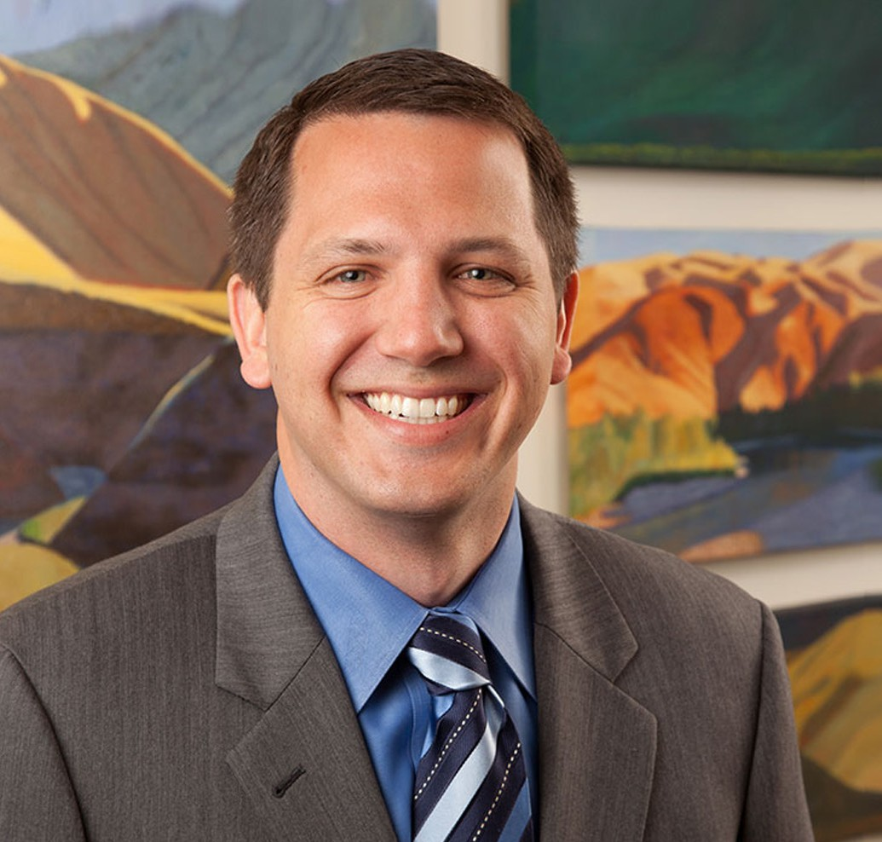
CHRISTOPHER WALTHER
Director
Business & Finance
Las Vegas
P: 702.791.8226
F: 702.791.8227
cwalther@fennemorelaw.com
The credit belongs to the man who is actually in the arena...who at the best
“khenofailsthose,ws, inattheaoldTheodore-cstl e enfaandilsd, thwhimidRoosevelt,tilee triumaoulssringdph ofgwhorea"ThetneithManerly,high acsohiethkninowhetatvemhisenpicArena"toryvlacet, and wnorhalls ho defeat.neverat thebewowithrst, if
”

CHRISTOPHER WALTHER
Christopher Walther’s transactional practice focuses on corporate, business, and commercial real estate matters.
As a seasoned business attorney, Chris counsels clients on corporate organization, governance and restructuring (including mergers and acquisitions), as well as negotiating, drafting,
interpreting, complying with and minimizing risk under a diverse range of business agreements and contracts. Chris aids commercial lenders and borrowers in negotiating, documenting, modifying and foreclosing on secured loans, and advises sellers, buyers, lessors and lessees in acquiring, financing, operating, leasing and selling commercial real and personal property. He
has also developed a broad legal opinion letter practice, and his passion for this work has made him a sought-after attorney in this area.
With an enthusiasm for client service, Chris is adept helping his clients to identify their goals and make important legal decisions, often acting like an in-house counsel. Chris knows how to get answers — even if this means referring a matter to another attorney. Throughout Chris’s career as a business attorney, clients have relied on him to pinpoint the most important legal issues and recommend strategic solutions, giving them peace of mind and a clear blueprint to solve their problems. Typically, this process includes weighing and resolving the various litigation,
employment, regulatory, gaming, intellectual property, tax and environmental concerns businesses often face.

Originally from Portland, Oregon, Chris graduated from Brown University, where he was a proud member of the 1999 Ivy League Champion Brown Bears football team and was selected to the 2002 Academic All-Ivy team. Chris returned to Oregon and earned his Juris Doctor degree from the University of Oregon School of Law. As an entrepreneurial business attorney, Chris chose to practice in Las Vegas for its tremendous diversity and potential. Outside the office, Chris enjoys spending time with his wife and two young boys.

EDUCATION
J.D., University of Oregon School of Law A.B., Brown University
Executive/Staff Editor, Oregon Law Review, 2004-2006
Varsity Football Team (1999 Ivy League Champions), 1999-2002 Academic All-Ivy League, 2002
All-Ivy League Tight End, Honorable Mention, 2002

AREAS OF PRACTICE

OTHER EXPERIENCE

Real Estate Finance and Lending Business & Finance
Real Estate
Emerging Businesses & Technologies Venture Accelerator

REPRESENTATIVE CASES
Led the negotiations for the consignment and sale (via public auction) of the prestigious LeBron James Triple Logoman Basketball Card, the most expensive sports trading card ever to be pulled from its packaging and sold in the same year.
Guided a financial institution in entering into a long-term naming rights and sponsorship
agreement for a metropolitan, multi-purpose arena that is home to NCAA Division I men’s and women’s basketball teams
Assisted a casino-resort owner with all aspects of the lease and subsequent multimillion-dollar sale of the underlying real property to the United States Air Force for national security
purposes.
Advised a real estate development company on the acquisition and development of real estate projects located throughout the country and financed by a complex arrangement of public and private funds.
Counseled a residential apartment developer in obtaining and refinancing numerous loans from institutional lenders (including Freddie Mac loans), which efforts included negotiating loan document terms, performing due diligence, and delivering legal opinion letters.
Successfully negotiated with government authorities regarding the placement of a temporary building wrap on a partially constructed hotel and casino project in order to improve the
aesthetic experience of pedestrians on the Las Vegas strip.

Restructured a former Las Vegas casino owner’s corporate subsidiaries through several
mergers, conversions, and dissolutions in order to simplify the client’s ownership structure while achieving the client’s desired tax benefits.

AWARDS AND HONORS
Best Lawyers in America®, Lawyer of the Year, Commercial Finance Law, 2023 & 2025
Best Lawyers in America®, Commercial Finance Law, 2021-2026
Best Lawyers in America®, Real Estate Law, 2018-2026 Best Lawyers in America®, Corporate Law, 2025-2026 “Legal Elite,” Nevada Business Magazine, 2018-2019
“Best Up and Coming Attorneys,” Nevada Business Magazine, 2013, 2015
Mountain States Super Lawyers Rising Star®, 2009, 2021
National Football Foundation and College Hall of Fame Scholar Athlete of the Year Scholarship (Portland, Oregon Chapter), 1998
AV® Preeminent ™ Peer Review Rated (the highest rating available), by Martindale-Hubbell

ARTICLES AND PRESENTATIONS
Author, “New Nevada Precedent: Statutes of Limitation Can Be Waived by Contract,” Las Vegas Review-Journal, September 1, 2025
Co-Author, Fennemore Notice To Clients – Corporate Transparency Act, Fennemore Client Alert, December 29, 2023
Author, “5 Traps to Avoid When Selling CRE in Las Vegas Area,” Law360, December 14, 2023
Author, “Traps for Sellers of Commercial Real Estate in Clark County,” Fennemore Blog, August 24, 2023
Author, “What You Need to Know About Corporate Transparency in 2022,” The Nevada Independent, April 11, 2022
Co-Author, “Bishop and Zucker on Nevada Corporations and Limited Liability Companies” Co-Author, “Doing Business in Nevada: A Practical Guide”
Contributing Author, “State-by-State Guide to Commercial Real Estate Leases,” 2019-2022 Editions, Nevada Chapter

PROFESSIONAL AND COMMUNITY ACTIVITIES
Member, State Bar of Nevada
Secretary and Board Member, Family Promise of Las Vegas
Volunteer, Landlord/Tenant Ask-A-Lawyer Program, Legal Aid Center of Southern Nevada

ADMISSIONS
Nevada

