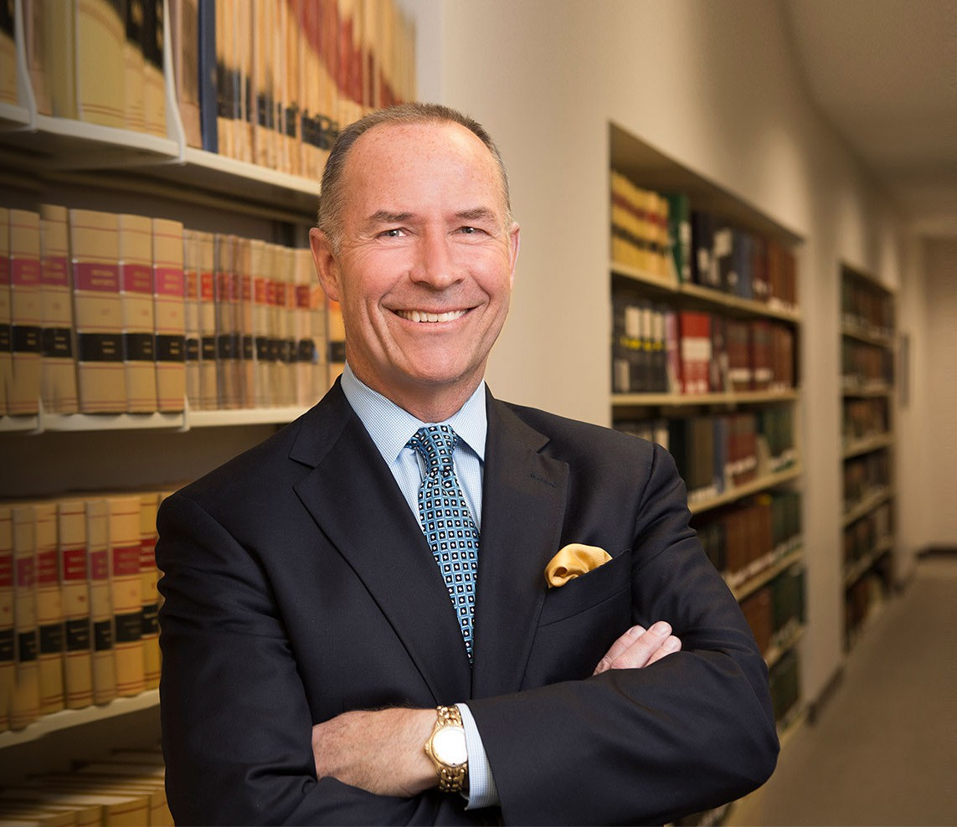

CRAIG ETEM

Director

[Real Estate](https://www.fennemorelaw.com/services/real-estate/)

[Reno](https://www.fennemorelaw.com/contact-us/reno/)

P: 775.788.2224 F: 775.788.2225

[cetem@fennemorelaw.com](mailto:cetem@fennemorelaw.com)

“

If you think you can or you think you can't, you're right.

Generally attributed to Henry Ford

**CRAIG ETEM**

”

Craig Etem is a Director in and leader of Fennemore’s [Business and Finance](https://www.fennemorelaw.com/services/business-and-finance/) practice group, where he covers a wide range of business matters, including mergers and acquisitions,

recapitalizations, and formations. His practice includes all manner of real estate transactions, including acquisitions, sales, and leases. He also serves as outside general counsel for a number of clients.

Craig represents a great variety of clients, from startups to public companies and from small local developers to national builders, and loves working cooperatively with them to solve

complex problems. He takes great pride in listening to their concerns carefully, as deep understanding often leads to creative strategies. According to Craig, the best compliment he has received from a client is that he was “practical.”

Craig has been an active member of the community. He is a former member of the board of directors for the [Economic Development Authority of Western Nevada](https://www.edawn.org/) (EDAWN) and other non- profit boards. He is currently a member of the board of directors for the Food Bank of Northern Nevada and has served as a volunteer tutor to English language learner students in the Washoe County School District.

Prior to becoming an attorney, Craig held a number of jobs. He started work at 15 and was a part-time painter for the school district (he was bad at it), worked at McDonald’s, and then drove floats in the parades at Disneyland – culminating in numerous appearances as Pluto! He also worked as a property manager and budget analyst. In the latter role, while working with

some attorneys on a property tax appeal, he noticed their passion for the work. That experience inspired Craig to apply to and then attend law school. Outside of the office, you will probably find him on the go with his wife and two daughters – the whole family hits the ski slopes together, and Craig and his wife cycle, run, and work out together.

## EDUCATION

J.D., Georgetown University Law Center, *magna cum laud*e

B.S. California State University, Long Beach

**AREAS OF PRACTICE**

# OTHER EXPERIENCE

Real Estate Finance and Lending Real Estate

Business & Finance Mergers & Acquisitions Cannabis Business General Counsel Services

## AWARDS AND HONORS

*Best Lawyers in America®,* Banking & Finance Law, Corporate Law, Real Estate Law, 2008-2025 2025 Top Rank Attorney List, Nevada Business Magazine

*Best Lawyers in America®,* Lawyer of the Year, Corporate Law, 2020 “Legal Elite,” *Nevada Business Magazine,* 2015-2019, 2021

Highly Regarded – Banking, IFLR 1000, 2019 Recommended in *The Legal 500 US,* Real Estate, 2015 *Chambers USA,* Leading Lawyers for Business

AV® Preeminent™ Peer Review Rated (the highest rating available), by Martindale-Hubbell

## ARTICLES AND PRESENTATIONS

[Interview, “Find solutions to a problem your client is facing,” Fennemore Blog, July 22, 2021](https://www.fennemorelaw.com/find-solutions-to-a-problem-your-client-is-facing-with-craig-etem/)

[Quoted, “Let’s Celebrate Random Acts of Kindness Day,” Fennemore Blog, February 18, 2021](https://www.fennemorelaw.com/insights/blogs/2021/let-s-celebrate-random-acts-of-kindness-day) Quoted, “Home means Nevada? No, it means office,” *This is Reno,* November 11, 2020

Quoted, “Fennemore Craig merger gives Reno branch a ‘deeper bench’,” *Northern Nevada*

*Business Weekly,* August 3, 2020

Interview, “Face the State: Small Business Loans,” KTVN TV, May 23, 2020 Interview, “Face the State: Small Business Loans,” 2 News, May 10, 2020

Quoted, “Small Business Will Have Another Chance to Receive Financial Assistance,” 2 News Reno, April 24, 2020

Quoted, “‘We Hope This Ends Quickly’: Northern Nevada Businesses Face Uncertain Future,”

*Northern Nevada Business Weekly*, March 20, 2020

Co-author, “What You Need to Know About Opportunity Zone Funds,” *Daily Press*, May 5, 2019

[Co-author, “What You Need to Know About Opportunity Zone Funds,” Fennemore Client Alert,](https://clientalert.fennemorecraig.com/opportunity_zones) [April 30, 2019](https://clientalert.fennemorecraig.com/opportunity_zones)

[Co-author, “What You Need to Know About Opportunity Zone Funds,”](https://www.insidesources.com/what-you-need-to-know-about-opportunity-zone-funds/) [*Inside Sources,*](https://www.insidesources.com/what-you-need-to-know-about-opportunity-zone-funds/)[April 29,](https://www.insidesources.com/what-you-need-to-know-about-opportunity-zone-funds/) [2019](https://www.insidesources.com/what-you-need-to-know-about-opportunity-zone-funds/)

Co-author, “Inside the Do’s and Don’ts of How to Name Your Company (Opinion),” *Northern Nevada Business View,* October 31, 2018

Co-author, “All Dollars Are Not Created Equal,” *Northern Nevada Business Weekly Smart Money,* March 19, 2018

## PROFESSIONAL AND COMMUNITY ACTIVITIES

Member, Board of Directors, Economic Development Authority of Western Nevada (EDAWN) Member, Board of Directors, Food Bank of Northern Nevada

Member, Washoe County Bar Association Member, State Bar of Nevada

Member, American Bar Association Advisory Board, Nevada Land Trust

Volunteer Tutor, Washoe County School District

## ADMISSIONS

Nevada