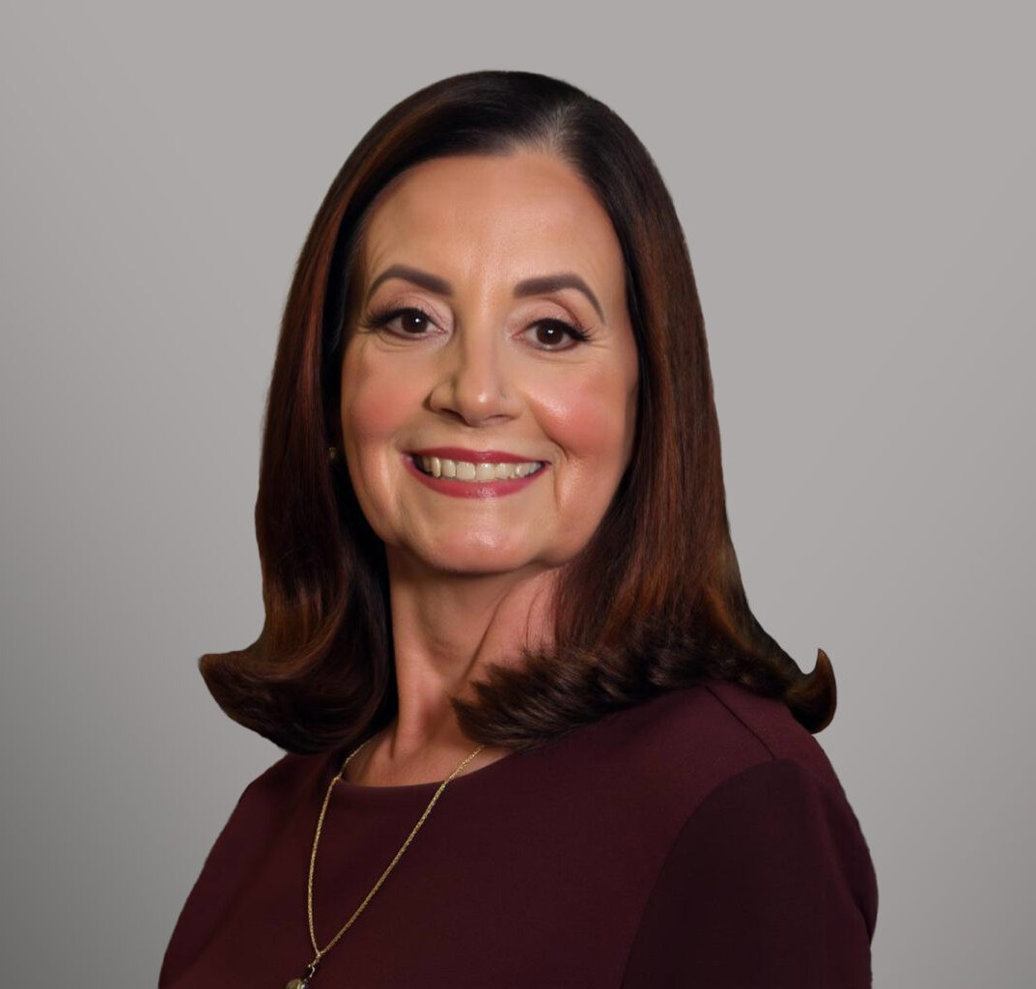

ESTELA OLIVIA PINO

Director

[Business & Finance](https://www.fennemorelaw.com/services/business-and-finance/)

[Sacramento](https://www.fennemorelaw.com/contact-us/sacramento/)

P: 916.273.1840

F: 916.920.8608

[epino@fennemorelaw.com](mailto:epino@fennemorelaw.com)

## ESTELA OLIVIA PINO

Estela Olivia Pino is a Director in Fennemore’s Business & Finance practice group, bringing more than four decades of experience in bankruptcy law, bankruptcy litigation, and debtor/creditor matters. Over the course of her distinguished career, she has represented Chapter 7 and Chapter 11 trustees, debtors in possession, creditors’ committees, creditors, and litigants across a wide range of complex proceedings.

Estela began her career at the boutique bankruptcy firm of Melvyn J. CoBen before practicing at Weintraub, Genshlea, Hardy, Erich & Brown, and later at Greve, Clifford, Diepenbrock & Paras. In 1995, she established her own practice, Pino & Associates. In 2025, she joined Fennemore, where she continues to focus on high-level bankruptcy and litigation matters.

She earned her law degree from the University of the Pacific, McGeorge School of Law, where she was inducted into the Order of the Coif and the Traynor Honor Society. During law school, she served as a staff writer and assistant editor for the *Pacific Law Journal*, publishing scholarship on an insolvency-related tax issue entitled, “*Contra Tufts: The Case Against the Fair Market Value of Limitation on Amount Realized*.”

Estela is a member of the California Bankruptcy Forum, the Sacramento Valley Bankruptcy Forum, and the Inland Empire Bankruptcy Forum.

A native of Havana, Cuba, Estela grew up in Miami, Florida, but considers herself a “Valley Girl,” Central Valley of California that is. She resides in Placer County with her husband, Mike, an estate planning attorney, and their three beloved Bichon Frises.

## EDUCATION

J.D., University of the Pacific, McGeorge School of Law, *magna cum laude*

Oakland University Rochester, Michigan University of Miami, Coral Gables, Florida

**AREAS OF PRACTICE**

# OTHER EXPERIENCE

Bankruptcy & Bankruptcy Litigation

Judgment Enforcement Business & Finance

Financial Restructuring

## ARTICLES AND PRESENTATIONS

Panelist, “Pleading with Particularity,” 2023 Northern California Bankruptcy Conference

Panelist, Case Updates, 2023 bankruptcy breakout session of the Eastern District Conference Panelist, “2024 Case Update,” 2024 Northern California Bankruptcy Conference

Panelist, “Civility,” 2025 Northern California Bankruptcy Conference

## PROFESSIONAL AND COMMUNITY ACTIVITIES

Member, California Bankruptcy Forum Member, Sacramento Valley Bankruptcy Forum Member, Inland Empire Bankruptcy Forum

## ADMISSIONS

Supreme Court of the United States of America California

United States Court of Appeals for the Ninth Circuit

The United States District Court for the Eastern District of California The United States District Court for the Northern District of California The United States District Court for the Central District of California

United States Bankruptcy Court, District of Nevada, *pro hac vice basis*

United States Bankruptcy Court, District of Arizona, *pro hac vice basis*

United States Bankruptcy Court, Northern District of Illinois, *pro hac vice basis*

United States Bankruptcy Court, District of Alaska, *pro hac vice basis*

United States Bankruptcy Court, Southern District of Florida, *pro hac vice basis*

## LANGUAGES

Spanish