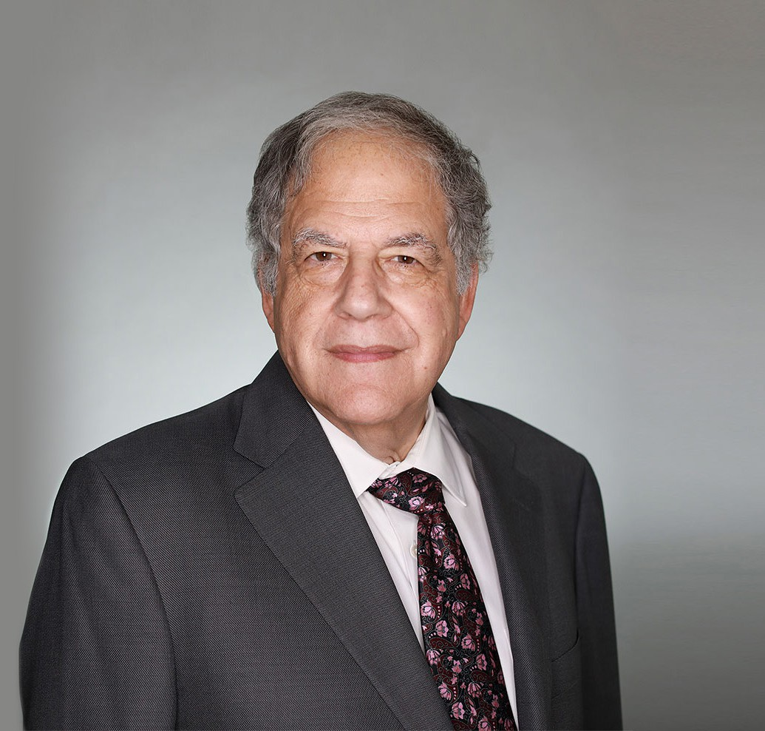

JEFFREY P. ZUCKER

Of Counsel

[Real Estate](https://www.fennemorelaw.com/services/real-estate/)

[Las Vegas](https://www.fennemorelaw.com/contact-us/las-vegas/)

P: 702.791.8231

F: 702.791.8232

[jzucker@fennemorelaw.com](mailto:jzucker@fennemorelaw.com)

“

Justice, justice you shall pursue!

-Deuteronomy 16:20

**JEFFREY P. ZUCKER**

”

Jeff’s practice focuses primarily on real estate and corporate transactions. He counsels and represents privately and publicly held companies and their owners in a wide variety of business matters. He has represented both lenders and developers in large and complex workouts and foreclosures. He also regularly plans, structures, negotiates and implements all types of business initiatives and transactions including very large, multi-million dollar transactions, as well as mergers and acquisitions, financial transactions, and various real estate projects.

Jeff sought a career in law because he enjoys applying analytical thinking to real-world scenarios. He likes seeing what his clients envision and build.

Away from work, Jeff is active in the Las Vegas Jewish community and is a stamp collector. He is also an avid traveler, and participated in a Game of Thrones tour of Croatia.

## EDUCATION

J.D., Harvard Law School B.A., Yale University

**AREAS OF PRACTICE**

# OTHER EXPERIENCE

Real Estate Finance and Lending Real Estate

Business & Finance Gaming & Hospitality

## AWARDS AND HONORS

*Chambers USA,* Leading Lawyers for Business, 2023 and 2024

*Best Lawyers in America®,* Real Estate Law, 1983-2026

*Best Lawyers in America®,* Corporate Governance Law, Corporate Law, 2015-2026 *Best Lawyers in America®,* Lawyer of the Year, Real Estate Law, 2008, 2014 *Mountain States Super Lawyers®,* 2016-2022

Highly Regarded – M&A; Real Estate Acquisitions; Real Estate Finance, IFLR 1000, 2019

*Mountain States Super Lawyers®,* Top 100, 2018 Recommended in *The Legal 500 US,* Real Estate, 2015 “Legal Elite,” *Nevada Business Magazine,* 2011-2015

AV® Preeminent™ Peer Review Rated (the highest rating available), by Martindale-Hubbell

## ARTICLES AND PRESENTATIONS

[Co-Author, Fennemore Notice To Clients – Corporate Transparency Act, Fennemore Client](https://www.fennemorelaw.com/wp-content/uploads/2023/12/Corporate-Formation-Filings-and-Deadlines-Fennemore-Notice-to-Clients-re-CTA.pdf) [Alert, December 29, 2023](https://www.fennemorelaw.com/wp-content/uploads/2023/12/Corporate-Formation-Filings-and-Deadlines-Fennemore-Notice-to-Clients-re-CTA.pdf)

[Author, “Night and Day: The Differences in Corporate Law Between Nevada and Delaware,”](https://businesspress.vegas/columns/experts-corner/night-and-day-the-differences-in-corporate-law-between-nevada-and-delaware/)

[*Las Vegas Business Press*, May 7, 2018](https://businesspress.vegas/columns/experts-corner/night-and-day-the-differences-in-corporate-law-between-nevada-and-delaware/)

Co-Author, “Bishop and Zucker on Nevada Corporations and Limited Liability Companies” Co-Author, “Doing Business in Nevada: A Practical Guide”

## PROFESSIONAL AND COMMUNITY ACTIVITIES

Founder and First Chair of the Business Law Section, State Bar of Nevada Member, American College of Real Estate Lawyers

Member, American College of Real Estate Lawyers, Opinion Committee Member, American College of Mortgage Attorneys

Chair, State Bar of Nevada, Business Law Section, Opinion Committee

## ADMISSIONS

Nevada