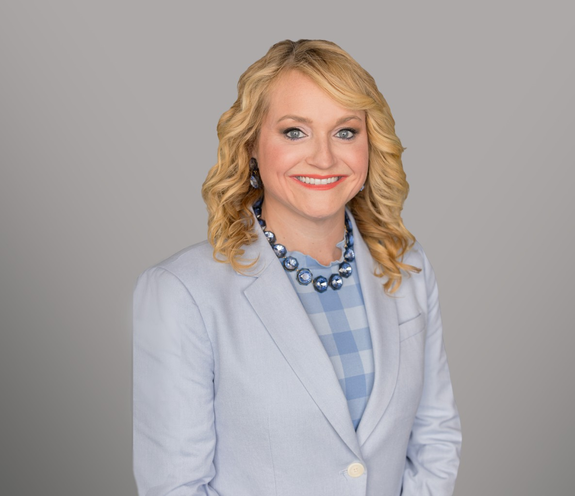

JENNI HARMON

Of Counsel

[Trusts & Estates](https://www.fennemorelaw.com/services/trusts-estates/)

[Sacramento](https://www.fennemorelaw.com/contact-us/sacramento/)

P: 916.920.5286

F: 916.920.8608

[jharmon@fennemorelaw.com](mailto:jharmon@fennemorelaw.com)

# JENNI HARMON

Jenni Harmon practices trust and estate litigation, probate and trust administration, estate planning, taxation, and business transactions. Her comprehensive estate planning services

include skillfully crafting tailored plans that include drafting complex estate planning documents, including wills, trusts, special needs trusts, and other key documents to meet the unique needs and goals of her clients.

Jenni navigates the complexities of probating estates, administering trusts, and advising personal representatives, trustees, and beneficiaries to ensure a smooth and compliant process for her

clients. Jenni’s probate litigation practice involves representing fiduciaries and beneficiaries in all types of trust and estate matters, as well as conservatorships and guardianships. Her skill in this area, combined with her knowledge in taxation and business transactions, makes her a valuable asset to clients looking for well-rounded legal guidance in trusts and estates matters.

# EDUCATION

E-LL.M., Taxation, New York University School of Law

J.D., with Distinction, Concentration in Tax Law, McGeorge School of Law, University of the Pacific

B.S., Political Science with Pre-Law Emphasis and an Italian Minor, Santa Clara University

# AREAS OF PRACTICE

Trusts & Estates Estate Litigation Tax Law

Estate Planning

# AWARDS AND HONORS

Witkin Award for highest grade in Fundamental Rights in Europe and the United States Witkin award for highest grade in Bankruptcy Law

Witkin Award for highest grade in Taxation (U.S.) of International Transactions

Sacramento Magazine List of 2017 Top Lawyers in Sacramento (Tax) Sacramento Magazine List of 2018 Top Lawyers in Sacramento (Tax)

Sacramento Magazine List of 2019 Top Lawyers in Sacramento (Estate Planning and Probate) Sacramento Magazine List of 2023 Top Lawyers in Sacramento (Estate Planning and Probate) Sacramento Business Journal Best of the Bar – 2017

# ARTICLES AND PRESENTATION

Presenter, “Third Time’s a Charm? Key v. Tyler and No Contest Clauses,” 2025 Estate and Gift Tax Conference, March 6-7, 2025

Presenter, “The Tip of the Iceberg: How Not to Muck Up An Estate Plan,” 2024 Estate and Gift Tax Conference, California Lawyers Association, March 21, 2024

Co-Author, “Clarifying Standards for Trade or Business Real Estate Debt,” Viewpoint Tax Notes, September 11, 2015

# PROFESSIONAL AND COMMUNITY ACTIVITIES

Member, Executive Committee, Taxation Section, State Bar of California Member, State Bar of California

Trusts and Estates Section Taxation Section

Member, Sacramento County Bar Association Probate and Estate Planning Section

Tax Section Business Section

Sacramento Estate Planning Council, Education Chair, 2021-2022

Director, 2021-2022

Program Co-Chair, 2022-2023

Social Co-Chair, 2023-2024

Board Member at Large, Barristers Club of Sacramento Member, Women Lawyers of Sacramento

Anthony M. Kennedy Inns of Court

Co-Chair for the 54th Annual CalCPA Golf Tournament

# ADMISSIONS

California

U.S. District Court, Eastern District of California

U.S. District Court, Northern District of California

U.S. Tax Court