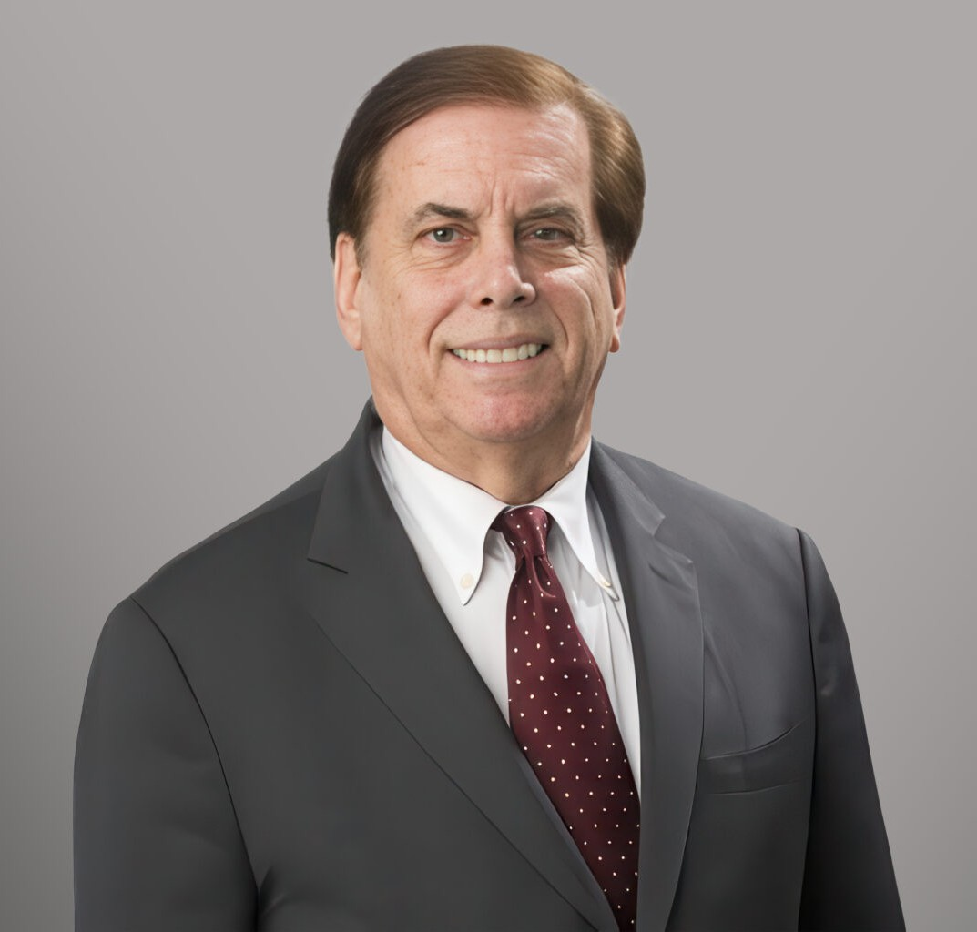

LESLIE ALAN GLICK

Director

[Business & Finance](https://www.fennemorelaw.com/services/business-and-finance/)

[Fennemore Forward](https://www.fennemorelaw.com/contact-us/fennemore-forward/)

P: 202.220.1468 F: 602.916.5999

[lglick@fennemorelaw.com](mailto:lglick@fennemorelaw.com)

## LESLIE ALAN GLICK

Leslie Alan Glick (Les) is a Director in Fennemore’s [Business & Finance](https://www.fennemorelaw.com/services/business-and-finance/) practice group, based in Washington, D.C., and focusing on international trade and customs law, representing clients before the U.S. International Trade Commission, Department of Commerce, Office of the U.S. Trade Representative, and the Court of International Trade. He has extensive experience with antidumping and countervailing duty cases, as well as investigations under Sections 232 and 337 of U.S. trade law. He has handled complex tariff matters for many exporters, importers, and retailers for many years, including the first Trump administration, where he obtained exclusions from section 232 and 301 tariffs for many companies. During the current administration, he has been widely consulted for his ability to develop “tariff mitigation” strategies and has been a

frequent speaker before various trade associations. Les also conducts trade and tariff-related “due diligence” in mergers and acquisitions.

Les is a particularly a specialist in manufacturing in Mexico and so-called “maquiladora” plants where U.S. companies send raw materials to Mexico for assembly and manufacturing, taking advantage of special tariff provisions in US and Mexican laws. Les is the author of books on the North American Free Trade Agreement (NAFTA) and its successor, the U.S.-Mexico-Canada Agreement (USMCA).

Les previously served as counsel to a subcommittee in the House of Representatives and has an active lobbying practice in Washington, D.C., where he is based and has been a registered

lobbyist for many years.

In addition to trade matters, Les advises both domestic and international clients on compliance with regulatory requirements enforced by the Food and Drug Administration (FDA) and the U.S.

Department of Agriculture (USDA), particularly in matters involving food products, meat and poultry, plants, medical devices, and the importation of pharmaceutical and biological

materials. His practice also includes regulatory guidance concerning consumer product safety and automotive product compliance and recalls under the National Highway Traffic Safety Administration (NHTSA) and the Federal Motor Vehicle Safety Standards (FMVSS). Les has also had experience in the regulation of alcoholic beverages, including import matters before the

U.S. Treasury Department Alcohol and Tobacco Tax and Trade Bureau, involving beer and wine imports from Italy and sake from Japan. He has represented one of the largest dietary

supplement importers in the United States, securing the reclassification of a product as a vitamin,

resulting in multimillion-dollar savings in customs duties. His work also includes advising a major

U.S. dietary supplement importer on FDA labeling requirements

Les is a former member of the Food and Drug Law Institute, where he served on the Dietary Supplements Committee and contributed several articles to the institute’s publication, UPDATE, on topics including the Bioterrorism Preparedness and Response Act of 2002. His USDA-related experience includes resolving issues involving meat product regulation and assisting a restaurant chain and retailer in avoiding a significant product recall.

## EDUCATION

J.D., Cornell Law School

Editor, Cornell International Law Journal Board Member, Moot Court

Legal Aid Society B.A., Cornell University

**AREAS OF PRACTICE**

# OTHER EXPERIENCE

International Trade Business & Finance Intellectual Property Agribusiness

Food & Beverage

## PROFESSIONAL AND COMMUNITY AFFILIATIONS

Co-Chair, American Bar Association International Law Section Chair, American Bar Association International Law Committee Chair, American Bar Association, Mexico Committee

Chair, American Bar Association, Customs Committee Chair, Federal Bar Association, International Law Section

## ADMISSIONS

New York Maryland

District of Columbia

## LANGUAGES

Conversational Spanish