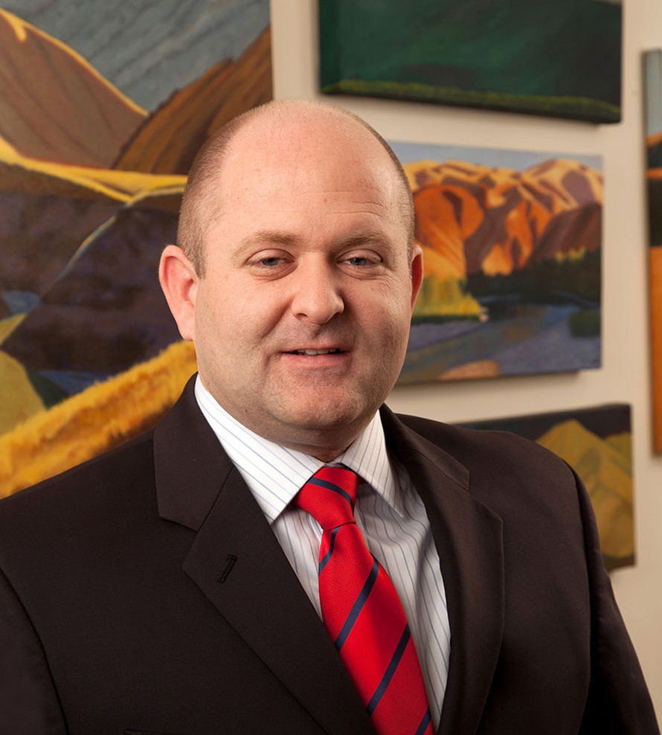

MARK A. HAWKINS

Director

[Real Estate](https://www.fennemorelaw.com/services/real-estate/)

[Las Vegas](https://www.fennemorelaw.com/contact-us/las-vegas/)

P: 702.692.8012

F: 702.692.8072

[Reno](https://www.fennemorelaw.com/contact-us/reno/)

P: 702.692.8012

F: 702.692.8072

[mhawkins@fennemorelaw.com](mailto:mhawkins@fennemorelaw.com)

**MARK A. HAWKINS**

Mark practices in the areas of commercial real estate and corporate transactions, including business and entity planning, formation and governance. His practice includes negotiation and preparation of purchases and sales of commercial real estate agreements, leasing, business acquisitions and general business contracts.

Mark has worked on various multi-million dollar commercial developments, real estate purchase and sales and financing transactions. He also has experience representing local and regional banking institutions in all stages of lending, from loan origination through workout resolutions.

Mark enjoys problem-solving, which is why law was so attractive to him. He appreciates the relationship he has with his clients, and the process of working together to help them achieve their goals.

On weekends, Mark coaches his children’s teams and drives his daughters to dance practice, and occasionally sneaks away for a round of golf.

## EDUCATION

J.D., Southern Methodist University, Dedman School of Law, *cum laude*

B.S., Brigham Young University

**AREAS OF PRACTICE**

# OTHER EXPERIENCE

Asia Practice

Restaurant and Food Services Real Estate

Business & Finance

Emerging Businesses & Technologies Financial Restructuring

Mergers & Acquisitions

## REPRESENTATIVE CASES

Counseled corporate guarantor of $4.25 billion loan.

Advised local subsidiary of SEC reporting company on $407 million credit facility.

Negotiated, drafted and closed asset purchase agreement involving three car dealerships.

Counseled regional bank on the successful workout of two condominium/apartment secured loans.

Served as landlord counsel for property management group and national developer handling retail, office and industrial leases for multiple tenant-in-common owned properties.

Negotiated and closed the sale of leasehold interest in Forum Shops at Caesars to international retail chain.

Closed $64 million land acquisition deal for national homebuilder client.

## AWARDS AND HONORS

*Best Lawyers in America®,* Commercial Finance Law, Construction Law, Litigation – Real Estate, Real Estate Law, 2018-2026

Recommended in *The Legal 500 US*, Real Estate, 2020 “Legal Elite,” *Nevada Business Magazine,* 2013, 2015-2016

*Mountain States Super Lawyers Rising Stars®,* Real Estate, Business & Finance, Emerging Businesses & Technologies, Financial Restructuring, Mergers & Acquistions, 2025

*Mountain States Super Lawyers Rising Stars®,* Real Estate: Business, 2015 *Mountain States Super Lawyers Rising Stars®,* Business/Corporate, 2012-2014 *Mountain States Super Lawyers and Rising Stars®,* 2010

Honored as 1 of 20 “Best Up and Coming Attorneys”, *Nevada Business Magazine,* 2010

## ARTICLES AND PRESENTATIONS

[Interview, “Consistent Hard Work Still Remains the Key to Success,” Fennemore Blog, June 16,](https://www.fennemorelaw.com/consistent-hard-work-still-remains-the-key-to-success/) [2022](https://www.fennemorelaw.com/consistent-hard-work-still-remains-the-key-to-success/)

[Quoted, “Let’s Celebrate Random Acts of Kindness Day,” Fennemore Blog, February 18, 2021](https://www.fennemorelaw.com/insights/blogs/2021/let-s-celebrate-random-acts-of-kindness-day) Quoted, “Industry Focus,” *Nevada Business Magazine*, December 1, 2020

Quoted, “The Las Vegas Gambling Scene Has Gone Off-Strip. Here’s What Investors Need to Know,” *Million Acres,* October 31, 2020

[Author, “Five Things to do Before 2018 Ends,”](https://businesspress.vegas/columns/experts-corner/five-things-to-do-before-2018-ends-18187/) [*Las Vegas Business Press,*](https://businesspress.vegas/columns/experts-corner/five-things-to-do-before-2018-ends-18187/)[December 11, 2018](https://businesspress.vegas/columns/experts-corner/five-things-to-do-before-2018-ends-18187/) Quoted, “Movers & Shakers: Mark Hawkins,” *Nevada Business Magazine*, July 1, 2017

## PROFESSIONAL AND COMMUNITY ACTIVITIES

Member, State Bar of Nevada

Member, Clark County Bar Association

## ADMISSIONS

Nevada