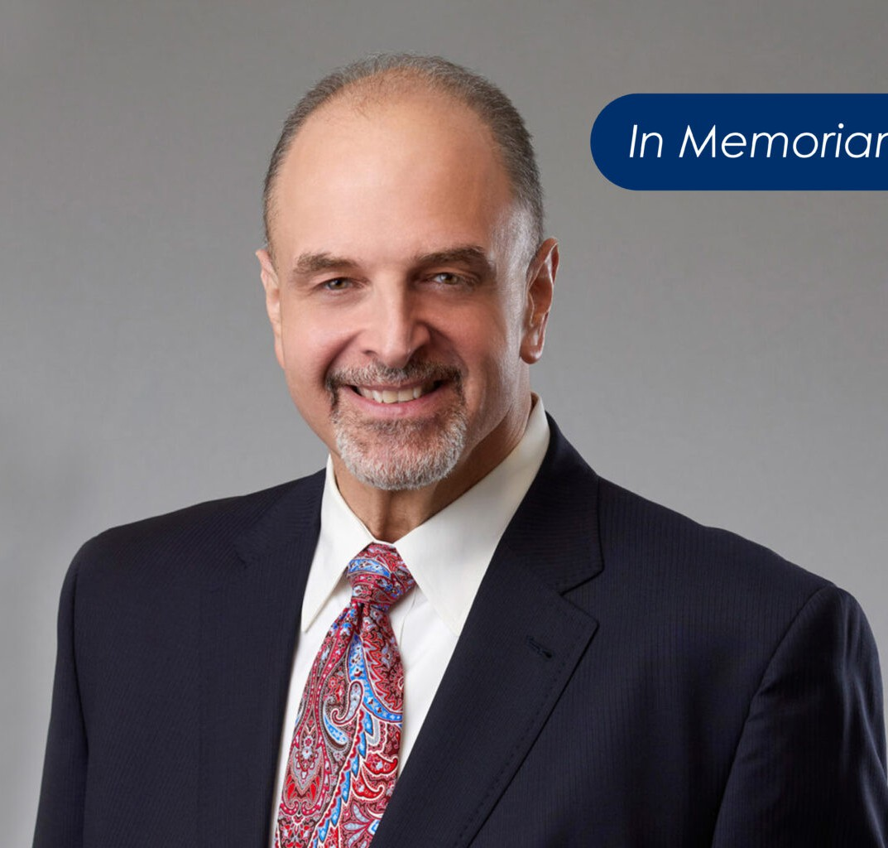

RICHARD DREITZER

Director

[Business Litigation](https://www.fennemorelaw.com/services/business-litigation/)

[Las Vegas](https://www.fennemorelaw.com/contact-us/las-vegas/)

P: 702.692.8000

F: 702.692.8099

[info@fennemorelaw.com](mailto:info@fennemorelaw.com)

**RICHARD DREITZER**

**In Memoriam** – It is with a heavy heart that we announce the passing of our colleague and friend, Richard (“Rich”) Dreitzer, on September 15, 2025.

Rich was a respected attorney and a force within our firm and the broader legal community. He served as Fennemore’s Las Vegas Office Managing Partner, a valued member of our

Management Committee, and was the immediate past president of the State Bar of Nevada.

Beyond his titles, Rich was a trusted advisor, a champion for others, and a steady hand in moments of challenge and change. His wisdom, generosity, and unwavering commitment to doing what is right touched the lives of countless colleagues, clients, and friends.

Rich’s leadership helped shape our Las Vegas office—and our firm—for the better. His legacy endures in the people he mentored, the cases he guided, and the spirit of integrity and service he instilled in all who had the privilege of working alongside him.

The Nevada legal community has lost a respected leader, and we join so many others in honoring Rich’s contributions to the profession and the lives he touched.

We extend our heartfelt condolences to Rich’s family, friends, and loved ones during this difficult time. He will be deeply missed.

## EDUCATION

J.D., Washington University School of Law

B.S., College of Industrial and Labor Relations, Cornell University

**AREAS OF PRACTICE**

# OTHER EXPERIENCE

Insurance Regulatory and Compliance Life, Health and Disability

Manage Care Litigation and Compliance

Business Litigation Construction Law

Employment & Labor ERISA

Real Estate

## AWARDS AND HONORS

*Best Lawyers in America®,* Commercial Litigation/Employment Law – Individuals/Employment Law—Management/Litigation –Construction/ Litigation– Labor & Employment, 2019-2026

“Legal Elite,” *Nevada Business Magazine*, 2020-2021

“Rookie of the Year,” State of Nevada Office of the Attorney General, 2005

AV® Preeminent™ Peer Review Rated (the highest rating available), by Martindale-Hubbell

## ARTICLES AND PRESENTATIONS

Author, “Wellness and Mental Health: What Can We Offer Each Other?,” Nevada Lawyer Magazine, October 1, 2024

Featured, “[ON THE MOVE: Nevada State Bar president named](https://businesspress.vegas/in-brief/on-the-move/on-the-move-nevada-state-bar-president-named-45974/),” Las Vegas Business Press, August 20, 2024

Quoted, “[Richard Dreitzer Sworn in as President of the State Bar of Nevada](https://ourcommunitynow.com/P/richard-dreitzer-sworn-in-as-president-of-the-state-bar-of-nevada),” Our Community Now, June 29, 2024

Quoted, “[Richard Dreitzer Sworn in as President of the State Bar of Nevada](https://nevadabusiness.com/2024/06/richard-dreitzer-sworn-in-as-president-of-the-state-bar-of-nevada/),” Nevada Business Magazine, June 28, 2024

Author, “[Labor and Employment Impacts to Consider as the Big Game Comes to Vegas](https://www.fennemorelaw.com/labor-and-employment-impacts-to-consider-as-the-big-game-comes-to-vegas/),” Fennemore Blog, February 1, 2024

Featuring, “ON THE MOVE: Wells Fargo announces promotion,” Las Vegas Business Press, July 10, 2023

Featuring, “People on the Move: July 10, 2023,” Las Vegas Sun, July 10, 2023

Featuring, “Nevada Business: Industry Focus,” Nevada Business, December 2, 2022 Featuring, “Mandatory overtime: What you need to know,” Clockify, April 7, 2023

[Interview, “It is only in the presence of humility that learning and professional growth becomes](https://www.fennemorelaw.com/it-is-only-in-the-presence-of-humility-that-learning-and-professional-growth-becomes-possible/) [possible,” Fennemore Blog, October 7, 2021](https://www.fennemorelaw.com/it-is-only-in-the-presence-of-humility-that-learning-and-professional-growth-becomes-possible/)

Interview, “Labor, employment specialist discusses President Biden’s vaccine mandates,” KTNV Las Vegas, September 9, 2021

Interview, “Can employees who refuse the COVID-19 vaccine get unemployment benefits?” KTNV Las Vegas, September 8, 2021

Quoted, “Las Vegas small business owner leaves mask decision to customers,” KTNV Las Vegas, May 14, 2021

Quoted, “Mask guidance relaxed for vaccinated individuals, employers can impose their own mask requirements,” KTNV Las Vegas, May 13, 2021

Quoted, “BACK TO WORK: Can remote employees be forced back to work in-person?” KTNV Las Vegas, May 3, 2021

Quoted, “Get vaccine or submit to weekly test: Wynn Las Vegas employee fumes over options,” KTVN Las Vegas, April 8, 2021

[Podcast, “Fenn.Talks: Reaching New Heights with Richard Dreitzer,” April 7, 2021](https://www.youtube.com/watch?v=tifuvxyUv7M)

Quoted, “COVID-19 Vaccine and Employers,” KTNV Las Vegas, December 8, 2020 Quoted, “COVID-19 Vaccine and Employers,” KVVU Fox 5, December 7, 2020

Quoted, “Insurer fires back against Durham business owners’ Covid claims,” *Triangle Business Journal,* September 30, 2020

Speaker, “Pandemic Paradigm Shift: The Perils and the Promise,” State Bar of Nevada Webinar, June 30, 2020

Quoted, “As Georgia Reopens Nail and Hair Salons, Lawyers Say Companies May be Putting Themselves at Risk,” *Yahoo Life,* April 24, 2020

Quoted, “How to Keep Your Employees Healthy During the Coronavirus,” *Business.com*, April 7, 2020

Interview, “Small business loans: How and when to apply,” Fox 11, April 7, 2020 Interview, “Assistance for Small Businesses,” Fox 11, April 7, 2020

[Co-author, “COVID-19: Health Plan Coverage For Furloughed Employees,” Fennemore Client](https://www.fennemorelaw.com/insights/newsletters/2020/covid-19-health-plan-coverage-for-furloughed-employees) [Alert, March 26, 2020](https://www.fennemorelaw.com/insights/newsletters/2020/covid-19-health-plan-coverage-for-furloughed-employees)

[Co-author, “Understanding the Emergency Family Medical Leave Expansion Act and](https://www.fennemorelaw.com/insights/newsletters/2020/understanding-the-emergency-family-medical-leave-expansion-act-and-emergency-paid-sick-leave-in-the-families-first-coronavirus-response-act) [Emergency Paid Sick Leave in the Families First Coronavirus Response Act,” Fennemore Client](https://www.fennemorelaw.com/insights/newsletters/2020/understanding-the-emergency-family-medical-leave-expansion-act-and-emergency-paid-sick-leave-in-the-families-first-coronavirus-response-act) [Alert, March 20, 2020](https://www.fennemorelaw.com/insights/newsletters/2020/understanding-the-emergency-family-medical-leave-expansion-act-and-emergency-paid-sick-leave-in-the-families-first-coronavirus-response-act)

[Interview, “Coronavirus Relief Bill,” Fox 5 News Las Vegas, March 19, 2020](https://muckrack.com/broadcast/savedclips/view/eObGWekWNa)

Quoted, “Q + A: Las Vegas Lawyer Talks About Labor Law as Coronavirus Alters Workplace,”

*Las Vegas Sun,* March 17, 2020

[Co-author, “Frequently Asked Questions About the Coronavirus in the Employment Setting,”](https://www.fennemorelaw.com/insights/newsletters/2020/frequently-asked-questions-about-the-coronavirus-in-the-employment-setting) [Fennemore Client Alert, March 17, 2020](https://www.fennemorelaw.com/insights/newsletters/2020/frequently-asked-questions-about-the-coronavirus-in-the-employment-setting)

Interview, “MGM Resorts report layoffs: Local attorney explains workers’ rights,” KTNV News, March 14, 2020

Quoted, “New Trade Deal Provisions Give US Tech Firms Legal Shields,” *eCommerce Times,*

October 9, 2019

## PROFESSIONAL AND COMMUNITY ACTIVITIES

President, State Bar of Nevada, 2024-2025

Vice President, Board of Governors, State Bar of Nevada, 2022-present Member, Advisory Council, The Mob Museum, 2022-present

Chairman of the Board of Directors, Nevada Public Radio, 2021-present Vice Chair, Nevada Public Radio, 2019-2021

Member, Board of Governors, State Bar of Nevada, 2013-present Board Member, Nevada Public Radio, 2013-present

Member, Fee Dispute Committee, State Bar of Nevada, 2011-present

Member, Lawyers Referral Information Service Committee, State Bar of Nevada, 2011-2014

Member, Ethics and Professional Responsibility Committee, State Bar of Nevada, 2001-2004 Member, State of Nevada Board of Continuing Legal Education, 2014-2021

Justice of the Peace, Pro Tempore, Justice Court, Las Vegas Township, 2009-2018 Small Claims Court Referee, Justice Court, Las Vegas Township, 2009-2020

## ADMISSIONS

Arizona Missouri Nevada

U.S. District Court, Northern District of California

U.S. District Court, District of Nevada

U.S. Court of Appeals, Fifth Circuit

U.S. Court of Appeals, Ninth Circuit

U.S. Bankruptcy Court, District of Nevada