
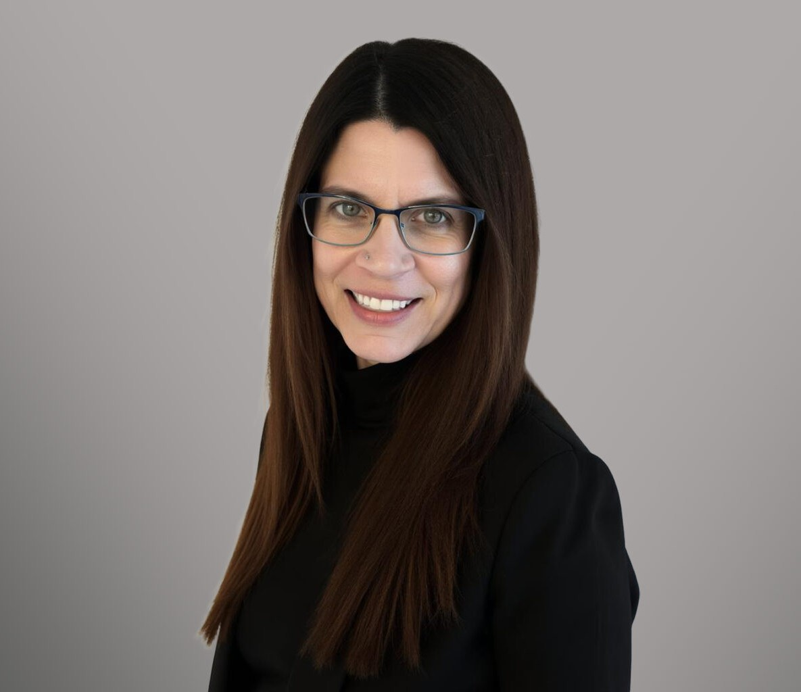
AMANDA SWEET
Paralegal
Business Litigation
Denver
P: 303.813.3887
asweet@fennemorelaw.com
“
The question isn't can they think, or can they reason, but can they suffer.
Philosopher Jeremy Bentham
AMANDA SWEET
”

Amanda Sweet began her paralegal career in 2001. Now, she is a paralegal in the firm’s Business Litigation group. With over two decades of experience in commercial collections, Amanda has built enduring relationships with sheriff’s offices, court clerks, and legal professionals across various organizations.
Outside of work, Amanda is an avid outdoor enthusiast who enjoys paddleboarding, hiking,
kayaking, snowshoeing, and road cycling. A passionate advocate for farmed animals for over 23 years, she dreams of one day establishing her own sanctuary to provide a safe haven for animals in need.

AREAS OF PRACTICE
Business Litigation

EDUCATION
Paralegal Certificate, Arapahoe Community College
B.A., Criminal Justice, Chadron State College, cum laude
AAS, Police Science, Sheridan College, with honors

ADMISSIONS
*Not licensed to the practice of law

