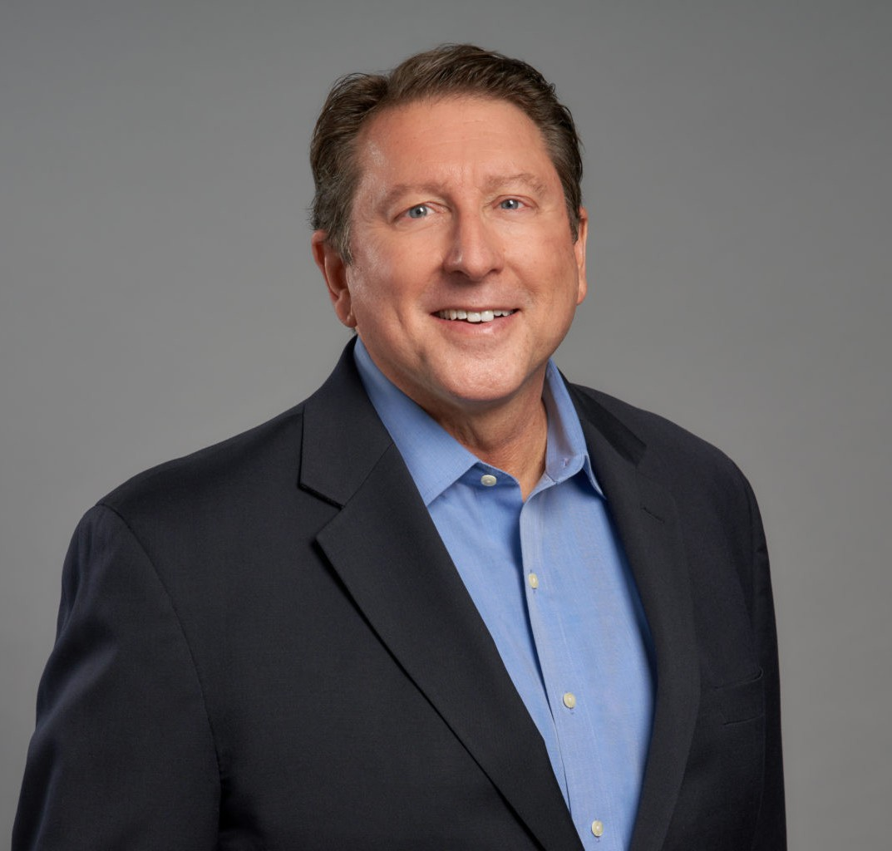

C. GREGG ANKENMAN
Director
Real Estate

Oakland
P: 510.834.6600 F: 510.834.1928
gankenman@fennemorelaw.com

C. GREGG ANKENMAN
Raised by a real estate broker and investor, Gregg has been absorbing the nuances of property deals since childhood. He earned his real estate license at age 18. Today, Gregg offers clients a lifetime of real-world experience and deep legal insight to real estate matters.
Gregg has extensive experience in real estate and business transactional work, including commercial real estate leases, sales, 1031 exchanges, and financing. He has handled hundreds of commercial lease transactions for retail, office, industrial, agricultural, and telecommunications sites. Gregg also advises developers, landlords and property owners with matters such as sales, acquisitions, development, property management, and financing. He has counseled apparel and shoe chains, , restaurants, fitness club operators, jewelry store chains and manufacturing companies in numerous real estate asset and business transactions.
Gregg has served in leadership positions in bar and industry organizations, as well as various leadership roles at the firm.
Long active with National Retail Tenants Association (NRTA), Gregg has a deep understanding of the issues facing the retail industry. He has served as NRTA’s general counsel, received its Founders Service Award, and co-chairs the curriculum committee working to provide retail,
office, corporate, industrial and franchise tenants with real estate education training.

Gregg has written extensively on legal and real estate issues, authoring chapters on retail
leasing, office leasing, real estate finance practices and real property sales transactions volumes for California Continuing Education of the Bar (CEB). He served as chief consultant on CEB’s Retail Leasing: Drafting and Negotiating the Lease.
Praised as dedicated and responsive to clients, Gregg is also committed to community
engagement. He is an active volunteer and leader with nonprofit and community groups, advancing humanitarian, sustainability and social issues.
Gregg volunteers with Baragwanath Blessings Inc., a nonprofit organization (founded by his daughter Colette) that helps babies and children around the world, including supplying babies in Latin America, Africa and Asia with hand-made hats and blankets and operating nutrition

programs and medical clinics in Guatemala. Long interested in music, he is head roadie for his musician-son Dan and sings bass in the Oakland Interfaith Community Choir.

EDUCATION
J.D., University of California Berkeley, School of Law
B.A., Brigham Young University, Phi Kappa Phi, magna cum laude

AREAS OF PRACTICE
Real Estate Business & Finance Advanced Energy Food & Beverage Apparel & Fashion

AWARDS AND HONORS
Best Lawyers in America®, Real Estate Law, 2023-2026
Named, Top 100 Bay Area Corporate Philanthropists, San Francisco Business Times, 2024

ARTICLES AND PRESENTATIONS
Contributing Author and Annual Update Author, Retail Leasing, California Continuing Education of the Bar
Contributing Author and Annual Update Author, Office Leasing, California Continuing Education of the Bar
Contributing Author and Annual Update Author, California Real Estate Finance Practice: Strategies and Forms, California Continuing Education of the Bar
Contributing Author, Handling Real Property Sales Transactions Action Guide, California Continuing Education of the Bar
Speaker, “Tenant Work Letter and Tenant Improvement Allowances: We Can Work It Out,” ICSC U.S. Shopping Center Law Conference, October 2024
Speaker, “Lifestyle & Mixed-Use Developments,” and “Understanding REA’s and OEA’s,” and “Tenant Work Letters and Tenant Improvement Allowances” and “Legal Ethics – The Times They Are a-Changin’,” NRTA Annual Conference, September 2024
Speaker, “Exclusives and Prohibited Uses: You Say “Yes”, I Say “No”: Say [Hello] Goodbye to Messy Exclusive and Prohibited Uses,” ICSC U.S. Shopping Center Law Conference, October 2023
Speaker, “Mixed-Use Developments,” and “Exclusives and Prohibited Uses,” and “Understanding REA and OEA Agreements and How They Affect Your Costs,” NRTA Annual Conference, September 2023
Featuring, “Meet Our Donors!” Operation Dignity, May 2, 2023
Speaker, “Exclusive Tips: Behind the Scenes of Negotiating Exclusive and Prohibited Use Provisions,” ICSC U.S. Shopping Center Law Conference, October 2022
Speaker, “Mixing it Up Over Mixed Use Projects,” NRTA Annual Conference, September 2022

Author, “Understanding the Retail Landlord Perspective,” California Centers, November/December 2019
Speaker, “Mixing it Up Over Mixed Use” and “What Are Landlord’s Thinking?” NRTA Annual Conference, September 2019
Author, “What are Landlords Thinking?” National Retail Tenants Association Tenants In-Common Virtual Newsletter, July 2019
Speaker, “The Responsible Salesperson: Guidelines to Reduce Your Liability Risks,” Colliers International, May 2019
Speaker, “Changing Face of Retail & Office Real Estate” and “Casualty Damage,” NRTA Annual Conference, September 2018
Author, “Changing Face of Retail and Office Real Estate,” NRTA Tenants In-Common Virtual Newsletter, August 2018
Co-Author, “Commercial Real Estate is Changing – Are You Prepared?” NRTA Tenants In-Common Virtual Newsletter, March 2018
Speaker, “Green Lease Leaders Webinar,” Real Estate Section of the American Bar Association, December 2017
Speaker, “Lease Acquisitions – Warts N’ All,” NRTA Annual Conference, September 2017
Co-Author, “Landlord’s Work and Tenant Improvement Allowances: Do You Need Security” NRTA Tenants In-Common Virtual Newsletter, August/September 2017
Co-Author, “Key Retail Leasing Issues” NRTA Tenants In-Common Virtual Newsletter, July 2017
Speaker, “Checking Under the Hood: What to Look for When Acquiring Pre-Owned Leases” and “CAM Wars,” NRTA Annual Conference, September 2016
Speaker, “Green Retail Leases: The Bottom Line Benefits of Being Green,” Greenbuild International Conference and Expo, December 2015
Co-Author, “Hot Tips for a Tenant to Green its Space,” Oakland Business Review, October 2015
Speaker, “Negotiating Key Issues in Office Leases ” and “CAM Wars,” NRTA Annual Conference, September 2015
Author, “CAM Wars (Part 2 – Tenant’s Fair Share),” NRTA Tenants In-Common Virtual Newsletter, June 2015
Author, “CAM Wars (Part 1 – The Definition of CAM),” NRTA Tenants In-Common Virtual Newsletter, March 2015
Speaker, “Security for Tenant Improvement Allowance and Landlord’s Work,” ICSC U.S. Shopping Center Law Conference, October 2014
Speaker, “CAM Wars” and “Trends and Issues in Office Leasing,” NRTA Annual Conference, September 2014
Co-Author, “The Changes Ahead for Commercial Real Estate,” San Francisco Daily Journal, August 13, 2014
Co-Author, “The Changing Face of Real Estate Law in the 21st Century,” Western Real Estate Business, April 1, 2014
Speaker, “Trends and Issues in Office Leasing,” and “Site Plan Workshop: Site Selection and Development in Retail Leases,” NRTA Annual Conference, September 2013

Co-Author, “A Roadmap to Retail Subleases, Part 2,” NRTA Tenants-in-Common Newsletter, August 2013
Co-Author, “A Roadmap to Retail Subleases, Part 1,” NRTA Tenants-in-Common Newsletter, July 2013
Speaker, “Build a Store: Construction Provisions in Retail Leases” and “Managing Outside Counsel” NRTA Annual Conference, October 2012
Speaker, “Environmental Issues With an Impact on Leasing,” Law Seminars International Conference on Commercial Real Estate Leases, April 2012
Speaker, “Developments in Real Estate Law,” NRTA Retailer In-House Counsel Forum, November 2011
Co-Author, “Retail Twists on Green Leasing: Addressing the Unique Needs of the Retail Sector,” San Francisco Daily Journal, October 26, 2011

PROFESSIONAL AND COMMUNITY ACTIVITIES
General Counsel, National Retail Tenants Association
Member, Board of Governors, National Retail Tenants Association Chair, Ethics Committee, National Retail Tenants Association
Co-chair and Member, Curriculum Committee, Annual Conference, National Retail Tenants Association
Member, International Council of Shopping Centers
Member, Board of Directors, Golden Gate Area Council, Inc., Boy Scouts of America Chair, Scouting For Food, Golden Gate Area Council, Inc., Boy Scouts of America Member, Advisory and Planning Committees, Emeryville Citizens Assistance Program Member, Institute of Real Estate Management
Member, Real Property Section, State Bar of California
Member, Board of Directors, Real Property Section, Alameda County Bar Association
Member, Legislation Committee and Delegation to California State Bar Conference of Delegates, Alameda County Bar Association
Member, CEB Real Property Advisory Committee, California Continuing Education of the Bar

ADMISSIONS
California

