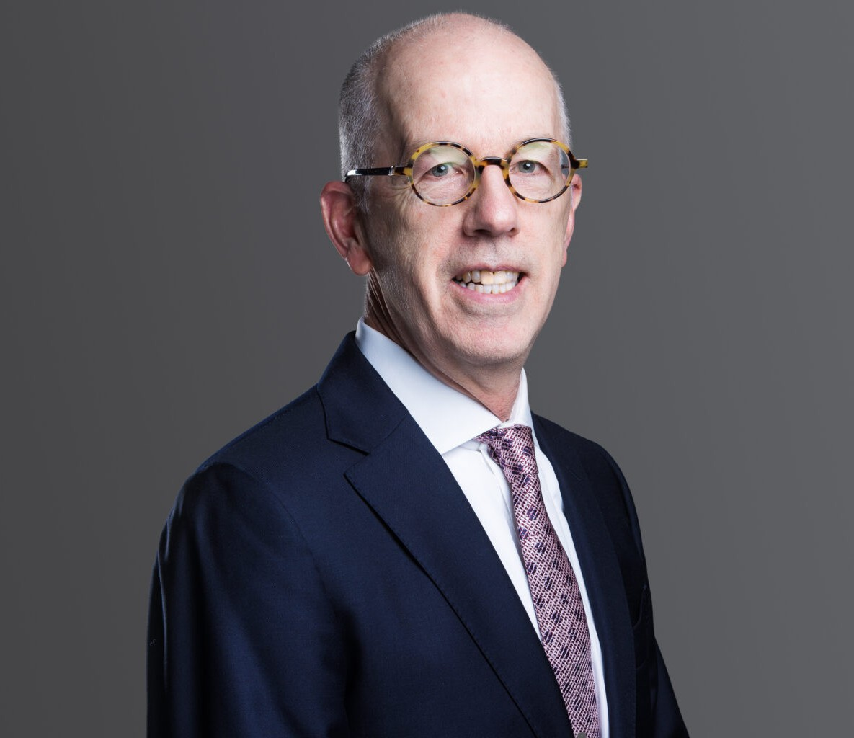

DUFFY GRAHAM
Of Counsel
Business Litigation

Seattle
P: 206.749.0500 F: 206.749.0600
dgraham@fennemorelaw.com

DUFFY GRAHAM
Duffy Graham provides clients with thoughtful and strategic guidance in complex commercial disputes. His comprehensive experience spans pretrial, trial, and appellate proceedings in both federal and state courts, as well as alternative dispute resolution forums.
Duffy is a graduate of the Yale Law School and is licensed to practice in California and
Washington. He clerked for the Honorable Alan B. Handler at the Supreme Court of New Jersey. Duffy is a recipient of the Wiley W. Manuel Pro Bono Services Award from the State Bar of California and has served on the Court Rules and Procedures Committee of the Washington State Bar Association, reflecting his commitment to public service in the legal field.
Duffy is also the co-editor of essay collections on social thinkers and the author of The Consciousness of the Litigator, published by the University of Michigan Press.

EDUCATION
J.D., Yale Law School
B.A., Williams College, magna cum laude with highest honors

AREAS OF PRACTICE
Business Litigation Estate Litigation Intellectual Property

REPRESENTATIVE MATTERS
Gamble v. City of Seattle. Successfully defended against appeal to Washington Court of Appeals and petition for review to the Washington Supreme Court from complete defense verdict in jury trial on employment discrimination claims by former municipal employee for disparate treatment, retaliation, and hostile work environment.
DeNault v. Nice Group USA, Inc. et al. Represented former owner and CEO of manufacturer and marketer of industrial security devices in action against foreign corporation and American subsidiaries for alleged breach of stock purchase agreement and earnout
agreement; obtained favorable settlement.

Quackenbush et al. v. Lehua USA et al. Represented major cannabis industry player and senior executives in the prosecution of trade secret theft and trademark infringement claims against former executive and former employee, and in defending against employment and defamation claims; obtained preliminary injunction ordering the immediate return of intellectual property and equipment, and the cessation of the use of client trade secrets and trademarks, and then ultimately a permanent injunction against trade secret or trademark use and the dismissal of all claims against our clients.
Move, Inc. v. Zillow, Inc. Represented executive defending against trade secret and employment claims in lawsuit seeking $2 billion in damages and career-ending relief;
obtained summary judgment on purported trade secret document, defended at evidentiary hearing spoliation allegations, and obtained favorable settlement prior to trial.
Baerwaldt v. City of Seattle, et al. Defended challenge under Initiative-91 to agreement among the City of Seattle, King County and Chris Hansen’s ArenaCo regarding public financing for a new NBA basketball arena in Seattle; prepared motion to dismiss on behalf of all defendants and obtained dismissal of all claims on ripeness grounds.
ChemPoint v. Xenon Arc Inc., et al. Defended technology startup and its founders against claims for misappropriation of trade secrets, false advertising, usurpation of corporate opportunity and breach of fiduciary duty; obtained ruling entitling clients to advancement of fees under plaintiff’s articles of incorporation, partial summary judgment, and then favorable settlement.
Pande Cameron v. Central Puget Sound Regional Transit Authority, et al. Defended inverse condemnation and constitutional due process claims arising from City of Seattle’s participation in regional transit authority construction project; obtained summary judgment on all claims; defended judgment on appeal and prevailed in the Ninth Circuit.
Paley v. Radar Networks Inc., et al. Defended claims alleging unfair competition, conversion and fraudulent transfer arising from sale of technology company assets; obtained partial summary judgment dismissing most claims and then favorable settlement on remaining claim.
Maier v. Sesame Communications Inc. Prosecuted claims for breach of employment agreement, wage and hour law violations, and tortious interference with exercise of stock options arising from termination of company founder and CEO’s employment; obtained favorable settlement.
Rufin v. City of Seattle and Carrasco. Successfully defended against petition for review to the Washington Supreme Court from Court of Appeals decision affirming trial court denial of post-trial motion for relief alleging discovery violations.
1426 First Avenue LLC v. City of Seattle. Defended challenge to City of Seattle ordinance temporarily extending Pike Place Market Historical District to encompass the historical
entertainment venue The Showbox Theater property; obtained favorable settlement.
Weld v. Dawson, et al. Defended claims for breach of fiduciary duty, minority shareholder oppression, and violations of Blue Sky laws against senior corporate officer; obtained dismissal of all claims against client on motion to dismiss.

AWARDS AND HONORS
Washington Super Lawyers, 2019-2025
Wiley W. Manuel Pro Bono Services Award from the State Bar of California, 1993

ARTICLES AND PRESENTATIONS

Lead Editor, with Robert Jackall, From Albert Salomon: Essays on Social Thinkers, Newfound Press, University of Tennessee Libraries, 2019
Editor, with Robert Jackall, From Joseph Bensman: Essays on Modern Society, Newfound Press, University of Tennessee Libraries, 2014
The Consciousness of the Litigator, University of Michigan Press, 2005

PROFESSIONAL AND COMMUNITY ACTIVITIES
Member, Federal Bar Association of the Western District of Washington, 2003-present
Member, Court Rules and Procedures Committee, Washington State Bar Association, 2019-2023

ADMISSIONS
Washington California
United States Court of Appeals, Ninth Circuit
United States District Court, Western District of Washington United States District Court, Eastern District of Washington United States District Court, Northern District of California United States District Court, Central District of California

