# Food & Beverage

The trusted partner for legal and regulatory counsel in the food & beverage industry.

Fennemore draws upon our years of industry experience to solve legal issues in every facet of our clients’ businesses, whether they be corporate transactions, regulatory counseling, or litigation and dispute resolution.

Fennemore represents clients throughout the food and beverage, alcohol beverages, restaurant and hospitality industries. Our food and beverage clients include multinational corporations, foreign companies selling to the U.S. market, closely-held businesses, entrepreneurs and high-growth, venture capital-backed businesses. We represent food and beverage clients in all tiers of the chain, including producers, co-packers, distributors, and retailers. Our restaurant and café clients range from single-location businesses to nationwide chains. Combining deep experience, broad insight, and close relationships, Fennemore offers food and beverage clients comprehensive guidance for long-term success.

The firm represents clients in the alcoholic beverage industry, breweries, wineries, and distilled spirits companies, as well as distributors and retailers. We also advise agricultural companies and growers, many in organic and sustainable crop agriculture, as well as manufacturers, packers, storage and transportation providers, wholesalers and retailers.

#### LEADERSHIP

[FOOD &](https://www.fennemorelaw.com/services/food-and-beverage/) [BEVERAGE](https://www.fennemorelaw.com/services/food-and-beverage/)

[BUSINESS &](https://www.fennemorelaw.com/services/business-and-finance/) [FINANCE](https://www.fennemorelaw.com/services/business-and-finance/)

[**Richard A. Lyons**](https://www.fennemorelaw.com/people/attorneys/richard-a-lyons/)

Chair

[**Oakland**](https://www.fennemorelaw.com/contact-us/#oakland)

PH 510.834.6600

FX 510.834.1928

[rlyons@fennemorelaw.](mailto:rlyons@fennemorelaw.com) [com](mailto:rlyons@fennemorelaw.com)

[FOOD &](https://www.fennemorelaw.com/services/food-and-beverage/) [BEVERAGE](https://www.fennemorelaw.com/services/food-and-beverage/)

[INTELLECTUAL](https://www.fennemorelaw.com/services/intellectual-property-and-ip-litigation/) [PROPERTY](https://www.fennemorelaw.com/services/intellectual-property-and-ip-litigation/)

[**Eugene M. Pak**](https://www.fennemorelaw.com/people/attorneys/eugene-m-pak/)

Vice Chair

[**Oakland**](https://www.fennemorelaw.com/contact-us/#oakland)

PH 510.834.6600

FX 510.834.1928

[epak@fennemorelaw.](mailto:epak@fennemorelaw.com) [com](mailto:epak@fennemorelaw.com)

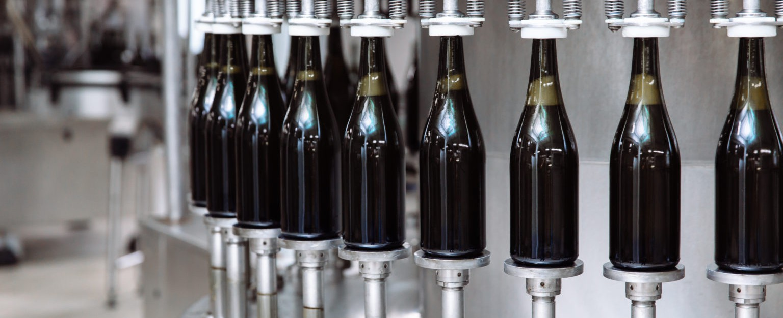

## CORPORATE GUIDANCE

Regardless of their industry focus, clients turn to us for corporate guidance due to our deep experience with entity formation, intellectual property, human resource management, corporate governance, raising capital, and liquidity events. We also assist with specialized industry agreements, including agreements for contract manufacturing, supply, processing, warehousing, brokerage, and distribution.

## REGULATORY COMPLIANCE

We provide guidance on regulations and statutes pertaining to food and beverage quality and safety, labeling, and advertising, including compliance with regulatory requirements enforced by the Food and Drug Administration (FDA), the U.S. Department of Agriculture (USDA), and the Bureau of Alcohol, Tobacco, Firearms and Explosives (ATF). We are well versed in federal laws

(e.g., the Food, Drug and Cosmetic Act, the Food Safety Modernization Act, the National Organic Program, and the Pure Food and Drug Act) and state laws governing food and beverages, and alcoholic beverages including TTB and ABC regulations. In addition to counseling clients on applicable regulations and guidelines, our attorneys assist when it becomes necessary for market withdrawals and recall actions.

## BUSINESS PROTECTION

We know that our clients’ success depends on their ability to mitigate risk and resolve disputes before they turn into bigger challenges. We offer litigation support for business disputes and class action litigation. Our skilled litigators partner with our clients to defend them from employment, Prop 65, labeling, advertising, intellectual property, product liability, and contractual claims. We singularly focus on efficiently resolving litigation and minimizing its effect on our clients’

businesses.

## ALCOHOLIC BEVERAGE

Fennemore handles many transactional and litigation matters for clients in the wine, beer and alcohol beverage industry.

### Regulatory

The alcoholic beverage industry is highly regulated and includes many special considerations. For these types of businesses we advise in areas including:

ABC licensing, recordkeeping and compliance Tied house regulations

Labeling requirements

Distributor and licensing agreements Proposition 65

### Business Operations

For beer, wine and distilled spirits companies, we advise on every aspect of business operations, including:

Business entity formation and ownership structures Capital raises and financing

Succession planning for family-owned businesses, estate planning and wealth management matters

Mergers, acquisitions and sales of businesses, real property or assets

Intellectual property (trademarks and copyrights)

Review of advertising, sweepstakes and contest materials Employment

Wholesaling and retailing issues

Insurance matters and coverage litigation Real Estate, environmental and land use

Equipment leasing

Sustainability and green business practices

## CRAFT BREWING

The craft beer industry continues to expand and grow at a rapid pace as craft breweries constantly innovate, bringing interesting new beers and brands to the market. Consumers are also becoming more knowledgeable, demanding locally-brewed beers, organic ingredients, and other innovations. New craft breweries open every week and new beers are introduced every day, and the large breweries are taking notice too.

### Your Business Needs on Top

To compete in this dynamic marketplace, craft breweries not only need to brew top quality beers, but also need to be effective businesses. Our attorneys are particularly well-suited to advise craft breweries on a wide range of legal issues affecting their business. From business entity formation, to obtaining permits, to real estate leasing and land use issues, to protecting

trademarks, and employment law issues, our attorneys have the experience and knowledge to advise craft breweries on virtually all of their legal needs.

### Industry Immersion

Fennemore is an allied member of both the national Brewers Association and the California Craft Brewers Association (CCBA) and is a supporter of craft beer events. Attorneys frequently speak

at industry conferences and write about issues affecting the craft brewing industry.

## LITIGATION

Our experienced litigators are ready to defend and protect your rights. When a competitor’s mark strays too close to your design or a supplier is in breach of a contract, Fennemore’s attorneys will protect your market position. With experience successfully defending a range of business disputes for those in the alcohol beverage industry, we’ll help you make the strategic decisions to best protect your business interests.

## NATURAL & ORGANIC PRODUCTS

Not all products are created the same. Sustainable products are manufactured using methods intended to minimize environmental impacts over their life cycle. Natural products, within the commercial context, refer to cosmetics, dietary supplements, and foods that are minimally processed without adding artificial ingredients. Organic agriculture and foods are governed by the National Organic Program. There are many state and federal laws, regulations, and guidelines governing the manufacturing, marketing and distribution of sustainable, natural and organic products. Our attorneys help translate these legal requirements into actionable business guidance for clients whose focus remains on people, planet and profitability.

Our attorneys have a significant amount of experience working with large and small companies in the natural foods and products industry. While these companies share many of the legal needs as “non green” companies, there are several areas that require some special thought, including issues related to production done through “co-packing” arrangements with third party producers, third party development agreements and transfer of ownership for intellectual

property, and a number of laws governing labeling of organic and natural products. Areas of particular interest to our natural and organic clients include:

Fair Trade

Organic labeling Sustainable agriculture

Carbon offsetting for transportation and distribution “Green” product production and facility operations Licensing and intellectual property

Employment matters Mergers and acquisitions

Corporate social responsibility initiatives

We follow the issues faced by this market segment and enjoy playing a part in the success of companies that provide healthier alternatives to consumers.