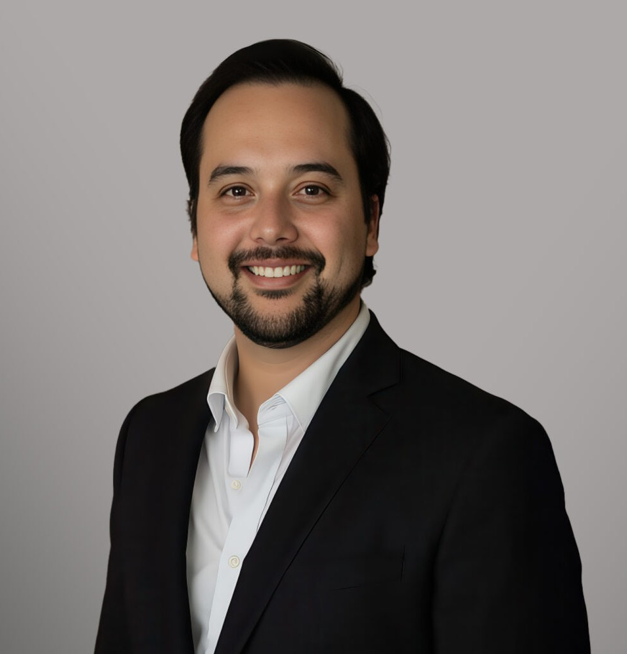

GILBERTO GALVAN

ZACARIAS

Associate

[Business & Finance](https://www.fennemorelaw.com/services/business-and-finance/)

[Phoenix](https://www.fennemorelaw.com/contact-us/phoenix/)

P: 602.916.5336

[ggalvan@fennemorelaw.com](mailto:ggalvan@fennemorelaw.com)

# GILBERTO GALVAN ZACARIAS

Gilbert is an attorney in Fennemore’s [Business & Finance](https://www.fennemorelaw.com/services/business-and-finance/) practice group, where he advises clients on a wide range of corporate, transactional, and financial matters.

Gilbert began his legal career in Mexico. Prior to joining Fennemore, he was a senior lawyer in

Chevez, Ruiz, Zamarripa, where he represented multinational clients in complex matters involving tax and administrative litigation, anti-money laundering compliance, and constitutional

challenges. He also served as an Adjunct Professor and Member of the Examination Board at Universidad Anáhuac, Querétaro, School of Law.

Drawing on his dual qualifications in Mexico and the United States, Gilbert offers clients the

benefit of an international perspective and a versatile approach to legal problem-solving. His cross-border experience enables him to anticipate the challenges businesses face in today’s global economy and to deliver practical, business-minded solutions.

Outside of work, Gilbert enjoys spending time with his friends and partner, golfing, cooking, volunteering, and snowboarding.

# EDUCATION

J.D., *Magna Cum Laude*, University of Arizona, James E. Rogers College of Law Arizona Law Ambassador 2024–25

Professional Outreach Officer and Secretary of the Foreign Lawyers Student Association (FLSA) 2023

LL.B., Universidad Anáhuac, Querétaro, Mexico Academic excellence scholarship

Highest score in the Comprehensive Exam for Degree Completion (“*Examen General para el Egreso de la Licenciatura (EGEL)*”), December 2018

Academic Coordinator of the Federation of Student Societies (FESAL)

# AREAS OF PRACTICE

Business & Finance

# REPRESENTATIVE MATTERS

Negotiated favorable settlements with Mexican tax authorities to resolve

disputes totaling over $50M USD through quasi-judicial mediation procedures before the PRODECON

Led litigation strategies involving tax contingencies assessed by the Mexican tax authorities in excess of $1B USD, stemming from rejected deductions on interest payments in international in-house banking operations, including administrative appeals, tax court complaints, and amparo lawsuits in federal courts

Directed a major internal review and remediation project that helped a corporate group avert over $1.5B USD in potential anti-money laundering compliance penalties

# AWARDS AND HONORS

Recipient, CALI Excellence for the Future Awards (Legal Research, Analysis & Communication I, Legal Research, Analysis & Communication II, and Contract Drafting)

Recipient, Outstanding Performance in Legal Writing Award at University of Arizona, James E. Rogers College of Law, Spring 2024

# PROFESSIONAL AND COMMUNITY ACTIVITIES

Student Mentor, Student Bar Association, University of Arizona, James E. Rogers College of Law

# ADMISSIONS

Arizona Mexico

# LANGUAGES

Spanish