
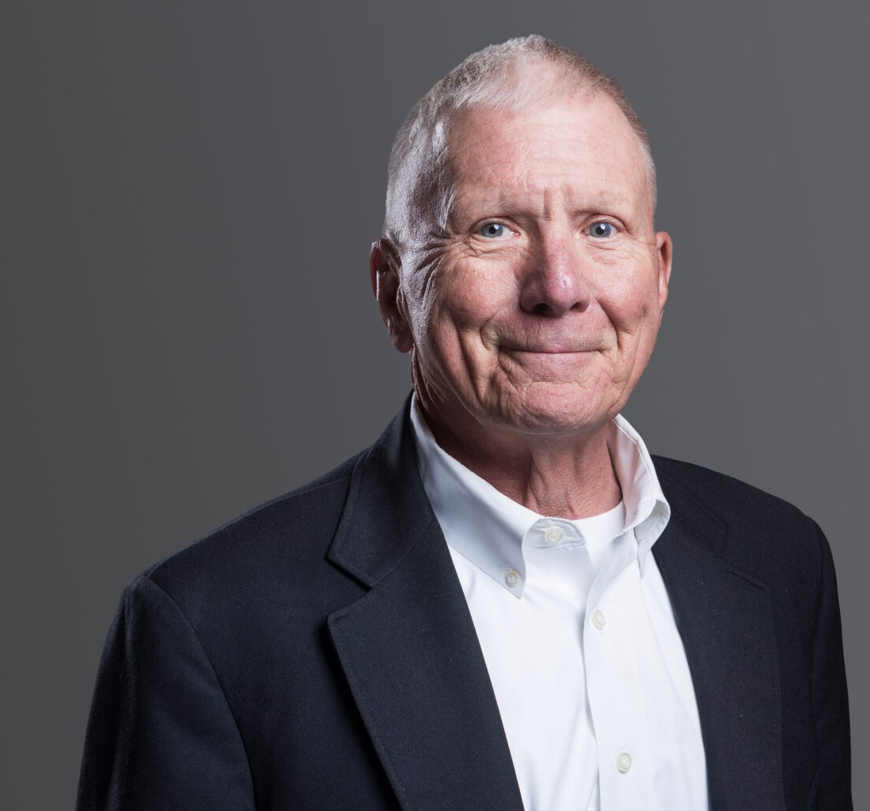
JAMES R. CAGE
Of Counsel
Business Litigation
Denver
P: 303.813.3809
P: 303.726.6105
F: 303.291.3201
jcage@fennemorelaw.com

JAMES R. CAGE
For more than 48 years, Jim has provided outstanding representation in complex litigation matters before federal and state courts and administrative tribunals.
Experienced and highly versatile, Jim counsels plaintiffs and defendants in general commercial, banking, civil, construction, employment, and equine litigation. He offers specific experience in matters involving shareholder disputes, contracts, receiverships, employment discrimination, and labor relations, as well as occupational health and safety concerns.
An expert in equine law, Jim’s practice encompasses business risk management, contracts, liability waivers, and regulatory matters, as well as personal injury and malpractice defense of the equine industry.
Jim also serves as a strategic advisor on issues related to agricultural law, intellectual property, product liability, breach of duty, bad faith, real estate disputes, and securities fraud.
With an extensive knowledge of both the law and its practical applications in the commercial marketplace, Jim works with individual and corporate clients to resolve disputes through trial, appeal, arbitration, or mediation.
Before joining the firm, Jim was the lead partner in the Denver-based law firm of Cage Williams
P.C. for 17 years. He has earned an “AV” Preeminent rating for both legal ability and ethical standards from Martindale-Hubbell, the directory’s highest rating for attorneys.
Outside the courtroom, Jim enjoys spending time with his family, as well as a variety of horseback-related activities including polo, fox hunting, trail riding, and breaking and training horses. He is a lecturer and instructor and donates pro bono legal services to religious,
educational, and nonprofit organizations.

EDUCATION
J.D., University of Missouri-KC, with distinction Managing Editor, Law Review
B.S., Southwest Missouri State University

AREAS OF PRACTICE
Business Litigation

PROFESSIONAL AND COMMUNITY AFFILIATIONS
Member, Colorado Bar Association Member, Colorado Cattlemen’s Association Member, Denver Bar Association
Member, National Western Scholarship Trust Member, National Western Stock Show Member, Roundup Riders of the Rockies

AWARDS AND HONORS
Best Lawyers in America®, Commercial Litigation and Litigation – Banking and Finance, 2023 – 2026
Benchmark Litigation: Local Litigation Star – General Commercial Litigation, Construction Litigation, and Intellectual Property Litigation 2020 – 2024
Colorado Super Lawyer: Civil Litigation, 2008, 2010 – 2015; 2020; General Litigation, 2021 – 2022 Martindale-Hubbell Rating: AV® Preeminent™

ADMISSIONS
Colorado
U.S. Court of Appeals for the Tenth Circuit
U.S. District Court for the District of Colorado

