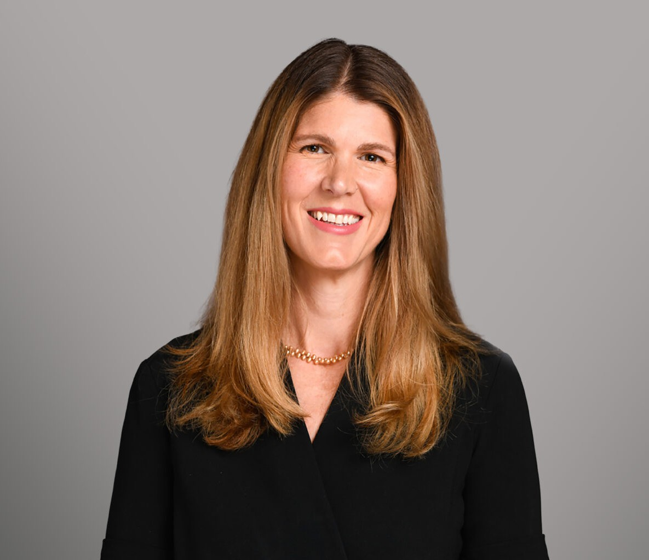

JANUARY ALLEN

Director

[Business Litigation](https://www.fennemorelaw.com/services/business-litigation/)

[Denver](https://www.fennemorelaw.com/contact-us/denver-2/)

P: 303.704.4061

[jallen@fennemorelaw.com](mailto:jallen@fennemorelaw.com)

# JANUARY ALLEN

January Allen has over 20 years of experience providing efficient, solution-oriented assistance to clients in both transactional and litigation matters. She is an advocate and counselor for her clients in a broad array of areas, including:

Construction Intellectual property Real estate Insurance coverage Environmental

Product liability Employment

Prior to joining Fennemore, she was a founding member of Galvanize Law Group, a Denver-based law firm focused on serving the construction industry. January also worked previously as a patent attorney and intellectual property litigator with two boutique law firms.

Prior to law school, January worked as a wetlands and conservation biologist. In her spare time, she enjoys hiking, biking, skiing, and scuba diving with her husband and two sons.

# EDUCATION

J.D., University of Hawaii, William S. Richardson School of Law, 2005 Recipient of a scholarship for academic achievement

Native American Moot Court, 2nd Place Nationally for Best Brief

B.S. Biology, College of Charleston, *with honors*, 2000 Golden Key Honors Society

# AREAS OF PRACTICE

Business Litigation Construction Law

Intellectual Property Real Estate

Natural Resources

# REPRESENTATIVE MATTERS

Trial victory on behalf of homeowner in case involving real estate non-disclosure, contractor standard of care, and asbestos contamination issues.

Negotiated series of contracts for acquisition, entitlements, development, and re-sale of 300 lot multi-family development.

Part of trial team in patent infringement case successfully defending against efforts to invalidate small business owner’s patent through allegations of inequitable conduct during the patent prosecution process.

Drafted and closed transactions for mergers, acquisitions, and member buyout for conglomerate of construction and real estate holding companies.

Economically beneficial settlement reached for brewery client after two years of contentious litigation in trademark infringement suit.

Represented environmental professional in litigation involving brownfields development and CERCLA liability.

Favorable outcome at trial for C-suite employee of technology company in litigation involving eight figure damages on allegations of misappropriation of trade secrets and violation of restrictive covenants.

Represented EPA subcontractor in mining reclamation case involving CERCLA liability.

Successfully moved for dismissal of all claims in a 42 U.S.C. § 1983 case brought against a municipality.

Obtained summary judgment on behalf of a dock-leveling equipment manufacturer in a products liability case in which the Plaintiff was seeking seven figures in damages.

Obtained summary judgment on behalf of special district on 42 U.S.C. § 1983 and Rehabilitation Act claims brought against it by former employee.

Represented produce distributor in food-borne illness and product liability multi-district litigation, with 36 lawsuits filed in Colorado.

Successful briefing to the 10th Circuit Court of Appeals on the idea-expression dichotomy on behalf of artist in a copyright infringement case.

Represented homeowners through litigation and appellate process in key Colorado case on tolling of the statute of limitations in construction defect disputes.

Prosecuted patent applications on behalf of a variety of clients including a flow meter company, construction materials manufacturer, agricultural irrigation company,

ophthalmologist, and endodontist.

# AWARDS AND HONORS

Colorado Bar Foundation – Fellow

Martindale Hubbell AV Pre-eminent Peer Review Rating

Colorado Super Lawyers, Construction Litigation, 2020-2025

# ARTICLES AND PRESENTATIONS

Co-Presenter, “Emerging Legal Issues Affecting Your Contracts, Insurance, and Employees,” American Council of Engineering Companies of Colorado’s Annual Conference, April 2025

Presenter, “Die Hard for the Holidays: Jobsite Safety and Insurance Coverage,” Tradecraft Industries, November 2024

Presenter, “Fundamentals of Construction Contracts: Concepts, Clauses, and Compliance,” Rocky Mountain Masonry Institute, September 2023

Presenter, “Construction Employers Lunch and Learn: Employees and Vehicle Accidents,” Tradecraft Industries, August 2023

Presenter, “Employment Law Considerations for 2023: Overview of Colorado Legal Changes & Remote Employees,” American Council of Engineering Companies of Colorado’s Annual Conference, May 2023

Presenter, “Contract Basics, ACEC Member Lunch and Learn,” October 2022

Presenter, “Acquiring and Selling Businesses Part 1,” Tradecraft Industries Lunch and Learn, May 2022

Presenter, “Federal, State & Local Vaccine Mandates: What Do They Mean for Your Firm?, “American Council of Engineering Companies of Colorado Fireside Chat, November 2021

Presenter, “When the S#it Hits the Fan: How to Navigate Contract Disputes,” Rocky Mountain Masonry Institute, July 2021

Presenter, “The Americans with Disabilities Act & the Accessibility Code,” J.S. Held LLC, CLE Webinar, May 2021

Author, “Post-Cyberattack Professional Duties: A Review of ABA Formal Ethics Opinion 483 and a Recent Colorado Malpractice Suit,” Professional Liability Defense Federation Quarterly, Spring 2019

Presenter, “The Ethics of Insuring Maryjane: An Update on Cannabis Law,” Lloyd’s of London, 2019

Presenter, “Product Malfunction Theory,” Liberty International, 2019

Presenter, “Lions & Tigers & Technology: LPL Risks Associated with the Use/Misuse of Technology,” Professional Liability Defense Federation, 2019

Presenter, “The Data Behind the Data: Use of Metadata in Litigation,” National Retail and Restaurant Defense Association, 2019

Presenter, “Cyber Competence 101,” Nebraska Defense Federation, 2019

Author, “Bits and Bytes: Cyber Case Law Review,” Professional Liability Defense Federation Quarterly, Fall 2018

Author, “Cybersecurity Breaches Involving Personal Identifying Information: Survey of State Notification Laws,” Professional Liability Defense Federation Quarterly, Spring 2018

Presenter, “Trademarks for Startups,” Colorado Preferred Partners, 2018 Presenter, “Intellectual Property Basics,” Jeffco Innovators, 2016

Presenter, “An Intellectual Property Toolbox for Inventors,” Denver Indian Bureau 2014

# PROFESSIONAL AND COMMUNITY ACTIVITIES

American Council of Engineering Companies of Colorado Former Board Member, Colorado Defense Lawyers Association Chair, Trial Academy

Former Board Member, Professional Liability Defense Federation

Colorado Bar Association, Intellectual Property and Construction Sections American Intellectual Property Association

Habitat for Humanity

# ADMISSIONS

United States Patent and Trademark Office Colorado

Wyoming

The United States District Court for the District of Colorado The United States District Court for the District of Wyoming Tenth Circuit Court of Appeals