
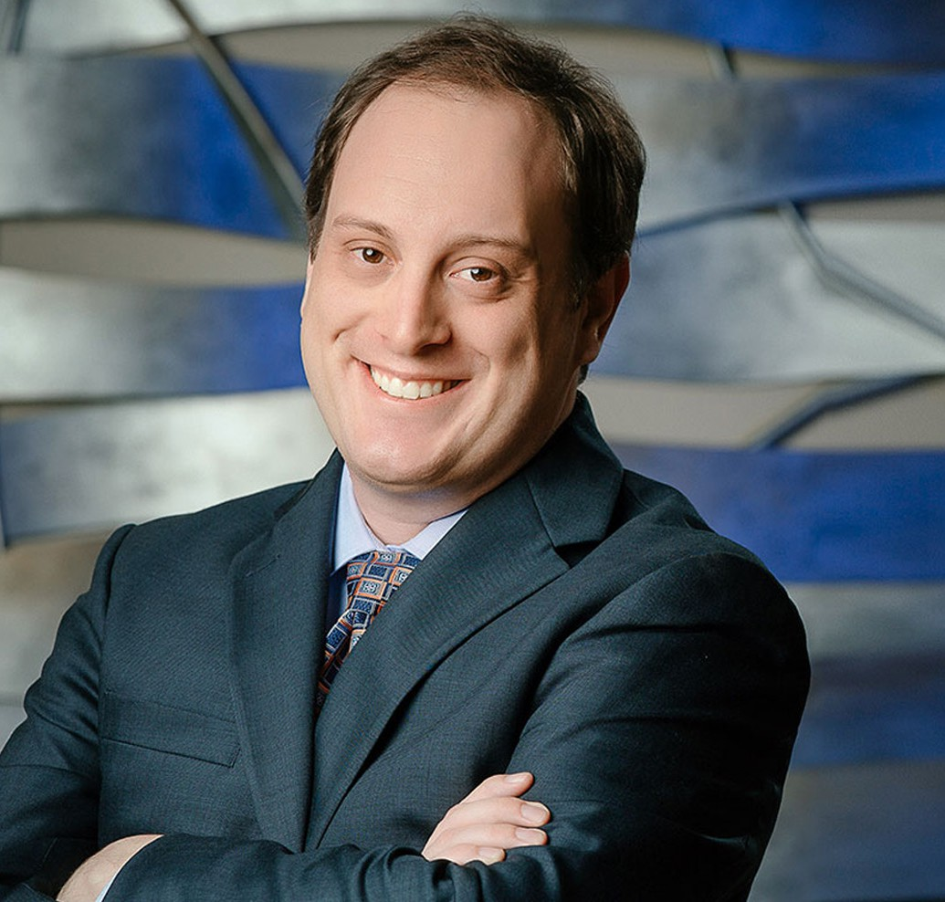
JARED C. MARSHALL
Director
Trusts & Estates
Fresno
P: 559.432.4500
F: 559.432.4590
jmarshall@fennemorelaw.com

JARED C. MARSHALL
Jared Marshall is a director in Fennemore’s Fresno office, where he focuses his practice on trust and estate litigation. He represents beneficiaries, heirs, fiduciaries, and family members in
complex and often sensitive disputes involving inheritance, trust and estate administration, and the care of elderly or incapacitated individuals.
Jared combines strategic insight with practical experience to guide clients through emotionally charged matters such as challenges to estate planning documents, asset distribution disputes, and issues involving fiduciary conduct. Known for his balanced approach, he works to resolve conflicts efficiently and effectively—whether through negotiation or in court.
In addition to his litigation practice, Jared is dedicated to legal education. He serves as an
Adjunct Professor at Fresno City College, where he teaches Probate, and has previously taught Advanced Legal Research and Writing at Fresno City College and Moot Court at San Joaquin College of Law. He also coached San Joaquin’s Traynor Moot Court team, mentoring law students in advocacy and oral argument.
Jared earned his law degree from the University of Southern California and served as a law clerk to the Honorable Lawrence J. O’Neill in the United States District Court for the Eastern District of California. He is a member of the California State Bar, the Fresno County Bar Association, and the Association of Business Trial Lawyers.

EDUCATION
J.D., University of Southern California, Gould School of Law B.A., Philosophy, University of California, Davis, with honors
AREAS OF PRACTICE

OTHER EXPERIENCE

Trust and Estate Administration Trust and Estate Litigation

Trusts & Estates Estate Planning Intellectual Property Business Litigation Estate Litigation

AWARDS AND HONORS
Northern California Super Lawyers® Rising Stars®, 2021, 2023-2025 Peter D. Knecht Memorial Award, Los Angeles Copyright Society

ARTICLES AND PRESENTATIONS
Interview, “Enjoy yourself. The process will be stressful and difficult, but it will also be a lot of fun,” Fennemore Blog, January 5, 2023
Podcast, “Understanding the Difference Between a Will and a Trust with Jared Marshall,” Fenn.Talks Podcast, May 20, 2021
Presenter, “Legal Research and Writing for Law and Motion,” California Alliance of Paralegal Associations Annual Conference, 2020

PROFESSIONAL AND COMMUNITY ACTIVITIES
Member, Association of Business Trial Lawyers Adjunct Professor, Fresno City College, Probate
Former Adjunct Professor, Fresno City College, Advanced Legal Research and Writing Former Adjunct Professor, San Joaquin College of Law, Moot Court
Former Coach, San Joaquin College of Law Traynor Moot Court team Past President, Fresno County Young Lawyers Association

ADMISSIONS
California
U.S. District Court, Central District of California
U.S. District Court, Eastern District of California
U.S. District Court, Northern District of California
U.S. District Court, Southern District of California

