
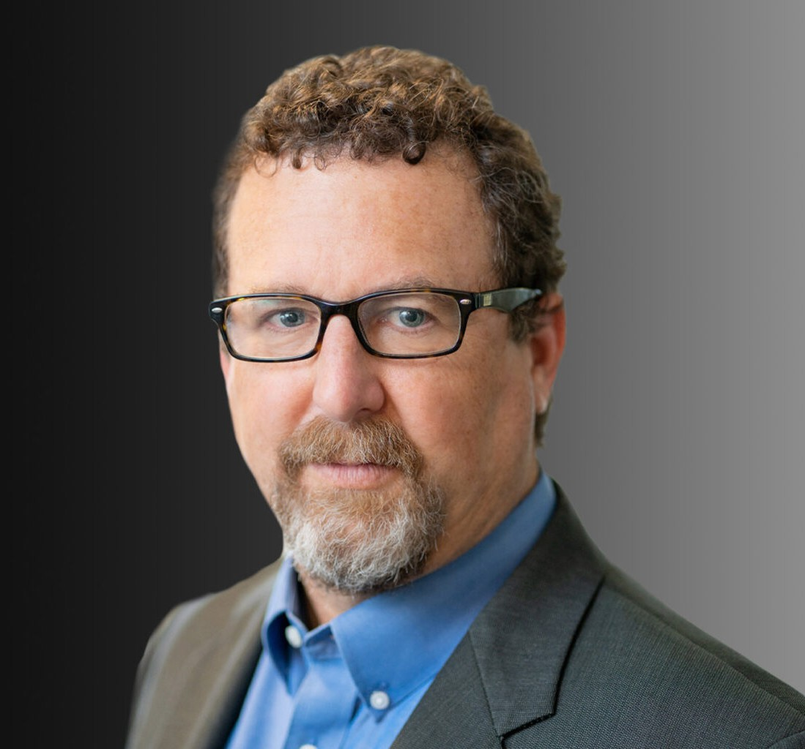
JOSHUA COHEN
Pronouns: he/him
Director
Business Litigation
Oakland
P: 510.834.6600
F: 510.834.1928
jcohen@fennemorelaw.com
“
We are men of action. Lies do not become us.
- Dread Pirate Roberts
JOSHUA COHEN
”

Joshua Cohen is a Director in Fennemore’s business litigation practice group, working closely with his clients to efficiently and effectively resolve their problems. Josh has extensive trial
experience, litigating a full spectrum of commercial disputes, including partnership “divorces,” trade secret matters, contract disputes, real estate, and technology matters. He is adept at addressing clients’ sophisticated litigation needs, representing clients in litigation prevention, mediation, arbitration, and trial in state and federal courts. He has a proven track record of success in high-stakes trials and arbitrations.
Josh’s business litigation experience includes handling disputes regarding high-tech product defects, indemnification and warranty, trademark, and copyright infringement, licensing, cannabis-real estate and business, and employment matters regarding non-compete, non-solicitation, and non-disclosure agreements.
Josh has represented major residential and commercial developers, as well as contractors and individuals in disputes regarding purchase and sale, brokers’ commissions, contractor licensing, non-disclosure/fraud/concealment actions, and land use issues.
Josh represents cities, counties, special districts, and other public agencies, as well as private clients throughout the state, in public acquisition (eminent domain) and similar matters.

EDUCATION
J.D., University of California, Davis School of Law B.A., University of California, Los Angeles

AREAS OF PRACTICE

Business Litigation Intellectual Property Real Estate
Eminent Domain Cannabis Business

REPRESENTATIVE CASES
Obtained $4 million plus verdict for client in partnership dispute.
Defended cannabis business against competitor’s unfair competition claim.
Obtained jury verdict and attorneys’ fee award for mail processing company for wrongful termination by customer.
Negotiated clients’ favorable pre-litigation buy out in partnership
Defeated hostile takeover of real estate partnership and negotiated favorable sale of its core holdings.
Successfully had receiver appointed in partnership dispute where clients were stonewalled by 50% partners.
Defended international manufacturer and its U.S. subsidiaries against fraud and breach of merger agreement claims in California state and federal courts.
Full defense verdict in jury trial for East Bay engineering firm accused of trade secret misappropriation and unfair competition.
Prosecuted fraud/product defect/breach of warranty action against computer chip manufacturer resulting in $7.1 million eve of trial settlement.
Obtained substantial damages and attorneys’ fee award in involuntary dissolution action for partners who were held hostage by managing member.
Defeated restraining order and preliminary injunctions for terminated employees accused of trade secret, breach of non-disclosure and non-compete agreements.
Obtained verdict and attorneys’ fees award in bench trial for specific performance for one of the country’s top five residential developers.

AWARDS AND HONORS
Northwest Super Lawyers®, Top Rated Business Litigation Attorney, 2022-2025

ARTICLES AND PRESENTATIONS
Articles

“US Patent and Trademark Office Stripped of Power to Deny Disparaging or Vulgar Trademarks,” The Recorder, April 2018
“Gold Rush for Cannabis Trademarks,” Marijuana Venture, July 2017

Presentations

Council One Business Advisors, Protecting Your Trade Secrets, April 2025

International Right of Way Association “Annual Legal Update,”, 2019-2025 Council One Business Advisors, Countdown to Trial, January 2023
International Right of Way Association Chapters 2 & 42 “Can Appraisers Still Reply on Hearsay After the Sanchez and Stamps Decisions?,”April 2020
Wendel Rosen LLP “Saving Your Assets,” Wendel Rosen LLP, May 2019

PROFESSIONAL AND COMMUNITY ACTIVITIES
Member, Intellectual Property Section, Contra Costa County Bar Association Member and Former Chair, Litigation Section, Contra Costa County Bar Association Member, International Right of Way Association
Member, Alameda County Bar Association
Board of Directors & East Bay Chair, CouncilONE Advisors

ADMISSIONS
California
U.S. District Courts, Eastern District of California
U.S. District Courts, Northern District of California
U.S. Court of Appeals, Ninth Circuit

