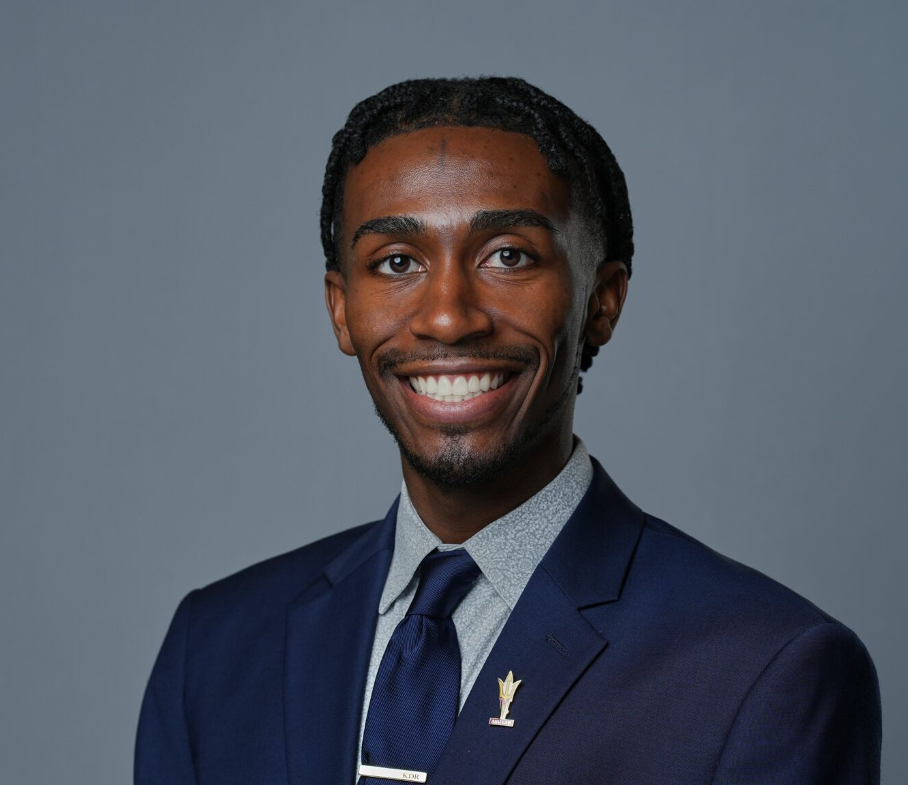

K.J. RUSSELL
Associate
Business & Finance

Phoenix
P: 602.916.5326 F: 602.916.5999
krussell@fennemorelaw.com

K.J. RUSSELL
K.J. Russell is an associate attorney in Fennemore’s Business & Finance practice group. He focuses on advising clients on a range of business matters, including the preparation of commercial agreements, corporate formation and structuring, transactional work, and mergers and acquisitions. His practice spans multiple industries, including technology, real estate, as well as sports and entertainment. K.J also counsels clients in the evolving space of collegiate athletics name, image, and likeness (NIL). His work involves advising collectives, athletes, and agencies on eligibility compliance and the negotiation of branding, sponsorship, and marketing
agreements.

Prior to joining Fennemore, K.J. served as a legal extern to the Klutch Sports Group, assisting in drafting and reviewing client agreements, endorsement deals, and sponsorship contracts. He conducted legal research on sports-related contracts, name image and likeness (NIL)
regulations, and compliance issues. Also, while in law school, K.J. held robust legal externships with Granderson Des Rochers, the Arizona Coyotes, and the Arizona Department of Gaming. Early on in his career, he also worked in sales and marketing for Paragon Marketing Group, the Atlanta Hawks, the Milwaukee Bucks, Fiserv Forum, Ohio University Ticket Operations, and Southern Ohio Copperheads Baseball Team. He is a certified Athlete Agent.
Outside of work, K.J. enjoys staying active by playing sports such as basketball and tennis. He enjoys playing videogames, especially sport games such as NBA 2K, Madden, or FIFA. When not on the game, K.J. enjoys traveling, and his favorite thing to do while traveling is to try a hole-in-the-wall donut shop and local ice cream parlor wherever he goes.

EDUCATION
J.D., Arizona State University, Sandra Day O’Conner College of Law
MSLB, Master of Sports Law and Business, Arizona State University, Sandra Day O’Conner College of Law
B.S.M, Ohio University, College of Business B.A., Ohio University, College of Business

AREAS OF PRACTICE
Business & Finance

Intellectual Property Apparel & Fashion

AWARDS AND HONORS
Arizona State University College of Law, Outstanding Graduate Award Arizona State University College of Law, Dean’s Award
Sports and Entertainment Law Journal Zealous Leader Award Fennemore Craig, ASU Law Diversity Scholarship/Fellowship
Fiesta Bowl McLendon Award
Excellence in Leadership and Scholarship Award Outstanding Senior Leader Award

PROFESSIONAL AND COMMUNITY AFFILIATIONS
Community Relations Chair, Black Sports Professionals Member, Forbes BLK
Member, Black Entertainment and Sports Lawyer Association Member, Maricopa County Bar Association
Member, Arizona Black Bar Association Member, Sports Lawyer Association
Managing Editor, Sports and Entertainment Law Journal Membership Chair, Sports Law & Business Society
Alumni Relations Chair, John P. Morris Black Law Student Association

ARTICLES AND PRESENTATIONS
Co-Author, “NCAA settlement, Arizona’s SB 1615 reshaping student-athlete compensation — here’s how,” Wrangler News Independent, July 3, 2025
Co-Author, “A new chapter in college athletics,” Arizona Capitol Times, July 2, 2025
Co-Author, “Finally, Arizona schools will pay student athletes. But it could cost you | Opinion,” AZ Central, July 2, 2025
Co-Author, “NIL Agents: The Good, the Bad, and the Unregulated,” Fennemore Blog, March 4, 2025
Co-Author, “A patchwork of name, image and likeness agent regulations leaves student-athletes largely unprotected,” Phoenix Business Journal, March 1, 2025
Featured, “Meet recent grads beginning their careers right after commencement,” ASU News, May 8, 2024
Author, “The Ten-Cent Infrastructure of a Billion-Dollar Industry,” Arizona State Sports and Entertainment Law Journal
Author, “Adverse Advertisement Galore,” Arizona State Sports and Entertainment Law Journal

ADMISSIONS

Arizona

