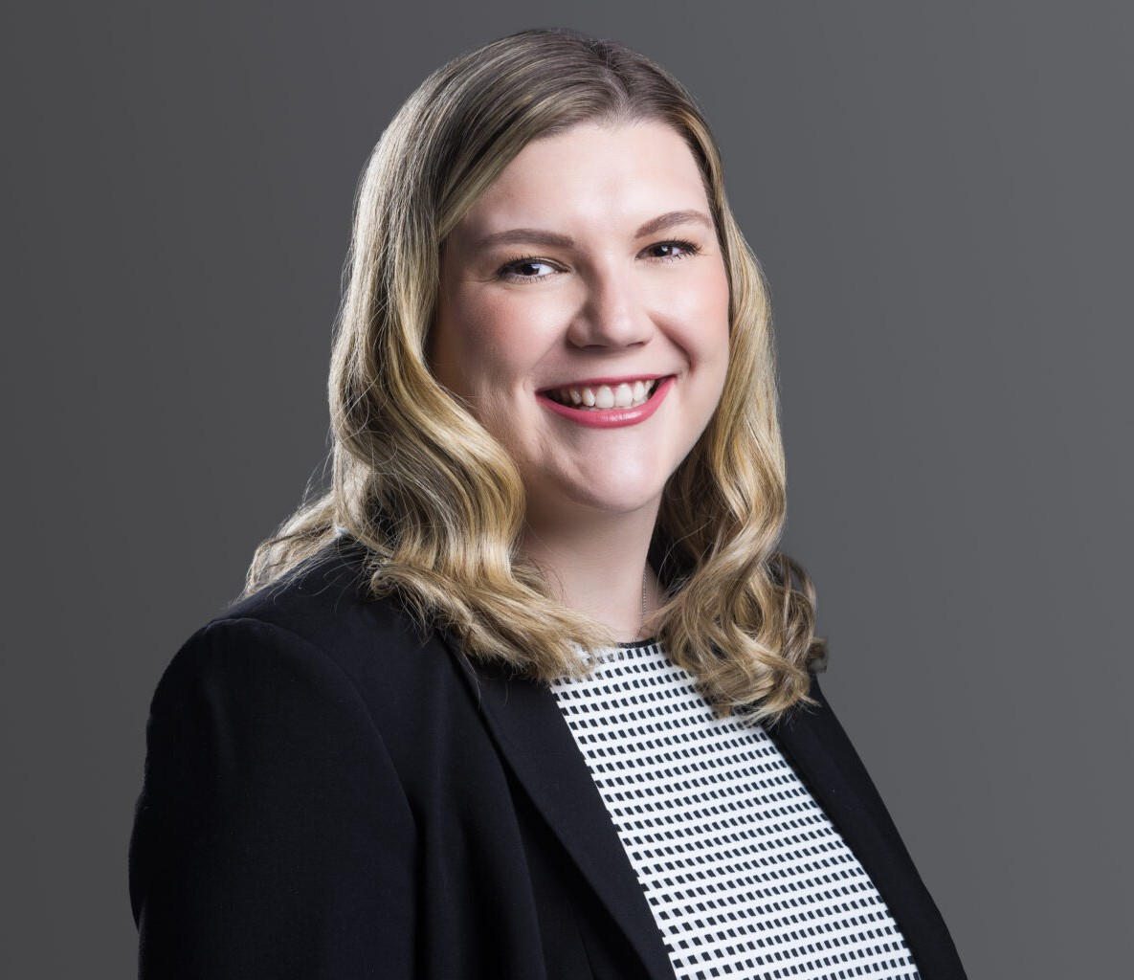

LEXIE DAVIS

Associate

[Business Litigation](https://www.fennemorelaw.com/services/business-litigation/)

[Denver](https://www.fennemorelaw.com/contact-us/denver-2/)

P: 303.764.3730 F: 303.291.3201

[ldavis@fennemorelaw.com](mailto:ldavis@fennemorelaw.com)

# LEXIE DAVIS

Lexie Davis is an attorney in the firm’s Healthcare practice group, where she provides strategic legal counsel on health care law, compliance, and negotiations. She advises medical practices, health care entities, and health care professionals on matters including HIPAA and other regulatory compliance, physician employment and shareholder agreements, practice structuring and formation, credentialing, and licensing. Lexie is known for her practical approach and has become a trusted counsel for clients navigating complex legal and regulatory challenges in the health care industry.

In addition to her advisory work, Lexie maintains an active litigation practice. She represents clients in both state and federal courts, handling all phases of civil litigation. Her litigation experience includes high-stakes cases involving regulatory issues, business ownership disputes, employment matters, and contractual claims.

Lexie earned her J.D. from the Sandra Day O’Connor College of Law at Arizona State University. During law school, she served as a law clerk at the Colorado Office of the Attorney General and externed for the Honorable Douglas L. Rayes of the U.S. District Court for the District of Arizona.

She was also a teaching assistant for legal writing courses, a moot court competitor, and a staff writer and editor for the *Arizona State Law Journal*.

Lexie’s work reflects a deep commitment to client service and a nuanced understanding of the legal landscape in health care, making her a respected advisor and advocate in the field.

# EDUCATION

J.D., Sandra Day O’ Connor College of Law, Arizona State University B.A., Colorado State University

# AREAS OF PRACTICE

Business Litigation Health Care

# AWARDS AND HONORS

*Colorado Super Lawyers*®, Rising Stars, Health Care, 2024-2026

# PROFESSIONAL AND COMMUNITY AFFILIATIONS

Member, Colorado Bar Association: Health Law Section Member, American Health Law Association

Big Sister through Big Brothers Big Sisters of Colorado

# ADMISSIONS

Colorado

United States District Court for the District of Colorado

# LANGUAGES

Spanish – Proficient