
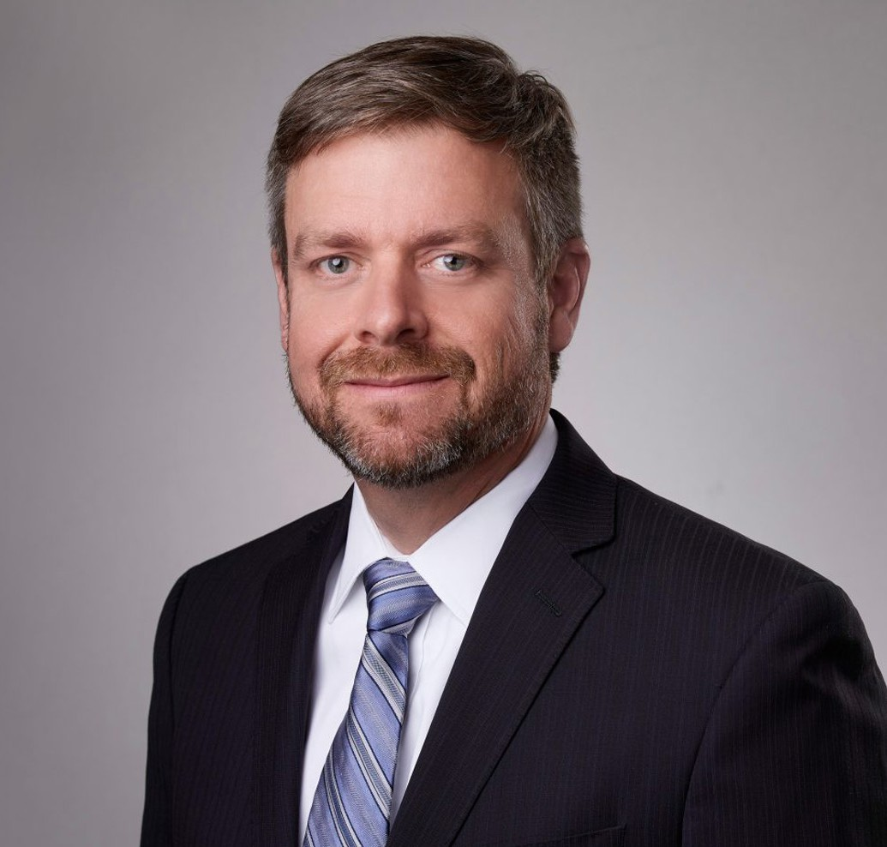
MATTHEW WM. NELSON
Director
Land Use
San Bernardino
P: 909.723.1812
F: 909.890.9877
mnelson@fennemorelaw.com
“
And I believe the truth is mighty, and shines by its own light.
— Vincent Bugliosi
MATTHEW WM. NELSON
”

Matthew Nelson is a director in our San Bernardino office where his practice focuses on land use,
CEQA, real estate and environmental law matters. He serves as a team leader in the land use
department and has successfully guided major commercial, industrial, health care, educational, and retail developers, as well as mining and transportation interests, through the challenges of obtaining approvals and permits from a wide range of federal, state, and local jurisdictions.
He takes great pride in skillfully assisting clients in the development and implementation of
strategies, which includes providing pragmatic counsel on legislative and administrative land use approvals such as the development of impacted properties, redevelopment projects, public financing, development agreements, tentative maps and subdivision map issues, zoning, general plan amendments, specific plans, traffic and transportation issues, conditional use
permits, and variances.

Matt has extensive experience in land use and environmental CEQA document review and project entitlement for retail shopping centers; commercial, industrial, and residential
developments; and mining and transportation clients. He provides oversight to ensure that environmental review and development approvals are sufficient and legally defensible.
He is also involved in many high-profile projects currently operational, under construction, approved, or in development throughout the Inland Empire and greater Southern California, where he has earned a reputation for moving projects through challenges and obstacles with pragmatism.

EDUCATION
J.D., University of California Davis School of Law

B.S., University of California, Riverside, cum laude

AREAS OF PRACTICE
Land Use Real Estate
Natural Resources Logistics
Apparel & Fashion

REPRESENTATIVE MATTERS
Entitled two different 1,000,000 square foot warehouse/distribution center projects in the High Desert.
Entitled over ten warehouse/distribution centers ranging from 200,000 to 1,200,000 square feet in the Inland Empire
Entitled a 100+ bed hospital and medical office building in Southwest Riverside County
Entitled over ten commercial shopping center projects ranging from 200,000 to 400,000 square feet throughout Southern California.

PROFESSIONAL AND COMMUNITY ACTIVITIES
Member, Riverside County Bar Association Member, San Bernardino County Bar Association Leadership Riverside, Class of 2010
Past Chair, UC Riverside Athletics Association Scoutmaster, Boy Scout Troop 90

ADMISSIONS
California Nevada
U.S. District Court, Central District of California
U.S. District Court, District of Nevada

