
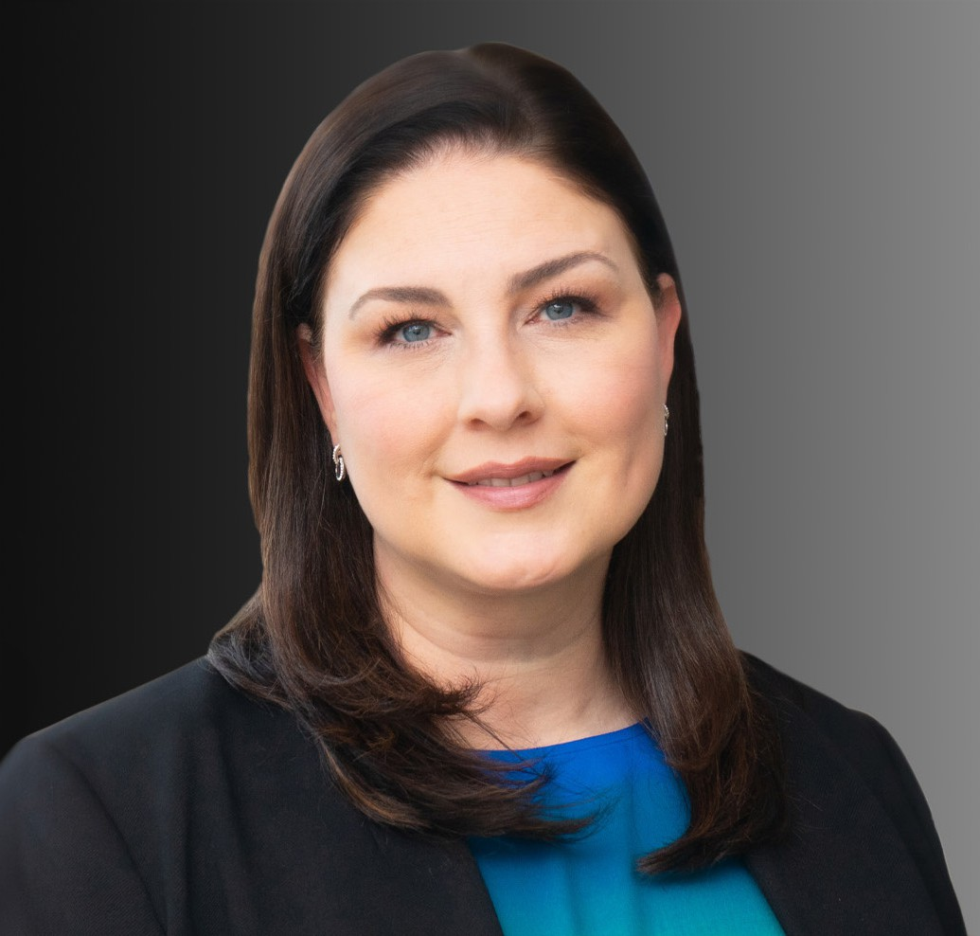
MICHELE C. KIRRANE
Director
Business Litigation
Oakland
P: 510.834.6600 F: 510.834.1928
mkirrane@fennemorelaw.com
“
An intellectual solves a problem. A genius avoids it.
Einstein
MICHELE C. KIRRANE
”

Michele Kirrane is an experienced litigator who handles a wide variety of business litigation
matters, including commercial disputes, claims of breach of contract, misappropriation, fraud and breach of fiduciary responsibility for clients ranging from individuals to large, multinational companies. She has been representing employers in matters involving discrimination,
harassment, retaliation, whistleblower and wrongful termination. She’s also well-versed in real estate property issues such as premises liability, nuisance, conversion, unlawful detainer, and commercial lease disputes.
Michele’s background with handling large exposure insurance defense matters in both state and federal courts, from intake to trial also makes her a trusted personal and monitoring counsel where she helps navigate complex litigation matters, including commercial, products liability, premises liability and catastrophic loss actions. She is trusted by a wide range of clients who include product manufacturers and suppliers, business owners, municipalities, schools,
individuals, community organizations, and retailers.

Michele understands the high stakes of litigation and takes a tailored approach to each matter she handles. She is tenacious in her investigation and development of strategies carefully designed to protect her clients’ interests. She enjoys a challenge, and thoroughly relishes investigations that utilize her innate problem-solving skills. A born multitasker who you want on your side, Michele allows her clients to “take a deep breath,” especially in high-stakes, high-pressure situations.
Married with twin boys, Michele recharges her batteries with intriguing hobbies including pottery, gardening and home renovation.
Business Litigation

Real Estate
Employment & Labor

EDUCATION
J.D., West Virginia University College of Law B.A., Syracuse University

AREAS OF PRACTICE
Business Litigation Real Estate
Employment & Labor

ARTICLES AND PRESENTATIONS
Interview, “A Conversation On Lessons Learned & Life In The Law With Attorney Michele Kirrane,” Fennemore Blog, May 4, 2023

PROFESSIONAL AND COMMUNITY ACTIVITIES
Member, Alameda County Bar Association
Former Member, Women in the Law and Products Liability Committees, Defense Research Institute
Former Member and Chair, Board of Directors, Business Litigation Committee, Association of Defense Counsel of Northern California
Former Member, American Bar Association

ADMISSIONS
California

