
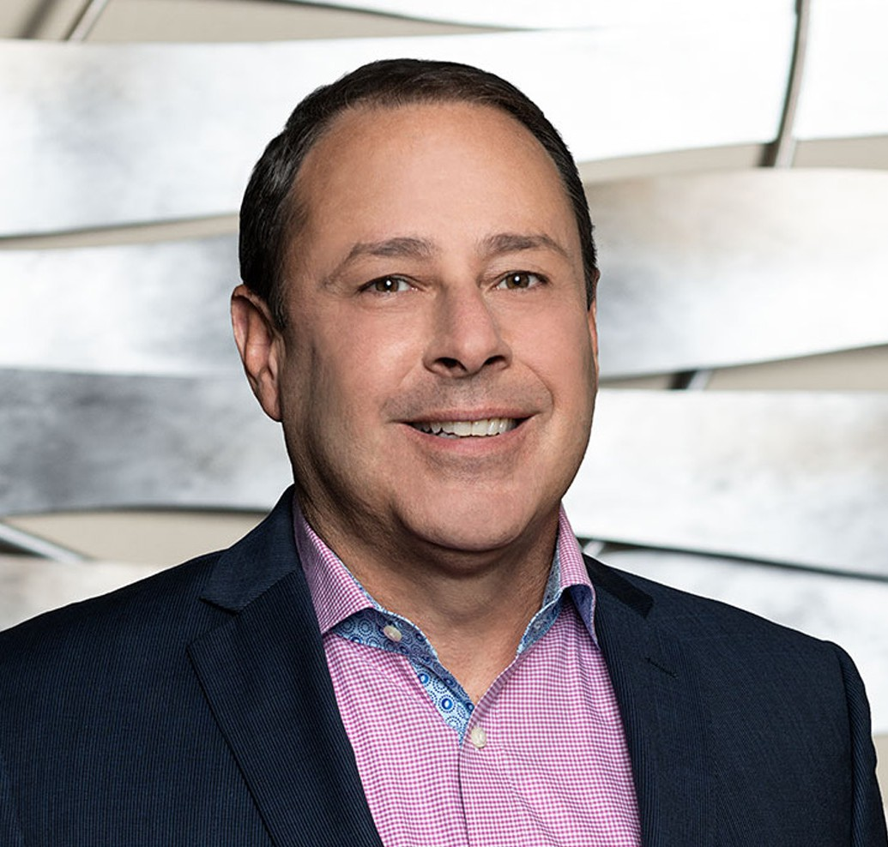
ROBERT D. TOOKOIAN
Of Counsel
Business & Finance
Fresno
P: 559.432.4500
F: 559.432.4590
rtookoian@fennemorelaw.com

ROBERT D. TOOKOIAN
Rob represents a broad range of clients in general business, transactions, contracts, healthcare law, privacy compliance, and real estate transactions. His diverse and extensive legal and business background allows Rob to counsel business owners and management providing
practical, business-oriented solutions to complex legal problems. His clients include such varied industries and service groups as healthcare providers, government entities, and food processors, as well as agribusiness, technology, and health benefit companies.
Rob began practice in the San Francisco Bay Area as counsel and General Counsel to internet and “high-tech” companies. He has been in-house counsel for start-ups, early-stage, and public companies, working on complex service and licensing agreements, compliance, real property
transactions, IP, and corporate governance, among other services.

Rob has spent the last 20-plus years working with small and midsize organizations to provide
strategic guidance on growth and transactions, as well as complex litigation, compliance, and public entity defense. In his healthcare practice, Rob assists clients with formation, contract negotiation and preparation, growth strategies, employment matters, regulatory and contractual compliance, and risk mitigation. Rob regularly counsels his clients about HIPAA,
Stark, Anti-kickback, CCPA, and other compliance matters.

Rob is also the Co-Chief Privacy Officer at Fennemore. Outside of work, Rob and his wife stay busy keeping up with young adult children living in three different states. He keeps active by
skiing, hiking, golfing and playing and coaching rugby. Rob grew up in Fresno and has served on the boards of several local non-profit organizations, including The United Way of Fresno County (Secretary), Charlie Keyan Armenian Community School, and CenCal Youth Sports (Chair).

EDUCATION
J.D., Golden Gate University School of Law
M.B.A., Golden Gate University, Ageno School of Business
B.S., Political Economy of Natural Resources, University of California, Berkeley B.A., History, University of California, Berkeley

AREAS OF PRACTICE

OTHER EXPERIENCE

Commercial Transactions Privacy
Real Property Technology Business & Finance
Employment & Labor Health Care
Privacy & Data Security Mergers & Acquisitions Apparel & Fashion

ARTICLES AND PRESENTATIONS
Co-Editor, California Lawyers Association Privacy Section Journal, 2024 and 2025
Author, “Privacy and Data Security Trends: Ensuring Compliance in the State of California in 2024,” Fennemore Blog, January 23, 2024
Author, “California Attorney General Signals Enforcement of CCPA Regulations on HR Data Following Temporary Exemption’s End,” Fennemore Blog, July 27, 2023
Author, “California Attorney General Signals Enforcement of CCPA Regulations on HR Data, Following Temporary Exemption’s End,” Fennemore Client Alert, July 27, 2023
Presenter, “Privacy Law for Fennemore Lawyers: What you need to know,” May 19, 2023
Interview, “A Conversation With Attorney Rob Tookoian On Lessons Learned and Life In The Legal Profession,” Fennemore Blog, March 24, 2022
Panelist, “Understanding Data, Decision making, and Design,” CPRA Law + Tech Series
Interview, “Pharma Group Sues Government to Keep Drug Prices Secret,” Verywell Health, October 20, 2021
Author, “Providers Beware: The Office For Civil Rights is Making an Example of Providers That Fail to Deliver Patient Records,” Fennemore Client Alert, February 2, 2021
Author, “SCOTUS Brings the Hammer Down on Pharmacy Benefit Managers,” Fennemore Client Alert, December 17, 2020
Presenter, “California Consumer Privacy Act’s Application to Employers” Presenter, “Handling Contract Performance Issues During COVID”
Author, “Coronavirus Aid Relief and Economic Security CARES Act Overview”
Author, “A Brief Overview of the Paycheck Protection Program, a 100% Forgivable Loan” Author, “Franchises, Hotels and Restaurants, Oh My: PPP Progress”
Author, “SBA Warns Borrowers to Double Check That They Qualify for a PPP Loan”

Author, “SBA Clarifies Effect of Laid-off Employees in Calculating PPP Loan Forgiveness” Author, “SBA Provides Safe Harbor Guidance for Some PPP Loan Recipients”
Author, “SBA Publishes PPP Loan Forgiveness Application and Some Clarifications”

PROFESSIONAL AND COMMUNITY ACTIVITIES
Member, International Association of Privacy Professionals Member, Fresno County Bar Association
Member, Executive Committee, Privacy Law Section of the California Lawyers Association Member, State Bar of California
Member, California Society for Healthcare Attorneys Member, American Health Law Association
Board Member, Cal Alumni of Central California Board Member, CenCal Youth Sports

ADMISSIONS
California
U.S. District Court, Central District of California
U.S. District Court, Eastern District of California
U.S. District Court, Northern District of California

