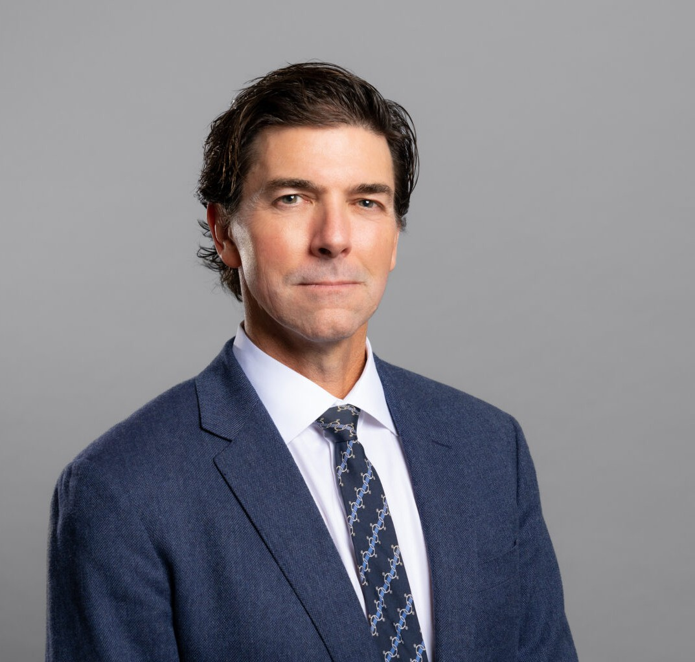

TODD A. WILLIAMS
Director
Land Use

Oakland
P: 510.834.6600 F: 510.834.1928
toddwilliams@fennemorelaw.com

TODD A. WILLIAMS
Todd represents clients in the broad spectrum of land use, real estate and environmental issues in both litigation and administrative proceedings.
He works with private clients and public entities, including landowners and developers of residential, infill, commercial and industrial property, as well as local agencies, providing
property entitlement processing and local government land use approvals; CEQA compliance and litigation; planning and zoning law advice; and real property litigation. He also has experience with infill project streamlining, density bonus and housing laws, affordable housing and historic preservation regulations, as well as advising clients on public-private partnerships, the Subdivision Map Act, the Williamson Act, and cannabis land use regulations, along with
easement and boundary dispute matters.

A contributing editor on the 2010 – 2011 edition of State and Local Government Land Use
Liability, and a reviewer of the 2012 and 2013 editions of the Municipal Law Handbook, Todd also has spoken throughout the state on land use law, with particular emphasis on CEQA.

EDUCATION
J.D., University of California College of the Law, San Francisco B.A., University of California, Los Angeles

AREAS OF PRACTICE
Land Use Real Estate
Natural Resources Cannabis Business Apparel & Fashion

AWARDS AND HONORS
Best Lawyers in America®, Lawyer of the Year, Land Use and Zoning Law, 2025

Best Lawyers in America®, Land Use and Zoning Law, 2018-2026
Northern California Super Lawyers®, 2010-2023

ARTICLES AND PRESENTATIONS
Co-Author, “Ninth Circuit Finds City’s Distance Requirement for Group-living Facilities Survives Challenge that Regulation Discriminated Against Persons with Disabilities,” June 2025, California Land Use Law and Policy Reporter
Co-Author, “Legislative Update: California Adopts New Housing Laws,” Fennemore Blog, October 16, 2024
Author, “Party On! California Supreme Court Paves the Way for Student Housing Project at People’s Park – Noise from Rowdy Students is not an Impact under CEQA,” Fennemore Blog, June 6, 2024
Featured,” Trumark Homes snags 30-acre Livermore site entitled for more than 400 homes,” San Francisco Business Times, February 3, 2023
Featured, “Five ‘builder’s remedy’ projects submitted in Mountain View, Los Altos Hills,” San Francisco Business Times, February 14, 2023
Author, “California Supreme Court Denies Review in Berkeley Shellmound Case Paving the Way for Housing Under SB 35”, Wendel Rosen Client Update, August 2, 2021
Speaker, “Bisnow East Bay Multifamily Update,” Bisnow, August 19, 2021
Speaker, “Density Bonus: a Strong Development Tool Gets Stronger,” Wendel Rosen LLP, June 8, 2021
Speaker, “Streamlined Housing Approval with SB 35, SB 330 and New Pro-Housing Legislation,” Wendel Rosen LLP, October 20, 2021
Speaker, “How the Housing Crisis Act (SB330) Can Ease Approvals for Housing Development Projects” Wendel Rosen Webinar, October 29, 2020
Speaker, “Demystifying the new 2018 Housing Laws and Update on Major Oakland Projects” Wendel Rosen Client Seminar, January 9, 2018
Co-Author, “Slate of New Housing Bills Take Effect,” Wendel Rosen Client Update, January 3, 2018
Speaker, “Oakland Construction & Development: The Boom Continues!” Wendel Rosen Client Seminar, November 10, 2016
Speaker, “What Every Real Estate Attorney Should Know About CEQA,” Wendel Rosen Client Seminar, October 21, 2016
Speaker, “Oakland’s Impending Development Impact Fees & the California Supreme Court’s Steps to Rein in CEQA,” Wendel Rosen Seminar, April 2016
Speaker, “What Every Lawyer Needs to Know About CEQA + New Supreme Court Developments,” Alameda County Bar Association, February 2016
Speaker, “Expert Briefing: CEQA Update,” Bay Planning Coalition, October 2015 Co-Author, “Inclusionary Housing Stays,” The Registry, June 29, 2015
Speaker, “Current Issues in CEQA and Planning and Zoning,” Building Industry Association’s 2015 BIG Show, April 2015

Author, “California Supreme Court Provides Key CEQA Guidance Regarding Categorical Exemptions,” Wendel Rosen Client Update, March 3, 2015
Speaker, Land Use and CEQA Update, Contra Costa Planning Directors, July 2014 Speaker, Land Use and CEQA Update, Marin County Planning Directors, June 2014
Speaker, CEQA Reform and Challenges to Plan Bay Area, Air and Waste Management Association, February 2014
Co-Author, “Court of Appeal Reinstates Regional Air Quality Thresholds for Greenhouse Gas Emissions,” Wendel Rosen Client Update, August 14, 2013
Participant, Land Use Law Update Roundtable, California Lawyer, June 2013
Speaker, Recently Adopted CEQA Streamlining for Infill, Air and Waste Management Association, May 2013
Speaker, Land Use and CEQA Update, Marin County Planning Directors, May 2013 Reviewer, The California Municipal Law Handbook, 2012-2013
Co-Author, “Air Quality District’s CEQA Thresholds Invalidated,” Wendel Rosen Client Update, April 6, 2012
Author, “Court Weakens Use of CEQA’s Categorical Exemptions,” Wendel Rosen Client Update, March 28, 2012

PROFESSIONAL AND COMMUNITY ACTIVITIES
Member, SPUR – Oakland
Member, Land Use Task Force, East Bay Leadership Council Member, Alameda County Bar Association
Vice Chair, Real Property Section, Land Use Subsection, State Bar of California

ADMISSIONS
California
United States District Court, All California Districts United States Court of Appeals, Ninth Circuit

