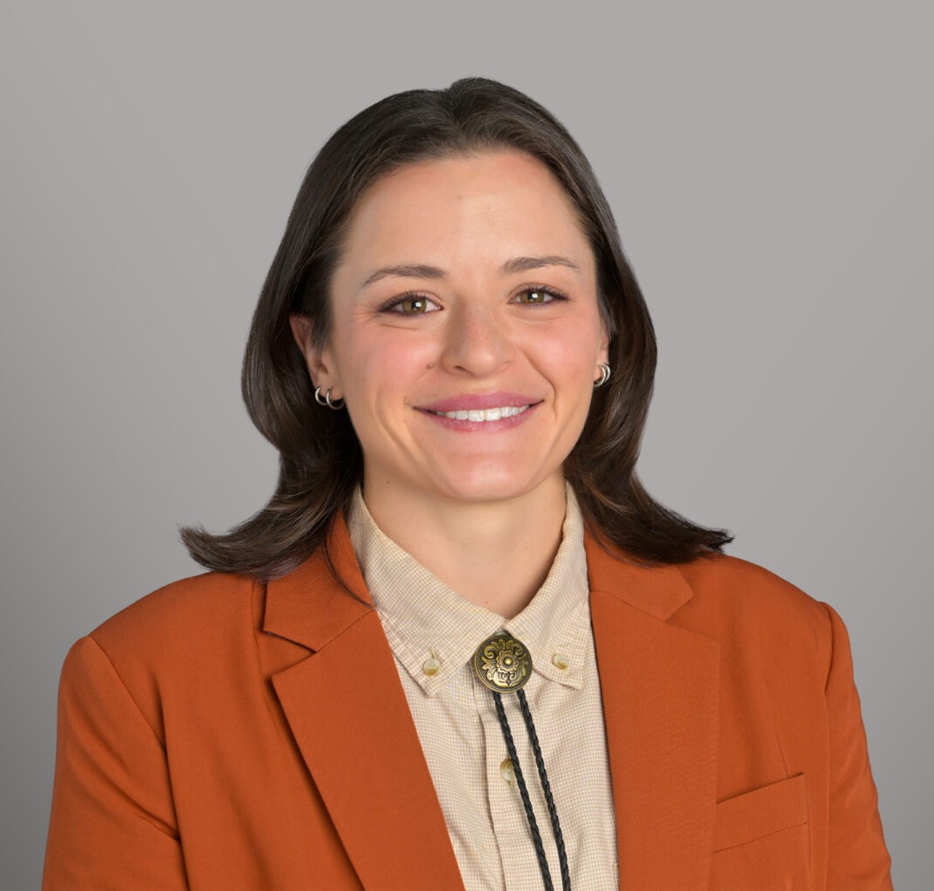

TRYSTAN MELANCON
Associate
Business Litigation

Denver
P: 303.285.0224
tmelancon@fennemorelaw.com

TRYSTAN MELANCON
Trystan Melancon is an attorney with Fennemore whose practice focuses on construction law, business transactions, and litigation in Colorado. She advises contractors, developers, and subcontractors on contract drafting and negotiation, regulatory compliance, entity formation, and day-to-day business operations. Trystan also represents clients in construction defect
disputes, mechanic’s lien claims, collections, and related litigation.

Before joining Fennemore, Trystan gained hands-on legal experience as a law clerk for a private firm in Louisiana and with Galvanize Law, where she developed skills in drafting motions, briefs, demand letters, contracts, and complaints. She earned her law degree and a graduate
diploma in Comparative Law from the Paul M. Hebert Law Center at Louisiana State University.

Trystan is dedicated to supporting construction industry clients with detailed and strategic legal guidance, ensuring that the solutions she provides are both practical and tailored to the unique challenges of the industry.

EDUCATION
J.D., Louisiana State University, Paul M. Hebert Law Center Louisiana Law Review Senior Editor, 2024
M.A., Oregon State University, 2021 B.A., University of Houston, 2018

AREAS OF PRACTICE
Business Litigation

ARTICLES AND PRESENTATIONS
“Fundamentals of Construction Contracts” Rocky Mountain Masonry Institute Certification Seminar, March 2025
Conflict Resolution: Navigating Ethical Dilemmas Between General Contractors and Subcontractors, Monthly Educational Journal of the Foundation of the American Subcontractors Association, October 2024

An Un-flippable Switch: How Religious Organizations in Texas are Seeking Widespread Religious Exemptions to Title VII and Bostock’s Prohibition on LGBTQ+ Employment
Discrimination, Louisiana Law Review, Vol. 84, Issue 2, Winter 2024

PROFESSIONAL AND COMMUNITY ACTIVITIES
Colorado Bar Association

ADMISSIONS
Colorado
U.S. District Court, District of Colorado

