
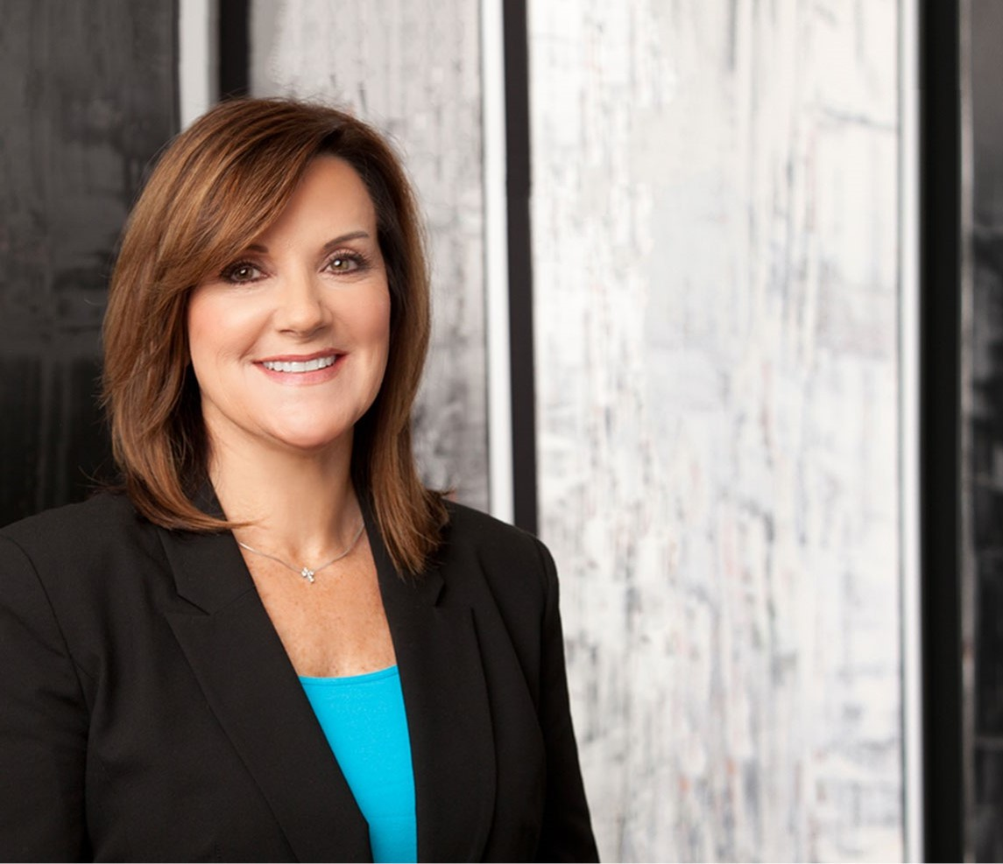
AMY ABDO
AMY ABDO
Director
Business Litigation
Phoenix
P: 602.916.5399 F: 602.916.5599
amy@fennemorelaw.com
“
I approach every high-stakes case with steadfast confidence, deliberate strategy, and unwavering integrity, advocating for outcomes that truly
matter.
”
A seasoned trial attorney, Amy represents leading law firms and attorneys in the defense of professional liability claims. Drawing upon her substantial courtroom experience, Amy brings a results-oriented approach to every matter. She is pragmatic, strategic, organized and efficient. Adept at leading legal teams, Amy has wide-ranging experience in business litigation, professional liability defense, employment law and public records law.
Amy is licensed to practice in Arizona, Nevada and California. She is experienced in all phases of litigation including bench and jury trials, arbitration, mediation, administrative proceedings and
investigations. Amy represents businesses in complex commercial matters, and she frequently litigates covenants not to compete and other restrictive covenants, often in compressed evidentiary proceedings. She defends employers against discrimination, harassment, breach of contract, wrongful discharge and employment-related tort claims. Amy counsels employers on policies, investigations, and related employment issues, including offer letters, executive
employment agreements, independent contractor agreements, separation agreements, confidentiality agreements, non-competition and non-solicitation agreements.
A natural leader, Amy served for several years on the firm’s management committee, compensation committee and as litigation section chair.

EDUCATION
J.D., University of San Diego School of Law
B.S., San Diego State University, with distinction,
Former Judicial Extern, Court of Appeals, Fourth Appellate District, State of California

AREAS OF PRACTICE

OTHER EXPERIENCE

Business Torts
Commercial Contingency Litigation E-Discovery and Data Management Litigation
Public Records Law
Tort and Insurance Litigation

Business Litigation Professional Liability Employment & Labor

REPRESENTATIVE CASES
Published Opinions: McAlister v. Loeb & Loeb, L.L.P., 571 P.3d 891 (Ariz. 2025) (lost profits in legal malpractice case); Malcolm v. Farmers New World Life Insurance Company (1992) 4 Cal. App. 4th 296 (life insurance case); and Smith v. Superior Court (1993) 10 Cal. App. 4th 1033 (legal
malpractice).
Secured dismissal of more than a dozen claims, including fraud, interference, abuse of process, breach of fiduciary duty, filed by a third party against a law firm, seeking over a billion dollars in damages (District Court – Clark County, Nevada).
Secured defense verdict on legal malpractice claims, and a seven-figure award of attorneys’ fees on a counterclaim, following a 12-day jury trial (Maricopa County Superior Court).
Secured judgment in favor of private entity prohibiting production of records under Arizona’s public records laws.
Bench trial to enforce restrictive covenants, settled mid-trial, for over $2.5 million in favor of client (U.S. District Court – Nevada).
Two-week jury trial on claims for sexual harassment, discrimination, wrongful termination, retaliation and interference with contract (U.S. District Court – Tucson) – defense verdict.
One-week jury trial on harassment and discrimination claims (U.S. District Court – Nevada) – defense verdict.
One-week jury trial on pregnancy discrimination and wrongful termination claims (U.S. District Court – Phoenix) – defense verdict.
Non-suit of harassment, discrimination and retaliation claims (U.S. District Court – Nevada).
Secured temporary restraining order and preliminary injunction against departing employee and competitor (U.S. District Court – Central District of California, Southern Division).
Secured preliminary and permanent injunction against departing employee and competitor (U.S. District Court – Nevada).

Dissolved temporary restraining order and defeated motion for preliminary injunction sought against departing employee (Maricopa County Superior Court).
Various summary judgments on employment-related and other claims.
Numerous restraining orders and injunctions secured to enforce restrictive covenants. Numerous no-cause findings on charges filed with EEOC, ACRD, NERC and NMHRD.
Bench trial for plaintiff to enforce commercial contract (U.S. District Court – Central District of California, Southern Division) – judgment for plaintiff in excess of $1,000,000.
One-week jury trial for plaintiff in equine litigation against an insurance company and insurance broker (U.S. District Court – Central District of California) – plaintiff’s verdict.
Secured dismissal of defamation action against dentists and professional organization (District Court – Nevada).
Secured summary judgments for national life insurance companies on disability/ERISA claims (U.S. District Court – Nevada).
Trial-styled arbitration – defense on defamation and slander claims (Ventura County Superior Court).
Summary Judgment on abuse of process and malicious prosecution claims (Pima County Superior Court).

AWARDS AND HONORS
Best Lawyers in America®, Lawyer of the Year, Professional Malpractice Law – Defendants, 2023, 2026
Best Lawyers in America®, Commercial Litigation, Employment Law Management, Litigation – Labor and Employment, Professional Malpractice Law – Defendants, 2014-2026
Benchmark Litigation, Benchmark Litigation Star, 2016-2019 and 2025 Top 100 Lawyers in Arizona, AZ Big Media, 2022 and 2025
Southwest Super Lawyers®, Top 25 Women in Arizona, 2020-2024
Chambers USA, Leading Lawyers for Business, 2020-2024 AZ Business Leaders, AZ Big Media, 2022
Southwest Super Lawyers®, Business Litigation, 2017-2024 Top 100 Lawyers, AZ Business Magazine, 2020
Selected, “Most Influential Women in Arizona Business,” AZ Business Magazine, 2015
bizAZ’s, “Up-And-Coming-Attorneys,” 2005
AV® Preeminent™ Peer Review Rated (the highest rating available), by Martindale-Hubbell

ARTICLES AND PRESENTATIONS
Featured, “Top 10 Most Influential Commercial Litigation Lawyers in Arizona for 2023,” Business Today, July 21, 2023
Featured, “Top 100 Lawyers in Arizona for 2023,” AZ Big Media, January 19, 2023
Interview, “Determine What is Important to You and Fully Commit to Making it a Priority,” Fennemore Blog, August 19, 2021

Co-author, Practical Challenges to Enforcing Confidentiality Agreements, 67 Rocky Mtn. Min.

L. Inst. 18-1, 2021
Quoted, “Let’s Celebrate Random Acts of Kindness Day,” Fennemore Blog, February 18, 2021 Quoted, “e-Discovery Process Impacted by Covid-19 Crisis?” Legal Reader, June 15 2020
Co-author, “COVID-19: Health Plan Coverage For Furloughed Employees,” Fennemore Client Alert, March 26, 2020
Co-author, “Understanding the Emergency Family Medical Leave Expansion Act and Emergency Paid Sick Leave in the Families First Coronavirus Response Act,” Fennemore Client Alert, March 20, 2020
Co-author, “Frequently Asked Questions About the Coronavirus in the Employment Setting,” Fennemore Client Alert, March 17, 2020
Quoted, “If I Knew Then,” Crain’s Phoenix, March 2017

PROFESSIONAL AND COMMUNITY ACTIVITIES
Member, Labor and Employment Section, American Bar Association Member, Arizona Association of Defense Counsel
Member, The Sedona Conference Working Group 1 on Electronic Documents Retention and Production
Vice-Chair, Board of Directors, Christian Family Care Agency
Past Chair, Labor and Employment Section, State Bar of Arizona
Past Chair-Elect, Treasurer and Secretary, Labor and Employment Section, State Bar of Arizona
Past Chair, Continuing Legal Education Committee, Labor and Employment Section, State Bar of Arizona
Past Co-Chair, Labor and Employment Section, State Bar of Arizona’s Annual Convention Former Arbitrator, Orange County Bar Association Mandatory Fee Arbitration Committee Former Barrister, William P. Gray Legion Lex Inn of Court Foundation

ADMISSIONS
Arizona California Nevada
U.S. District Court, District of Arizona
U.S. District Court, Central District of California
U.S. District Court, Eastern District of California
U.S. District Court, Northern District of California
U.S. District Court, Southern District of California
U.S. Court of Appeals, Ninth Circuit

