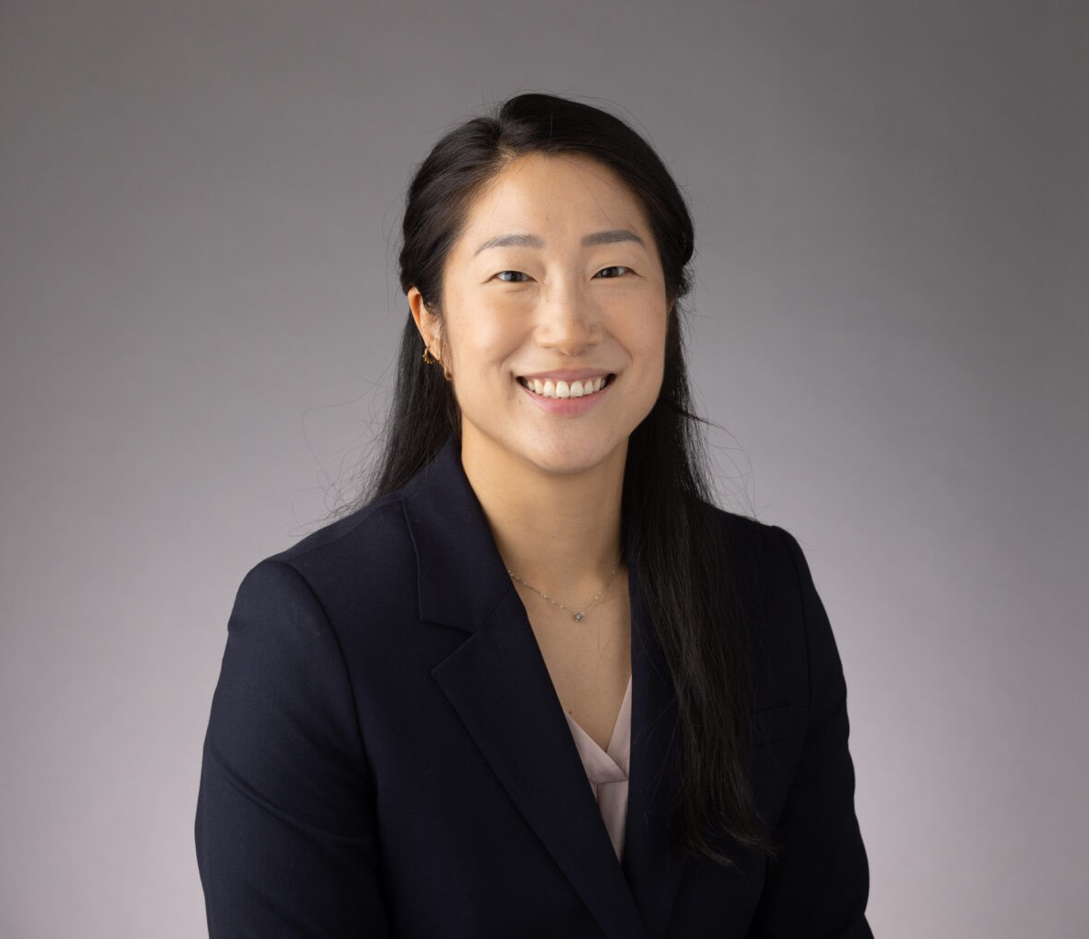

ANGELA HAN
Associate
Business Litigation

Oakland
P: 510.622.7523 F: 510.834.1928
ahan@fennemorelaw.com

ANGELA HAN
As a member of the firm’s Business Litigation group, Angela assists clients with their most challenging commercial litigation disputes from pre-litigation case assessment to resolution. She has experience defending a broad range of civil matters, including complex business and
contract disputes, products liability, mass torts, unfair competition, personal injury, premises liability, class actions, and more. In addition, Angela has experienced advising product
manufacturers, retailers, and distributors on risk management, both state and federal regulatory compliance issues, and related litigation. Angela is adept in all litigation phases, including case assessment and early strategy development, pleadings, discovery, and dispositive motions.
Prior to joining the firm, Angela worked as a litigation and dispute resolution associate in the San Francisco Bay Area. During law school, she served as a judicial extern for the Honorable Judge William H. Orrick, United States District Court, Northern District of California.

EDUCATION
J.D., University of California, Davis School of Law
Witkin Award, Academic Excellence in Legal Research and Writing Senior Editor, U.C. Davis Law Review
Staff Editor, U.C. Davis Business Law Journal
Korean American Law Students Association, President B.A., University of Washington

AREAS OF PRACTICE
Business Litigation Health Care

AWARDS AND HONORS
Best Lawyers in America®, Ones to Watch, Commercial Litigation, Health Care Law, 2026 California Lawyers Association, Wiley W. Manuel Pro Bono Legal Services Award, 2023

Leadership Council on Legal Diversity, Pathfinders, 2022

ADMISSIONS
California
U.S. Court of Appeals for the Ninth Circuit
U.S. District Court for the Northern District of California
U.S. District Court for the Central District of California
U.S. District Court for the Eastern District of California

