
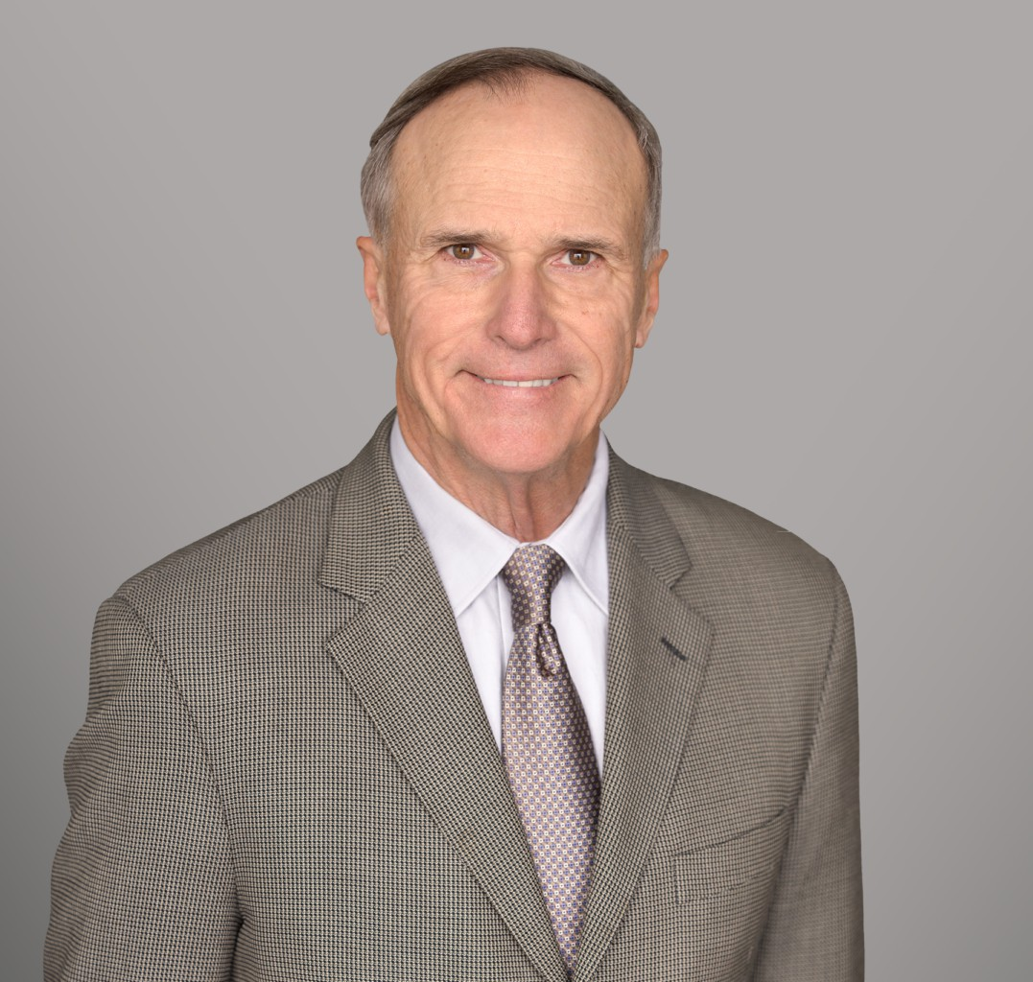
BELAN K. WAGNER
BELAN K. WAGNER
Director
Business & Finance
Sacramento
P: 916.920.5286
F: 916.920.5286
bwagner@fennemorelaw.com
Belan Kirk Wagner is a taxation and transactional attorney, bringing counsel that navigates the intricacies of both realms with proficiency. With over 40 years of experience in business, taxation, real estate, estate planning, and controversy work, Belan has crafted a unique practice that offers a client-centric approach. This approach ensures each legal solution is as distinctive and personalized as the clients themselves, ranging from business owners and executives to individuals navigating today’s multifaceted legal system.
Belan also provides general counsel services to privately held and family-run businesses, offering seasoned guidance informed by more than four decades of tax and transactional experience. Clients rely on him for strategic advice on governance, contract negotiation, operational issues, restructuring, and long-term planning. His practice is grounded in a deep understanding of how tax, business, and financial considerations intersect, enabling him to craft practical, forward-looking solutions that safeguard assets and support growth. Belan serves not only as legal
counsel, but as a trusted, steady advisor who helps business owners navigate complexity with confidence.
Belan’s practice goes beyond compliance; he creates a legal framework to safeguard his clients’ assets. He provides direct representation to clients while also serving as a resource to clients’ primary attorneys, accountants, financial advisers, and other representatives. His
knowledge is an advantage, offering proactive tax planning and transactional advice that is integrated to protect and maximize financial interests. Belan is a strategic attorney dedicated to your success.

EDUCATION
LL. M., Taxation, University of Miami
J.D., University of the Pacific, McGeorge School of Law B.A., University of Santa Barbara, magna cum laude
AREAS OF PRACTICE

OTHER EXPERIENCE

Estate and Generational Planning with Emphasis on Business Owners Mergers, Acquisitions and Business Sales
Partnership, LLC, Corporation and Business Entities Medical, Legal and Accounting Professional Entities Agricultural and Ranch Law
Business Controversies
General Counsel to Private Businesses Business & Finance
Mergers & Acquisitions Real Estate
Tax Law
Trusts & Estates Estate Planning
General Counsel Services

PROFESSIONAL AND COMMUNITY ACTIVITIES
Adjunct Professor, University of the Pacific, McGeorge School of Law Adjunct Professor, Golden Gate University
Phi Beta Kappa
Member, Traynor Honor Society
Member, Sacramento County Bar Association Member, American Bar Association
Member, State Bar of California
Former Vice Chairman, Executive Committee on Taxation for the State Bar of California Member, Society of California Accountants
Member, Sacramento County Farm Bureau
Former Member and Editor, McGeorge Pacific Law Journal

ARTICLES AND PRESENTATIONS
Co-Author, “Key considerations and legal requirements when buying and selling boomer-owned businesses,” Sacramento Business Journal, August 9, 2024

ADMISSIONS
California Certified Specialist, Taxation Law Supreme Court State of California
U.S. Tax Court
U.S. District Court, Eastern District of California
U.S. District Court, Northern District of California

U.S. Court of Appeals, 7th Circuit
U.S. Court of Appeals, 9th Circuit

