
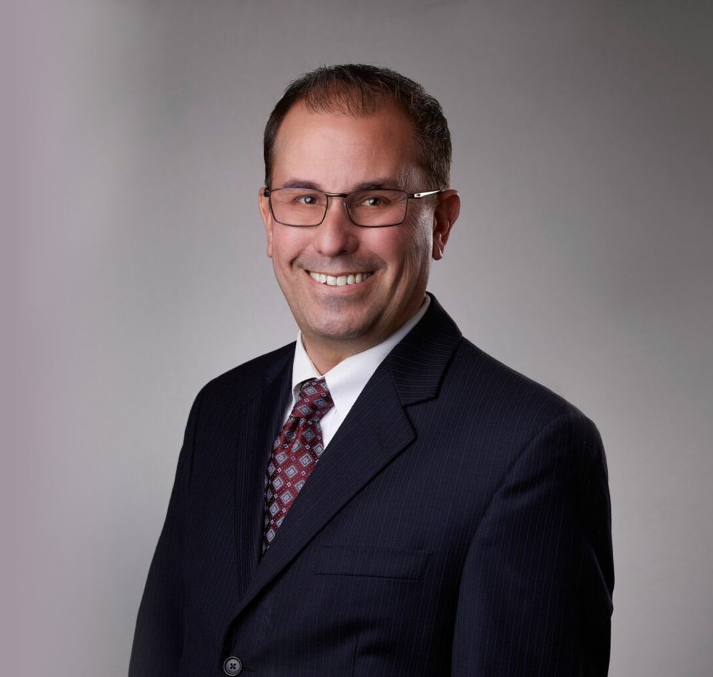
DONOVAN C. COLLIER
DONOVAN C. COLLIER
Director
Land Use
San Bernardino
P: 909.723.1814
F: 909.890.9877
dcollier@fennemorelaw.com
“
Society cannot exist without law. Law is the bond of society: that which makes it, that which preserves it and keeps it together. It is, in fact, the
essence of civil society.
- Joseph P. Bradley
”
Donovan Collier is a director in our San Bernardino office where he has extensive experience counseling clients to ensure compliance with complex federal and state environmental laws and regulations. This includes the California Environmental Quality Act (CEQA), National Environmental Policy Act (NEPA), Federal and California Endangered Species Acts, Clean Water Act, and Porter-Cologne Water Quality Act. Donovan has acted as lead entitlement counsel for numerous complex and controversial land use projects, successfully appearing before local agencies throughout Southern California.
He takes great pride in assisting clients with assessing, developing, and implementing strategies for land use and regulatory compliance, including counsel on legislative and administrative land use approvals, such as development of impacted properties, development agreements, tentative maps and subdivision map issues, zoning, general plan amendments, specific plans, traffic and transportation issues, and conditional use permits and variances.
During his distinguished career, Donovan has represented national and multi-national clients in obtaining local land use entitlements for the development of large commercial developments. His experience enables him to provide effective guidance and management of the entitlement process to ensure the entitlements obtained are legally defensible. He has successfully guided clients through the permitting of development projects involving water rights, wetlands, waste materials, species protection, the Surface Mining and Reclamation Act, and other environmental matters, including CEQA/NEPA document review and project entitlement.

Donovan represents clients in federal land issues, including mine permitting and reclamation, federal land exchanges, environmental compliance issues, and other natural resource and environmental matters. His practice also involves outdoor advertising law matters including local and state permitting under the California Outdoor Advertising Act and associated Caltrans
regulations.

EDUCATION
J.D., University of San Diego School of Law, magna cum laude
B.S., California State University, San Bernardino

AREAS OF PRACTICE

OTHER EXPERIENCE

Land Use Land Use Real Estate
Natural Resources Mining Law

REPRESENTATIVE MATTER
Mining Counsel for Mitsubishi Cement South Quarry Expansion Project

ARTICLES AND PRESENTATIONS
Reporter, Rocky Mountain Mineral Law Foundation Newsletter

PROFESSIONAL AND COMMUNITY ACTIVITIES
Member, Association of Environmental Professionals Member, CalCIMA Legal Action Committee
Member, The State Bar of California, Environmental Law Section Member, Rocky Mountain Mineral Law Foundation
Member, SOAR Charter Academy Board of Directors

ADMISSIONS
California

