
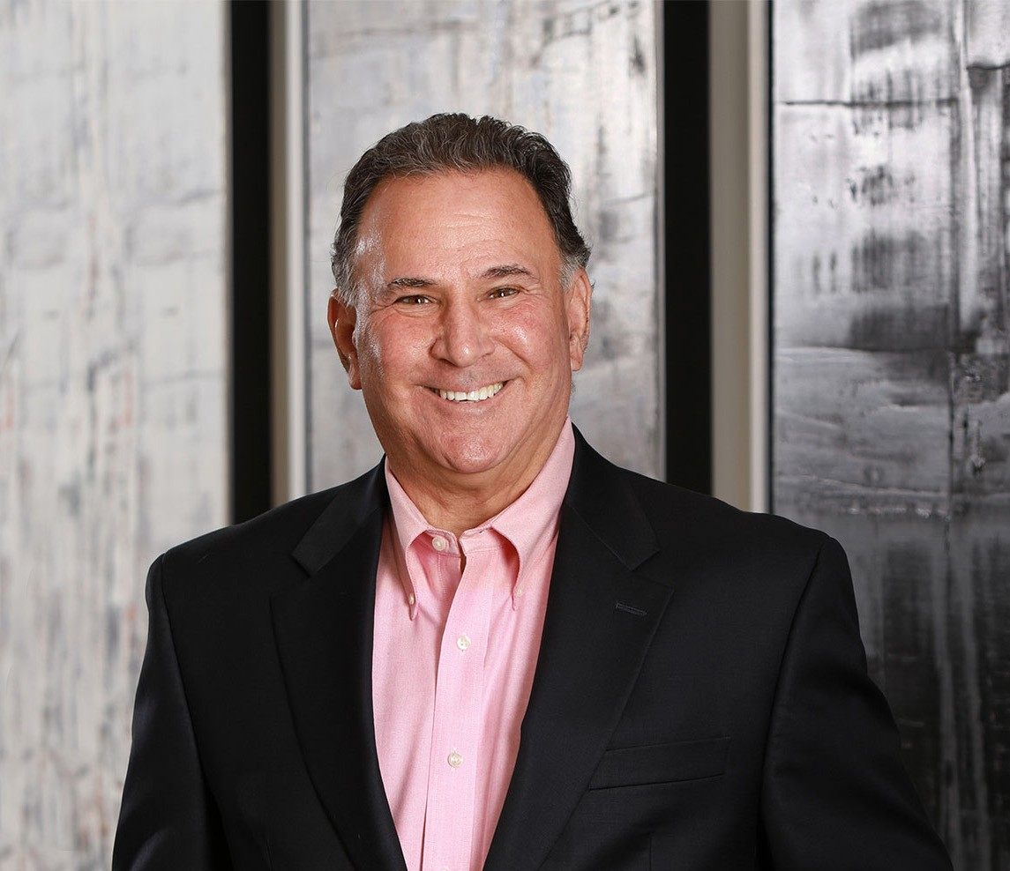
As an experienced real estate transactions and finance attorney, Jay Kramer’s leadership role in our commercial transactions section has helped to shape the region’s massive growth by counseling numerous commercial and industrial developers, data center developers and
JAY S. KRAMER
Director
Real Estate
Phoenix
P: 602.916.5341 F: 602.916.5541
jkramer@fennemorelaw.com
“
It takes years and years of honesty and integrity to build your reputation in
the community and five minutes to destroy it.
JAY S. KRAMER
”
operators, national and local homebuilders, planned community developers, as well as financial institutions.
This Phoenix-based real estate attorney’s experience, which includes acquisition, infrastructure financing, entitlements, development and sale, as well as loan workouts, restructuring and
enforcement at present extend to projects as diverse as renovating a professional sports team’s stadium to guiding an array of new data centers relocating to the Phoenix metropolitan area.
Jay holds both a master’s in business administration degree and a Juris Doctor degree from Vanderbilt University. This real estate attorney knew early on in his career that real estate
development would be an arena where he could utilize both his business and law acumen. As a transactional attorney, Jay takes great pride in creating value, and the tangible results of his
work are all over the area, at places where you see construction cranes in the city or when driving past well-appointed master-planned golf communities. His clients are loyal – many of this construction attorney’s partnerships extending for decades – and Jay relishes the notion of investing in the success of his entrepreneurial clients who share his passion for strategic growth and development.
Although raised in New York, after many years in the Valley, Jay is one of the biggest sports fans for all of Arizona’s professional sports teams. When not at one of the games, you will probably find him hiking, playing pickleball, golfing, traveling, or at the theater to recharge his batteries. He still considers his two grown children as his life’s greatest achievement.

EDUCATION

J.D., Vanderbilt University Law School
M.B.A., with emphasis in Finance, Vanderbilt University
B.A., with high honors, Political Science and English, Georgetown University

AREAS OF PRACTICE

OTHER EXPERIENCE

Commercial and Real Estate Finance Real Estate Finance and Lending Real Estate Litigation
Sports Law Real Estate
Financial Restructuring Construction Law

REPRESENTATIVE CASES
Represent a New York investment development company in connection with its successful acquisition of approximately 2,300 acres in north Phoenix in an Arizona State Land
Department (ASLD) public auction. The legal work included counseling the client on the ASLD auction process, real estate due diligence, and negotiations of a Participation and Infrastructure Agreement with ASLD that provides for construction and installation of approximately $1 billion of backbone infrastructure, including water, power, and roads, and sharing of net profits between the developer and ASLD. The successful bid for the property was $56.28 million. The project is anticipated to be a $7 billion master-planned mixed-use commercial center that will feature nearly 30 million square feet of space across office,
industrial, and retail uses. The project can also support up to 8,960 residential units. Eventually, the entire master-planned park could become the third largest employment center in Arizona and create up to 100,000 jobs.
Represent one of the largest global technology companies in connection with its acquisition, entitlement, tax structuring, development, and construction of the company’s next-
generation, hyperscale data center operations supporting the company’s different lines of
business. The initial investment for the first building is approximately $1 billion and full build-out is expected on or around 2030. The land and buildings will be the subject of a governmental property lease excise tax (GPLET) lease, which is a tax incentive mechanism to substantially reduce the property tax burden of the project for 25 years.
Represent an Arizona municipality in connection with a first-in-time intergovernmental
agreement (IGA) between the Arizona municipality and the Arizona State Land Department (ASLD), pursuant to which the municipality, at its cost, will construct and install backbone infrastructure on the ASLD-owned land within the municipality so that ASLD can auction for sale shovel-ready parcels, and the municipality can recoup its infrastructure investment through reimbursement agreements, impact fees, and connection fees from the ultimate developer, and then redeploy the monies on a revolving credit basis to construct and install backbone infrastructure for additional shovel-ready auction parcels within the municipality.

Represented various affiliates of the Phoenix Suns basketball franchise in connection with the sale of $72 million in senior secured promissory notes to New York Life Insurance Company and related affiliates. The funds were used to redeem outstanding taxable bonds previously issued by the Industrial Development Authority of City of Phoenix, Arizona to finance the acquisition, construction, development and equipping of U.S. Airways Center, an adjoining parking
garage, and the Sun Mercantile Building. A portion of the bonds were 28-day auction rate certificates that were unmarketable due to the lack of liquidity in the auction rate securities market.
Represented a national construction lender in connection with the workout, restructuring and refinancing of an aggregate credit facility exceeding $350,000,000 with a major apartment project developer in the metropolitan Phoenix area in order to complete construction of remaining projects and refinance the projects with HUD-guaranteed loan facilities. The work included negotiations of loan modification and forbearance agreements, government funding agreements, lockbox and construction disbursement agreements, appraisal and environmental testing protocols, potential receiverships and foreclosures.
Represented multiple out-of-state investment companies in connection with their business strategy to acquire finished lots in the metropolitan Phoenix area for investment and
subsequent resale to homebuilders. To date, the clients have acquired over 3,000 finished lots in Maricopa and Pinal Counties and continue to pursue additional acquisition opportunities.
Represented a top 5 national homebuilder in connection with the restructuring of over
$250,000,000 of land banking transactions in Arizona and the ultimate sale or other disposition of the land subject to the land banking transactions, including the exercise of options at reduced strike prices in full satisfaction of the obligations and disposition to investors; termination of options and entering into agreements with the land banker to complete infrastructure improvements of the retained lots in full satisfaction of the obligations; and forbearance and extension of pending option agreements.
Represented one of the largest and most well-respected non-profit senior living facility developers in the United States with respect to the refinancing of approximately $24 million of Pima County Industrial Development Authority bonds for the largest senior living project in
Pima County, to refund existing bond financing and provide additional bond financing for the conversion of units to provide assisted living services to residents of the project. The bonds are credit-enhanced by Fannie Mae pursuant to Fannie Mae’s Delegated Underwriting and Servicing (“DUS”) product line.
Represented the largest low income housing tax credit (LIHTC) multifamily developer in the United States with respect to obtaining tax credits from the Arizona Department of Commerce and the acquisition, financing, entitlement, development and construction of multifamily housing projects within the State of Arizona.
Represented multiple homebuilders and landowners (and acted as co-lead counsel for the Executive Committee) in connection with formation of the Watson Road Community Facilities District and issuance of $49 million of general obligation bonds for the expansion of the Town of Buckeye’s existing Water Reclamation Facility and represented multiple homebuilders and landowners (and acted as co-lead counsel for the Executive Committee) in connection with financing, construction and installation of a major sewer interceptor trunk line to serve approximately 19,000 residences in southeast Buckeye.

AWARDS AND HONORS
Best Lawyers in America®, Real Estate Law, 2003-2025

Best Lawyers in America®, Project Finance Law, 2024 and 2025 2024 Lawyers in Real Estate Award, ConnectCRE, 2024
Arizona Real Estate Attorneys To Know in 2024, AZ Big Media, November 13, 2023
Southwest Super Lawyers®, Real Estate, 2007-2024
Chambers USA, Leading Lawyers for Business, Real Estate, 2004-2024 AZ Business Leader 2020, AZ Business Magazine, 2020
Recommended in The Legal 500 US, Real Estate, 2011, 2014-2015, 2019-2020 AZ Business Leader 2019, AZ Business Magazine, 2019
Top 100 Lawyers, AZ Business Magazine, 2016-2018
Southwest Super Lawyers®, Top 50 Arizona, 2007-2011, 2013 and 2015-2016
Phoenix Magazine, Top 50, Real Estate Law, 2007-2011, 2013 and 2015
Phoenix Magazine, Top Lawyers, Real Estate Law, 2007-2015
AV® Preeminent™ Peer Review Rated (the highest rating available), by Martindale-Hubbell

ARTICLES AND PRESENTATIONS
Co-Author, “The Implications of Schires v. Carlat,” Arizona Attorney Magazine, October 2021
Quoted, “Valley could be heading for post-pandemic office glut,” Ahwatukee Foothills News, June 9, 2021
Quoted, “How Covid-19 is changing face of commercial real estate market,” Chamber Business News, June 1, 2021
Author, “Is golf the perfect sport during the COVID-19 crisis?” AZ Big Media, April 1, 2020
Co-author, “Model City Tax Code Gets Proposed Edits,” Fennemore Client Alert, March 5, 2019
Panelist, “Data Center Economic Development Panel,” CAPRE Great Phoenix Data Center and Cloud Infrastructure Summit, February 28, 2019
Featured, “Legends of Law,” Commercial Executive Magazine, April 2017
Interview, “2017 Top 100 Lawyers in Arizona,” AZ Business Magazine, March 2017 Panelist, The AZRE Forum, July 21, 2016
Quoted, “Valley Partnership Leaders Weight in on the Future of Development,” AZ Big Media,

June 27, 2016
Quoted, “Why Good Roads and Infrastructure Are Needed For Development,” AZ Big Media,
June 21, 2016
Quoted, “A View From the Top,” AZRE Magazine, May 2016

PROFESSIONAL AND COMMUNITY ACTIVITIES
Member, Real Estate Section, State Bar of Arizona Member, Business Law Section, State Bar of Arizona
Member, Corporate Counsel Section, Maricopa County Bar Association Member, Board of Directors, and General Counsel, Valley Partnership

Member, Board of Directors, and General Counsel, Phoenix Suns’ Charities Member, Make-A-Wish National Planned Giving Advisory Council Member, Home Builders Association of Central Arizona
Past President, Fennemore Craig Foundation Past Member, Board of Directors, COMPAS
Past Member, Board of Directors, The Chrysalis Shelter for Victims of Domestic Violence Past Member, Board of Directors, Kivel Campus of Care

ADMISSIONS
Arizona

