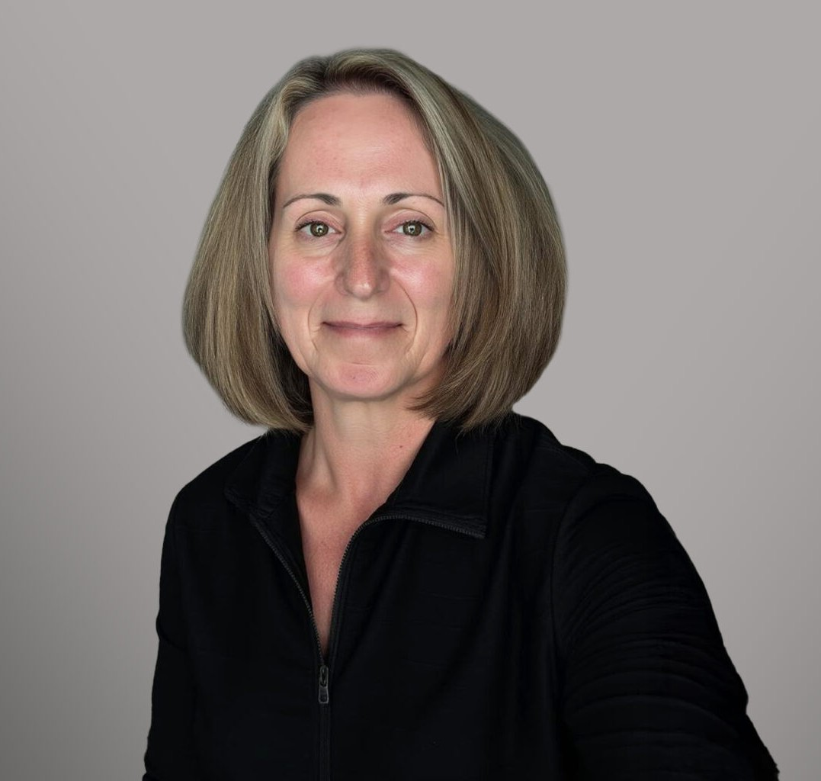

LAURA L. CHARTRAND
Director
Natural Resources

Fennemore Forward
P: 719.428.0707 F: 303.291.3201
lchartrand@fennemorelaw.com

LAURA L. CHARTRAND
Laura L. Chartrand is a Director in Fennemore’s Natural Resources practice group. With over 18 years of experience, Laura provides venture capital groups, industrial service providers (pipeline infrastructure, water, oil & gas, sand & gravel), governmental entities, small businesses, and trade associations with general counsel advice, trial and appellate litigation counsel, and transactional negotiation and drafting legal services. Her practice includes issues regarding water rights & quality, electric & gas utilities, environmental, real estate, land use, mining,
corporate, risk management, government affairs, and operations.

Laura’s career spans leadership roles in both public service and private practice. She has served as Regional Solicitor for the U.S. Department of the Interior, Deputy Attorney General for Colorado’s Natural Resources and Environment section, and legal advisor to the Western Governors’ Association. In these positions, she directed litigation and rulemaking involving
energy, water rights, environmental protection, tribal trust responsibilities, climate change, and public lands. She has also advised on high-stakes federal policy issues, from oil and gas royalties to endangered species and interstate water compacts.
In private practice, Laura has counseled clients in the energy, utilities, and industrial sectors, negotiating complex agreements and representing them in high-profile disputes and regulatory proceedings. Her work includes water and land use permitting, utility infrastructure projects, and environmental compliance. She has extensive experience in trial and appellate advocacy,
settlement negotiations, and strategic crisis management.

Beyond her legal practice, Laura is deeply engaged in professional and civic leadership. She serves as Commissioner and Chairperson for the Water Commission of Fort Collins, sits on the Colorado River Water Users Association Resolutions Committee, and contributes to numerous boards and mentoring programs. She is also a frequent lecturer and presenter on natural resources and environmental law.

EDUCATION
J.D., University of Denver, Sturm College of Law
Production Editor and Articles Editor, University of Denver Water Law Review Scholastic Excellence Awards, Highest Grade Honors for Water Law

Josiah G. Holland Memorial Scholarship B.A., State University of New York

AREAS OF PRACTICE
Natural Resources Land Use
Real Estate Cannabis Business Water Law

REPRESENTATIVE MATTERS
Tri-State Generation and Transmission Association, Inc. 2023 Electric Resource Plan (Colorado Public Utilities Commission), successfully negotiated settlement resulting in $73 million in tax
payments, economic development monies, and water rights for Moffat County and City of Craig.
Toxic Substances Control Act Enforcement Resolution, represented small business owner during Federal investigation and enforcement action resulting in no civil penalties.
Republican River Compact Settlement, directed Colorado’s settlement negotiations between Colorado, Nebraska and Kansas to resolve Colorado’s compact violations between 2006 and 2013.
Non-point Source Discharges and Consolidation of Wastewater Treatment Works, represented quasi-governmental organization in the management of Chatfield Reservoir’s phosphorus load in case of first impression for Colorado on the treatment of credits for removal of cattle from lands.
Leases of Power Privilege, represented water and data clients in negotiations and drafting of leases and agreements to support data center operations and small hydropower projects.

PROFESSIONAL AND COMMUNITY ACTIVITIES
Colorado River Water Users Association, Resolutions Committee Member, 2024-Present Water Commission, City of Fort Collins, Commissioner & Chairperson, 2025-Present Volunteer scholarship applicant reviewer, The Denver Foundation, March 2019 – Present Volunteer, University of Denver Law, Professional Mentoring Program, August 2016-Present Lecturer, Public & Resources Law, University of Denver Law, 2022 & 2024
Presenter, Rocky Mountain Land Use Institute/Carver Colloquium, “Rights of Nature,” March 2020
Non-Affiliated Member, Institutional Review Board, Colorado Technical University, September 2019 – December 2020
Lecturer, Natural Resources Practitioner Course, University of Denver Law, 2018 & 2020 Counsel & Ex-Officio Member, Colorado Water Conservation Board, July 2016-January 2019 Member, Colorado Supreme Court Water Court Rules Committee, July 2016-January 2019 Member, Nebraska Water Balance Alliance, August 2012 – October 2015

Leadership Program of the Rockies, Defender of Capitalism Award, 2010

ADMISSIONS
Colorado
U.S. Court of Appeals, Tenth Circuit

