
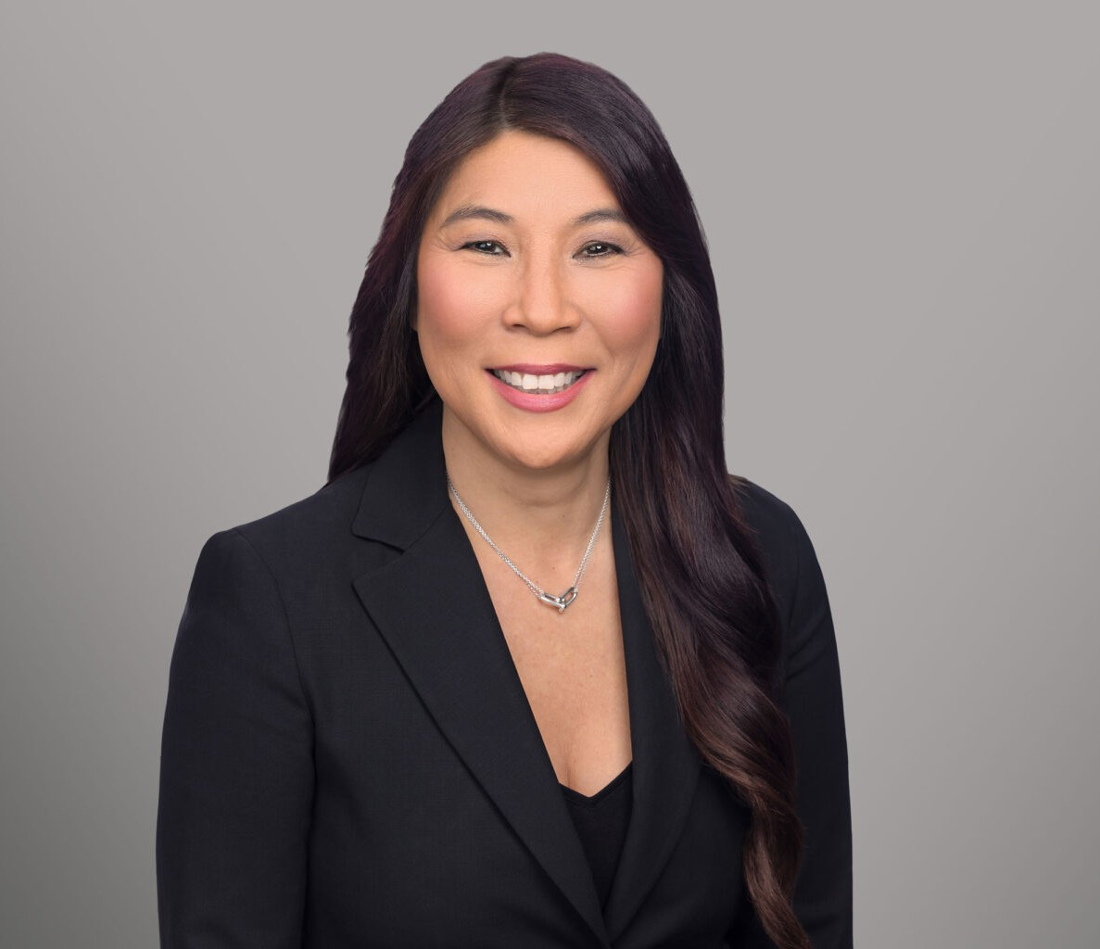
MINNA C. YANG
MINNA C. YANG
Director
Business & Finance
Sacramento
P: 916.920.5286
F: 916.920.5286
myang@fennemorelaw.com
Minna C. Yang is a Director in the Sacramento Office working in Fennemore’s tax practice group. With over 30 years of experience as a CPA and attorney, Minna is experienced in
federal and state income tax planning for business, real estate and estate planning transactions.
Minna is known for her efficiency and timely execution of complex business transactions and
restructuring. Working often with multi-generation enterprises, she ensures that client projects are completed within critical deadlines thus adding significant value to their business operations.
Areas of specific knowledge include Like-Kind Exchanges, Qualified Opportunity Zone Funds, and Pass-Through Entity Taxation.
Minna enjoys working with families and business owners to accomplish their succession planning objectives in a tax-efficient manner.
She also serves as outside general counsel to closely held and multi-generation businesses, providing practical, day-to-day guidance that helps owners and executives manage governance, operational issues, contract negotiations, and risk. With decades of combined
legal and CPA training, she brings a uniquely integrated perspective to business decision-making
—ensuring that clients understand not only the legal implications of a course of action, but also the tax and financial impact. Minna is known for her efficiency, clarity, and steady, solutions-oriented judgment, supporting businesses through routine operational matters as well as major transactions and long-range planning.
When not working Minna enjoys spending time with family over delicious food and attending live performances of music and theater.

EDUCATION
J.D., Lincoln Law School
M.S., Taxation, Golden Gate University, San Francisco B.S., California State University, Sacramento

AREAS OF PRACTICE
Business & Finance Mergers & Acquisitions

Real Estate Tax Law
Trusts & Estates Estate Planning
General Counsel Services

ARTICLES AND PRESENTATIONS
Speaker, “Estate Planning for the Real Estate and Agricultural Property Owner (E&G),” 2025 California All-Tax Conference, California Lawyers Association, November 14, 2025
Co-Author, “Key considerations and legal requirements when buying and selling boomer-owned businesses,” Sacramento Business Journal, August 9, 2024
Co-Author, “What the FTC’s new noncompete rule means for California businesses,” Sacramento Business Journal, August 8, 2024
Co-Author, “Corporate Transparency Act,” Firm Newsletter, January 19, 2024
Co-Author, “Musings on Implications of the Repeal of the Technical Termination Provisions Under IRC 708 for 1031 Exchanges,” Firm Newsletter, June 17, 2019
Presenter, “Partnership Allocation Rules – Impact of Recent Regulations,” November 15, 2017 Presenter, Honey, I Forgot About the Income Tax!” Firm Presentation, February 25, 2016

PROFESSIONAL AND COMMUNITY ACTIVITIES
Member, California Society of Certified Public Accountants Member, American Institute of Certified Public Accountants
Member, Tax and Business Sections, Sacramento County Bar Association Member, Tax Section, State Bar of California
Member, Adjunct Instructor, Golden Gate University, 2003-2005

ADMISSIONS
California
U.S. Tax Court
Certified Public Accountant

