
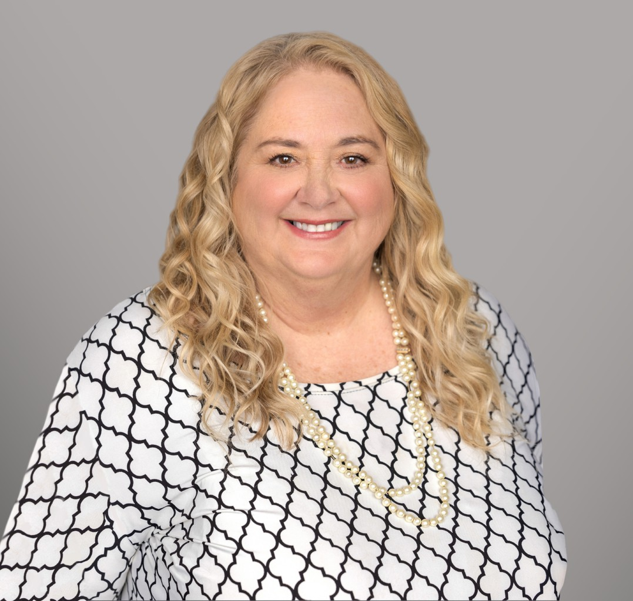
ROBIN L. KLOMPARENS
ROBIN L.
KLOMPARENS
Director
Trusts & Estates
Sacramento
P: 916.920.5286
F: 916.920.5286
rklomparens@fennemorelaw.com
Robin Klomparens is a tax attorney with a finance degree from the Warrington College of Business at University of Florida and a Juris Doctorate and LL.M. in Taxation from the University of Miami. Admitted to the Florida Bar in 1986 and the California Bar in 1987, she also practices before the U.S. Tax Court and the U.S. Supreme Court. Her achievements include receiving the Joanne Garvey Lifetime Achievement Award in 2019.
Renowned for her expertise in tax law, Robin excels in navigating complex tax code changes, providing her clients with up-to-date and effective legal counsel. She has contributed significantly to legal education as an adjunct professor at USF’s LLM program, Golden Gate University’s MS program, and currently at McGeorge School of Law. A prior member and current advisor to CLA’s Tax Section Executive Committee and Estate and Gift Committee, and a member of ACTEC, she also contributes to various charitable boards. Her extensive lecturing and publications further establish her knowledge in tax law.

EDUCATION
L.L. M., Taxation, University of Miami
J.D., University of Miami, School of Law B.S., B.A., University of Florida

AREAS OF PRACTICE
Trusts & Estates Business & Finance Estate Litigation
Tax Law
Estate Planning Cannabis Business

AWARDS AND HONORS

Joanne Garvey Distinguished Lifetime Achievement Award, State Bar of California
V. Judson Klein Award for Outstanding Achievement in Taxation, State Bar of California AV Preeminent 5.0 Peer Review Rated by Martindale-Hubbell

ARTICLES AND PRESENTATION
Speaker, “Estate Planning for the Real Estate and Agricultural Property Owner (E&G),” 2025 California All-Tax Conference, California Lawyers Association, November 14, 2025
Author, “Preparing for Tax Evolution: What Changes to the Tax Cuts and Jobs Act Means for Businesses and Individuals in 2025,” Fennemore Blog, January 28, 2025
Author, “Varying economic climates could impact how you navigate estate planning,” Sacramento Business Journal, August 7, 2024
Author, “The Future of Filing Taxes Explained,” Fennemore Blog, April 4, 2024
Presenter, “From Death to Distribution,” 2024 Estate and Gift Tax Conference, California Lawyers Association, March 21, 2024
Co-Author, “Corporate Transparency Act,” Firm Newsletter, January 19, 2024
Author, “California Senate Bill 131 Closes Loophole for Incomplete Gift Non-Grantor Trusts (“INGs”),” Firm Newsletter, July 18, 2023
Co-Author, “Proposition 19 Brings Substantial Changes to California’s Property Tax Assessment Rules,” Firm Newsletter, December 16, 2020
Author, “California v. Texas – Now is the Time to Consider Filing a Protective Claim for Refund,” Firm Newsletter, July 13, 2020

PROFESSIONAL AND COMMUNITY ACTIVITIES
Fellow, American College of Trusts and Estates Counsel Fellow, Tax Policy and Business Law Committees, 2018-present
Member, State Bar of Florida Member, State Bar of California
Vice Chair, Executive Committee of Taxation Section, State Bar of California (2004-2007) Advisor, Executive Committee of the Taxation Section, State Bar of California (2014 to present) Chair, Estate & Gift Tax Sub-Committee, State Bar of California (multiple years since 2000) Member, American Bar Association
Member, Sacramento County Bar Association Adjunct Professor, McGeorge School of Law

ADMISSIONS
California Florida
U.S. Supreme Court
U.S. Tax Court

