
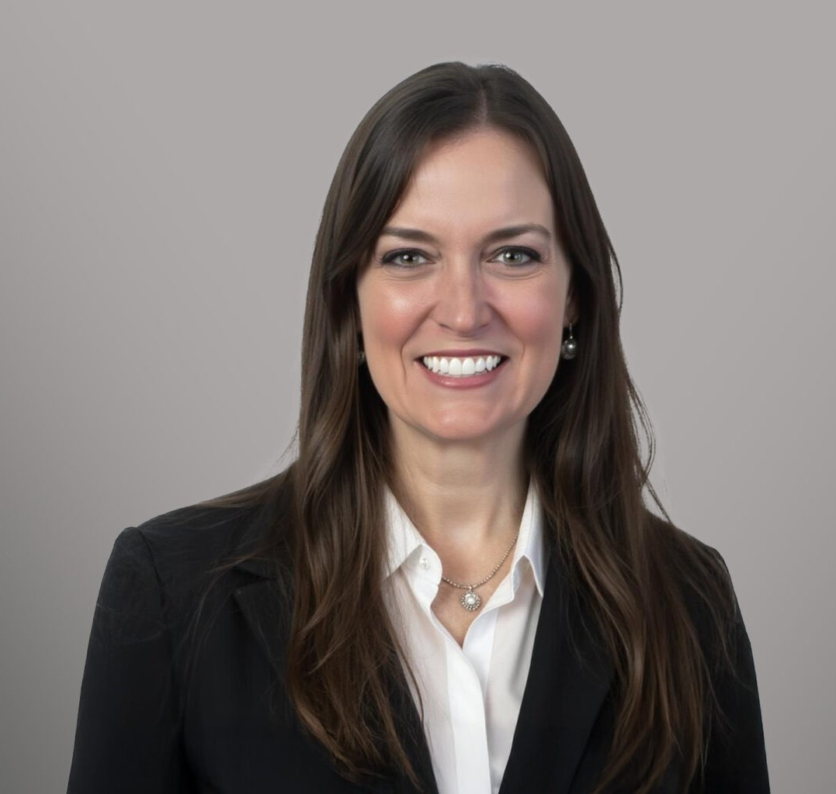
ALAINA LYNN SYLVESTER
ALAINA LYNN SYLVESTER
Of Counsel
Trusts & Estates
Reno
P: 775.788.2214
F: 775.786.1177
asylvester@fennemorelaw.com
Alaina Sylvester is an Of Counsel attorney in Fennemore’s Trusts & Estates group. Practicing out of the firm’s Reno office, Alaina works with her clients representing them in probate matters, trust administration matters, and in the development of estate plans of varying complexity. Her work ranges from basic revocable living trusts to more advanced plans involving irrevocable structures aimed at maximizing asset protection and minimizing estate taxes. She is known for advising clients with unique asset holdings, and collaborating with a team of knowledgeable professionals to develop plans that integrate varied assets into long-term estate planning and wealth- building strategies.
Prior to joining Fennemore, Alaina honed her probate and estate planning skills as an attorney licensed in both California and Nevada focused on availing the advantages of Nevada probate and trust law to her clients. She also acted as a Trust Officer with a local trust company where she assisted clients in understanding the nuances of various trust and estate structures and ensuring compliance with trust documents and governing policies. Alaina’s well-rounded background in both legal and financial aspects of estate planning make her a trusted advisor to clients with diverse needs.
When Alaina isn’t in the office you may find her on a golf course making everyone else feel better about their golf game, hiking the beautiful Great Basin with her family, or bribing her children with cookies and chocolates down a ski slope.

EDUCATION
LL.M. in Taxation, University of San Diego School of Law J.D., University of San Diego School of Law
B.A., University of Southern California, cum laude

AREAS OF PRACTICE
Trusts & Estates Estate Planning

AWARDS AND HONORS
Top Rank Attorney, Nevada Business Magazine, 2024

PROFESSIONAL AND COMMUNITY AFFILIATIONS
Member, Probate Bar Association of Washoe County

ARTICLES AND PRESENTATIONS
Author, “Navigating Trusts and Estates as the New Year Approaches,” Fennemore Blog, November 14, 2024

ADMISSIONS
California Nevada

