
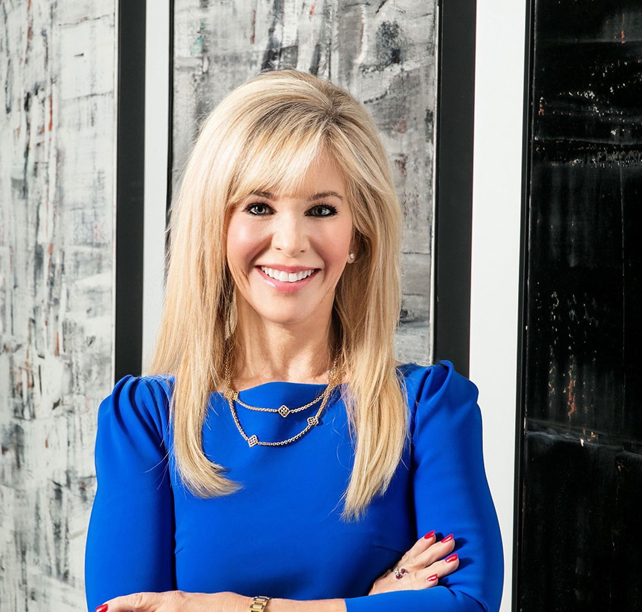
ALEXIS J. GLASCOCK
ALEXIS J. GLASCOCK
Director
Business & Finance
Phoenix
P: 602.916.5488 F: 602.916.5688
aglascock@fennemorelaw.com
“
Keep your mind on your objective, and persist until you succeed. Study, think, plan and advocate.
-W. Clement Stone
”
Alexis Glascock is chair of our Government Relations and Regulatory practice group, where she focuses on assisting businesses and associations to achieve their goals by advocating for or opposing changes to laws at the Legislature, agency, county and municipal level. Alexis has worked in both private practice and in senior staff positions in state government. She has served both as counsel to the President of the Arizona Senate and Assistant to the General Counsel of the Legislative Council. She effectively drafted and ensured the passage of complex legislation and was instrumental in halting or modifying legislation contrary to the interest of the majority
caucus.

While at the Legislative Council, Alexis co-authored a motion to protect the legislative privilege of legislative documents related to the national tobacco litigation, second chaired the hearing on the motion, and reviewed over 3,000 legal opinions to create a searchable data system and summary of these opinions. Additionally, Alexis garnered experience at the federal level during her tenure with the majority leadership of the Joint Economic Committee of the United States Congress. In that role, she selected witnesses to testify before the Committee on numerous
economic issues and published a three volume series on the economic impact of women in the labor market. She also assisted with the annual Economic Report of the Joint Economic
Committee. She also has successfully assisted with the passage of bills in industries ranging from trucking to trampolines.
Away from work, Alexis spends time with her family, whether it’s watching her children play
sports, participating in family sporting activities or simply enjoying weekends together watching movies. She also enjoys playing tennis, skiing, biking and hiking, and has completed six half-
marathons.

EDUCATION
J.D., University of Virginia School of Law
M.A., Harvard University Graduate School of Arts and Sciences
Masters Thesis: Technology Transfer to China, A Look at the Societal, Political, and Economic Aspects that Drive Success
B.A., Double Major in Economics and in Chinese Studies, Wellesley College

AREAS OF PRACTICE
Business & Finance
Government Relations & Regulatory Health Care

AWARDS AND HONORS
Distinguished Service Recognition Award, Arizona Society of Otolaryngology Head and Neck Surgery, presented at the Annual Scientific Meeting, November 2025
“Best Lobbyist of the Capitol” 2023 Honoree, Arizona Capitol Times
“2022 Leader of the Year Award” Political Lawyer, Arizona Capitol Times
“Best of the Capitol” 2022 Honoree – Best Capitol/Political Lawyer, Arizona Capitol Times
“2021 Athena Award Honoree”, Greater Phoenix Chamber of Commerce
Ranking Arizona Businesses, Law Firms: Government Relations Number 1 in State, AZ Big Media, 2021
Best Lawyers in America®, Administrative/Regulatory Law, Government Relations Practice, 2020-2025
Honoree, 2020 Women Achievers of Arizona, Arizona Capitol Times
Heart of a Hero Award, American Heart Association, 2018

ARTICLES AND PRESENTATIONS
Author, “Public Policy: WVCCA Tariffs and Taxes Forum,” The Voice of Business Glendale, Fall 2025
Speaker, “Navigating Change: Forecasting The Trump Administration’s Impact on Local, State & Federal Governments,” SCG Annual Meeting in Austin, TX, September 2025
Interview, “A recap of the Arizona legislative session,” Arizona PBS, July 2, 2025
Author, “My View: Hobbs should sign Arizona bill that cracks down on third-party legal funders,” Phoenix Business Journal, June 19, 2025
Author, “Trending in 2025: Current Federal and State Laws Have Set Arizona Up for Technology and Housing Growth,” Greater Phoenix InBusiness Magazine, January 8, 2025
Author, “Arizona’s technology and housing sectors are positioned for growth in 2025, hopefully,” Town of Paradise Valley Independent, January 2, 2025
Author, “Arizona’s technology and housing sectors are positioned for growth in 2025, hopefully,” Daily Independent, January 2, 2025

Presenter, “Legislative Panel,” Southwest Valley Chamber of Commerce, October 2024
Author, “Public Policy: New Arizona laws that mean business,” Glendale Chamber Voice of Business, Fall 2024
Interview, “Key highlights from the Arizona Legislative Session,” Arizona PBS, June 26, 2024
Author, “Public Policy: Forum Discusses Water Conservation and the Future of Water in Arizona,” The Voice of Business Glendale Chamber, Spring 2024
Author, “Arizona Again Ranks Among the Top Swing States for the 2024 National Elections,” The Voice of Business Glendale Chamber, Winter 2024
Presenter, “Water Forum,” Glendale Chamber Of Commerce, January 26, 2024
Author, “Legislation Furthers Economic Development in the State,” The Voice of Business, Fall 2023
Presenter, “National Trends in State Health Care Legislation,” SCG’s Legal 2023 Annual Meeting, September 21, 2023
Author, “Protecting children from their opportunistic social influencer parents,” Arizona Capitol Times, September 19, 2023
Presenter, “Child Influencer Compensation,” Fox 10, August 25, 2023
Author, “Protecting children from their opportunistic social influencer parents,” Arizona Digital Free Press, 2023
Author, “Tax credits and incentives for Arizona businesses from Inflation Reduction Act,” AZ Big Media, April 6, 2023
Author, “A roadmap to credits and incentives from the Inflation Reduction Act,” Phoenix Business Journal, April 3, 2023
Featuring, “Celebrating women who tell our stories – CAI’s female legislative advocates,” Community Associations Institute, March 9, 2023
Featured, “Congratulations to our 2022 ‘Leaders of the Year,’” Arizona Capitol Times, August 27, 2022
Interview, “Legislative Session, Solar Energy, and Cristela Alonzo,” Arizona PBS, July 7, 2022
Author, “Here’s how Arizona businesses can win federal infrastructure funds,” AZ Big Media, August 2, 2022
Interview, “Legislative Update,” Arizona Horizon, July 7, 2022
Interview, “$1 Billion infusion for water infrastructure,” KTAR, June 23, 2022
Author, “How to Cash in on Infrastructure Dollars Coming to Arizona,” AZ Big Media, June 6, 2022
Author, “How Businesses Can Cash In On Infrastructure Dollars Coming to Arizona,” AZ Big Media, April 6, 2022
Author, “Federal Infrastructure Funds are Flowing to Arizona: How Local Businesses Tap In,” Phoenix Business Journal, April 1, 2022
Speaker, “2021 Arizona Legislative Session,” WeServ Arizona Legislative Session Overview Meeting, November 3, 2021
Speaker, “Arizona Rules of Professional Conduct for Government Relations Attorneys,” State Bar of Arizona, September 28, 2021

Speaker, “The Impact of COVID-19 on Government Relations,” SCGLegal’s 2021 Annual Meeting in San Francisco, September 24, 2021
Speaker, “Recently Passed Arizona Law to Limit COVID-10 Liability Claims Against Businesses and Other Entities,” Association of Corporate Counsel, Arizona Chapter, September 2, 2021
Interview, “Chat with the President,” Southwest Valley of Chamber Commerce, August 19, 2021
Interview, “4 New Arizona Laws That May Impact You,” 12 News NMC, July 7, 2021
Quoted, “Legal Implications of Utah’s Proposed Prenatal Expenses Law,” Fox 10 Arizona, April 8, 2021
Interview, “Relationships built on trust and years of working together,” Fennemore Blog, August 5, 2021
Interview, “4 New Arizona Laws That May Impact You,” 12 News NMC, July 7, 2021
Author, “My View: Measure to Stop Arizona Forced Condo Conversion to be Included in Final Budget,” Phoenix Business Journal, June 29, 2021
Speaker, “Protect Your Business, Charter School or Healthcare Entity from COVID-19 Claims by Customers or Employees,” Association of General Counsel, Fennemore Webinar, June 2, 2021
Author, “New Sports Betting Law Means Increased Revenue for State, Tribes,” Arizona Capitol Times, April 23, 2021
Author, “Their Take: Proposed Modification of State’s Unemployment Insurance,” InBusiness, April 12, 2021
Quoted, “Legal Implications of Utah’s Proposed Prenatal Expenses Law,” Fox 10 Arizona, April 8, 2021
Quoted, “Here’s how bill protects businesses from COVID-19-related lawsuits,” AZ Big Media, March 31, 2021
Author, “COVID-19 Business Restrictions Update: Don’t Let it Surprise You,” Fennemore Client Alert, March 10, 2021
Speaker, “Lobbying—What to Expect and Registration Process,” State Bar of Arizona, January 14, 2021
Interview, “SCGGlobalSpin USA 2020 Presidential Election Executive Branch Discussion Part 1,” SCGGlobalSpin, October 6, 2020
Presenter, “Legislative Session and Legislation to Limit Liability for Businesses Should an Employee or Customer Bring a Claim That They Contracted COVID-19 on the Business Premises,” Community Associations Institute, June 2, 2020
Presenter, “Update: 2020 Legislative Session,” Scottsdale Chamber of Commerce, May 26, 2020
Quoted, “Business Briefcase,” Peoria Times, May 21, 2020
Co-author, “Get up to 100% Forgivable Loan from the SBA,” InBusiness, April 1, 2020 Author, “Chamber Alliance Promotes West Valley Business Interest to State Legislators,”
Glendale Living, November 21, 2019
Speaker, “Best Practices for Lobbyists to Develop Legislation Work with Legislative Council,” State Bar of Arizona: A Funny Thing Happened on the Way to the Capitol, June 21, 2018

Interview, “Arizona Lawmakers Pass New Laws on Photo RADAR, Physician Credentialing, Sober Living Facilities and More,” Arizona PBS, May 16, 2018
Author, “New Law Protect Those With Disabilities, Businesses,” Arizona Attorney, December 2017
Speaker, “Arizona Americans with Disabilities Act and Fair Housing,” West Valley Realtor’s Association, WeMarr, November 2017
Co-author, “Be Aware of Changes to Phoenix’s Rules for Lobbyists,” The Arizona Republic, October 25, 2017
Author, “Review of City of Phoenix Lobbying Ordinance Requirements,” Fennemore Client Alert, October 25, 2017
Speaker, “What Your Business Needs to Know About Changing ADA Compliance Law,” Fennemore Seminar, June 14, 2017
Speaker, 2017 Arizona Bankers Association Annual Convention and Meeting, June 9, 2017
Speaker, “Federal and State Legislation to Address Litigation Regarding the Americans with Disabilities Act,” Greater Phoenix Chamber of Commerce, June 2017
Speaker, “Overview of Legislation at the Federal and State Level to Protect Businesses from Litigation Arising Under the American with Disabilities Act,” 2017 Arizona Bankers Association Annual Convention and Meeting, June 2017
Speaker, “WHO, WHAT, WHERE, WHEN: The Future of ADA Litigation and Legislation” Fennemore Labor and Employment Seminar, May 4, 2017
Speaker, “ADA Compliance,” AZ Bankers Association April Seminar, April 18, 2017 Speaker, “New Laws Impacting Business,” Arizona PBS, June 6, 2016

PROFESSIONAL AND COMMUNITY ACTIVITIES
Vice Chair, Arizona Chamber of Commerce Infrastructure, Innovation and Competitiveness Committee
Member, Sandra Day O’Connor Ladies of the Court Committee at the O’Connor House, Sandra Day O’Connor Institute for American Democracy
Member, Foundation Board of Trustees, Barrow Neurological Institute, September 2020-December 2023
Chair of the Annual Fundraiser for Circle of Friends, Barrow Neurologic Institute Foundation, 2017, 2018, and 2019
Member, Board of Directors, Arizona Chamber of Commerce and Industry
President, Harvard Club of Phoenix, September 2007, Member, Board of Directors 2005-2012 Member, Desert Foundation Auxiliary, January 2006-Present
Member, American Heart Association Heart Ball, January 2004-Present
Member, Upper School Parent’s Board, Phoenix Country Day School, 2005 to 2007, 2014-2020 Gala Chairman, Phoenix Symphony, 2008
Benefit Chairman, Crisis Nursery, 2004

ADMISSIONS

Arizona
Washington, D.C.
U.S. District Court District of Arizona
U.S. Court of Appeals Ninth Circuit

