
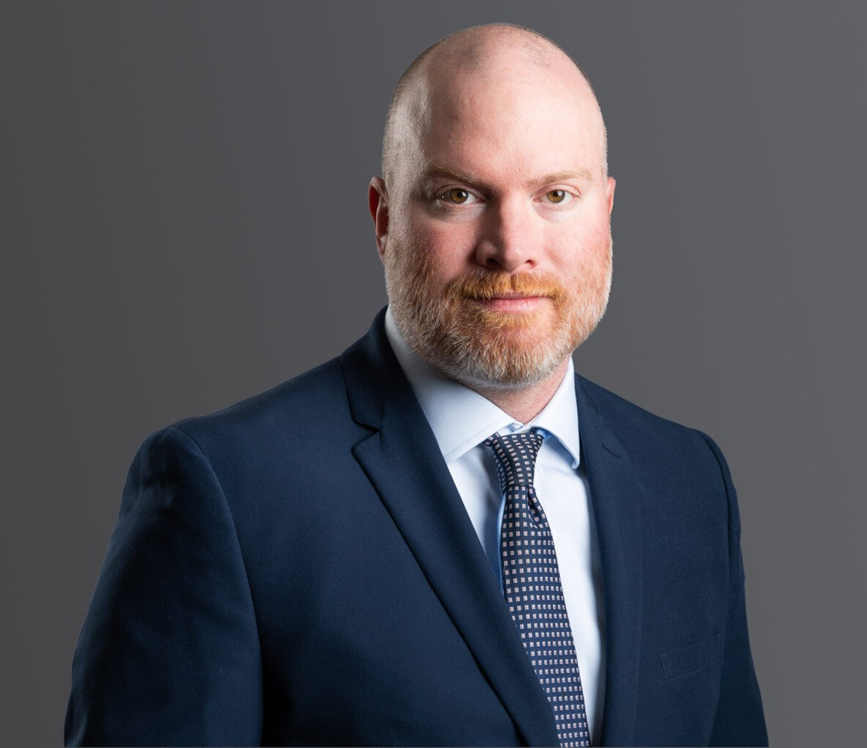
CHRIS LEVKULICH
CHRIS LEVKULICH
Of Counsel
Business & Finance
Denver
P: 303.813.3841
F: 303.291.3201
clevkulich@fennemorelaw.com
Chris advises businesses and their owners on matters relating to the taxation of corporations and partnerships, entity formation, mergers and acquisitions, private equity investments, asset sales, and real estate transactions. Chris also counsels individuals in estate planning and general income tax matters. Additionally, Chris represents buyers and sellers of closely held businesses in all aspects of M&A transactions, and advises sponsors in the formation and operation of private equity funds.
Prior to joining Fennemore, Chris worked for a local firm specializing in tax matters and practiced as a CPA at a Big Four accounting firm. Chris’s tenure as a CPA provides him with a unique perspective on the tax and financial reporting aspects of business transactions.
Chris enjoys spending time with his family, golfing, fly fishing, and watching all of Colorado’s sports teams.

EDUCATION
LL.M. in Taxation, University of Denver
J.D., University of Denver Sturm College of Law B.S., Boston College, cum laude

AREAS OF PRACTICE
Business & Finance Tax Law
Employment & Labor Blockchain & Cryptocurrency

REPRESENTATIVE MATTERS
Served as the exclusive legal advisor to the CFO Project in its acquisition by Broadtree
Partners, supporting its goal to expand its community as the demand for business finance expertise continues to grow.

Represented Argus Professional Storage Management, LLC in its combination with SmartStop Self Storage REIT, Inc. (NYSE: SMA).

AWARDS AND HONORS
Best Lawyers in America®, Tax Law, 2026
5280 Magazine Top Tax and Business Lawyer, 2024
Best Lawyers in America®, Ones to Watch – Business Organizations (including LLCs and partnerships), 2024-2025
Best Lawyers in America®, Ones to Watch – Corporate Law, 2025 Colorado Super Lawyer Rising Stars – Tax Law, 2021

ARTICLES AND PRESENTATIONS
Speaker, “Post-U.S. Election Debrief with 10 Tax Lawyer Perspectives,” 361Firm, 2024
Presenter, “Cryptocurrency: Tax and Estate Planning,” Boulder County Estate Planning Council, 2024
Presenter, “Corporate Transparency Act: Who are Beneficial Owners?,” CPE4U, 2024
Presenter, “Annual Update on the Taxation of Pass-Through Entities,” Colorado Bar Association – Tax Law Section, 2016 – 2023
Presenter, “An Introduction to the Taxation of Cryptocurrency,” Colorado Bar Association – Tax Law Section, March 2023
Presenter, “Like-Kind Exchanges: Fundamentals and Advanced Practice,” Colorado Bar Association, 2020
Presenter, “Pass-Through Entities: Critical Operating Issues,” CPE4U, 2017 – 2020
Presenter, “Tax Cuts and Jobs Act of 2017: Choice of Entity and Planning Considerations After Tax Reform,” Business Law Institute, 2018
Presenter, “2017 TCJA: In-Depth Look at Taxation of Pass-Through Entities,” Colorado Bar Association, 2018

PROFESSIONAL AND COMMUNITY AFFILIATIONS
American Bar Association
American Institute of Certified Public Accountants Board of Governors, Colorado Bar Association
Colorado Bar Association, Tax Section, Executive Council Member Colorado Society of Certified Public Accountants
Denver Bar Association, Young Lawyers Division, Executive Council Member Former Certified Public Accountant, Colorado
Chair of the Advisory Board, The Colorado Lawyer

ADMISSIONS
Colorado

United States District Court, District of Colorado

