
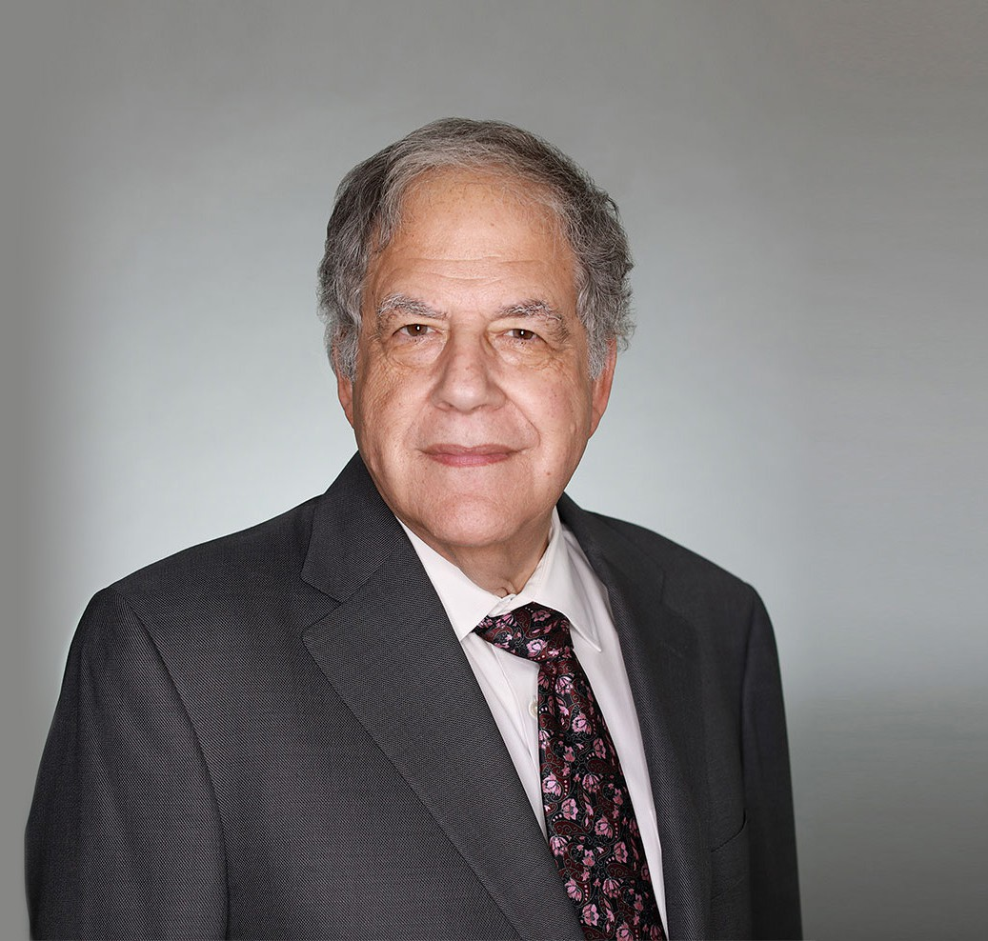
Jeff’s practice focuses primarily on real estate and corporate transactions. He counsels and represents privately and publicly held companies and their owners in a wide variety of business matters. He has represented both lenders and developers in large and complex workouts and foreclosures. He also regularly plans, structures, negotiates and implements all types of business initiatives and transactions including very large, multi-million dollar transactions, as well as mergers and acquisitions, financial transactions, and various real estate projects.
JEFFREY P. ZUCKER
Of Counsel
Real Estate
Las Vegas
P: 702.791.8231
F: 702.791.8232
jzucker@fennemorelaw.com
“
Justice, justice you shall pursue!
-Deuteronomy 16:20
JEFFREY P. ZUCKER
”
Jeff sought a career in law because he enjoys applying analytical thinking to real-world scenarios. He likes seeing what his clients envision and build.
Away from work, Jeff is active in the Las Vegas Jewish community and is a stamp collector. He is also an avid traveler, and participated in a Game of Thrones tour of Croatia.

EDUCATION
J.D., Harvard Law School B.A., Yale University
AREAS OF PRACTICE

OTHER EXPERIENCE

Real Estate Finance and Lending Real Estate

Business & Finance Gaming & Hospitality

AWARDS AND HONORS
Chambers USA, Leading Lawyers for Business, 2023 and 2024
Best Lawyers in America®, Real Estate Law, 1983-2026
Best Lawyers in America®, Corporate Governance Law, Corporate Law, 2015-2026 Best Lawyers in America®, Lawyer of the Year, Real Estate Law, 2008, 2014 Mountain States Super Lawyers®, 2016-2022
Highly Regarded – M&A; Real Estate Acquisitions; Real Estate Finance, IFLR 1000, 2019
Mountain States Super Lawyers®, Top 100, 2018 Recommended in The Legal 500 US, Real Estate, 2015 “Legal Elite,” Nevada Business Magazine, 2011-2015
AV® Preeminent™ Peer Review Rated (the highest rating available), by Martindale-Hubbell

ARTICLES AND PRESENTATIONS
Co-Author, “Nationwide Injunction Temporarily Halts Corporate Transparency Act BOIR Filing Requirements: What You Need to Know,” Fennemore Blog, December 5, 2024
Co-Author, Fennemore Notice To Clients – Corporate Transparency Act, Fennemore Client Alert, December 29, 2023
Author, “Night and Day: The Differences in Corporate Law Between Nevada and Delaware,”
Las Vegas Business Press, May 7, 2018
Co-Author, “Bishop and Zucker on Nevada Corporations and Limited Liability Companies” Co-Author, “Doing Business in Nevada: A Practical Guide”

PROFESSIONAL AND COMMUNITY ACTIVITIES
Founder and First Chair of the Business Law Section, State Bar of Nevada Member, American College of Real Estate Lawyers
Member, American College of Real Estate Lawyers, Opinion Committee Member, American College of Mortgage Attorneys
Chair, State Bar of Nevada, Business Law Section, Opinion Committee

ADMISSIONS
Nevada

