
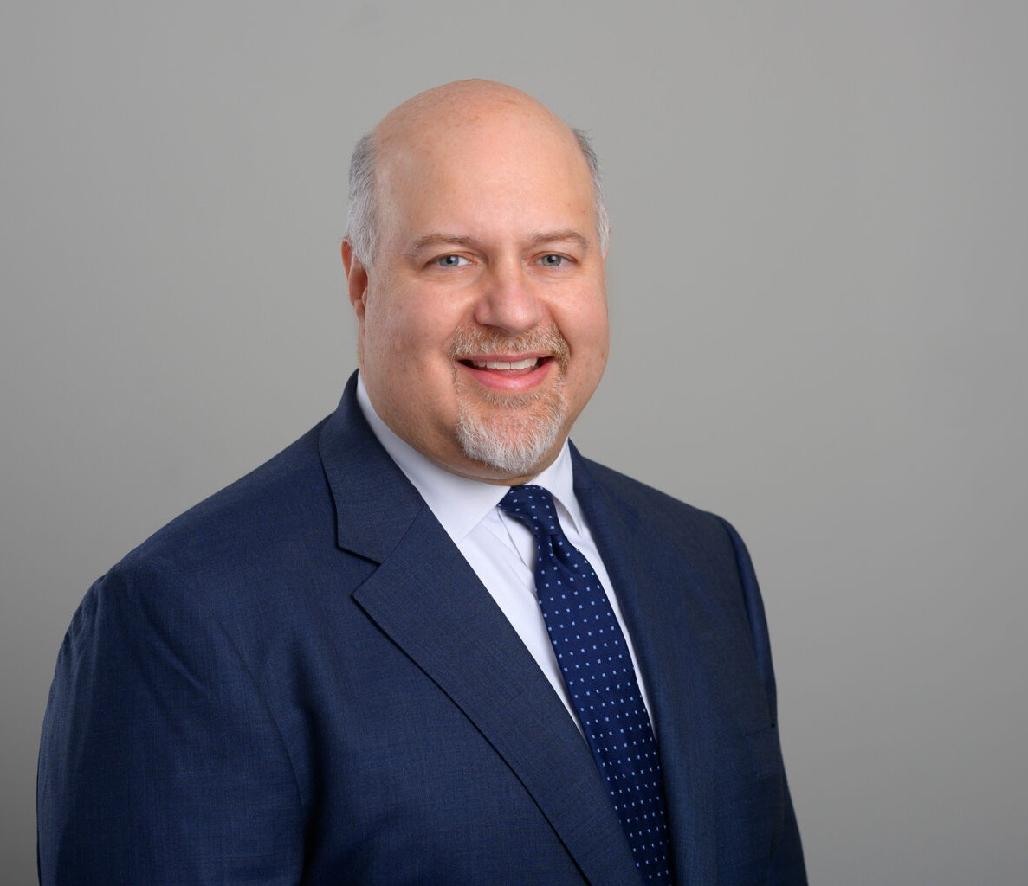
TIMOTHY C. EARL
TIMOTHY C. EARL
Director
Business Litigation
San Diego
P: 619.595.3279
F: 619.231.4372
tearl@fennemorelaw.com
Timothy C. Earl, an insurance coverage, construction and business litigation attorney, is a skilled litigation attorney with a focus on comprehensive insurance coverage and construction law. His practice spans, insurance coverage, construction litigation and business litigation, handling
complex cases including policy interpretation and bad faith litigation.

In insurance coverage litigation, Timothy represents policyholders and insurance companies in a variety of insurance coverage disputes primarily involving property damage or bodily injury arising out of construction defect and asbestos claims. He represents policyholders in declaratory relief and bad faith actions against insurers, and has represented insurers in subrogation and contribution actions against other insurers.
In construction litigation, Timothy represents a wide array of clients, such as developers, architects, and contractors in both residential and commercial projects. He’s skilled at managing indemnity claims, construction defect cases, mechanic’s lien disputes and bid protests. His knowledge also extends to representing sureties on bond claims.
Additionally, Timothy’s business litigation experience includes representing companies in disputes related to real estate, unfair competition, and various tort claims. His ability to provide strategic, efficient legal solutions makes him a valuable asset in the construction and insurance legal
sectors.

EDUCATION
J.D., University of San Diego School of Law B.A., University of California, Davis

AREAS OF PRACTICE
Business Litigation Construction Law Insurance Coverage

REPRESENTATIVE MATTERS

Navigators Specialty Insurance Company v. Golden Bear Insurance Company, 2024 WL 59694 (N.D. Calif., 2024). Defended an insurance company that issued an excess policy against an equitable subrogation and equitable contribution claim of another insurer arising out of personal injury action The District Court granted summary judgment in favor of the defendant insurer on the grounds that the plaintiff insurer did not qualify as an additional insured under the defendant insurer’s excess policy based upon the contractual language in the
subcontract between the named insured and the additional insured.
North American Capacity Insurance Company v. Entertainment, LLC et al., 2022 WL 19520262 (C.D. Calif., 2022). Prosecuted declaratory relief and equitable reimbursement action against insured arising out of an underlying employment dispute wherein the insurance policy in question barred coverage for actions by employees against the named insured. Prevailed on behalf of insurance carrier client on motion to dismiss or stay the action with the court finding, among other things, that the insurance carrier had properly stated a claim for equitable
reimbursement of a settlement payment through a proper reservation of rights.
Aviara Residence Club Owners Association v. Security National Insurance Company, 2020 WL 6083446 (S.D. Calif., 2020). Prosecuted a bad faith, equitable subrogation and equitable contribution claim based upon claims assigned to a homeowners association client by a general contractor arising out of a construction defect case. Successfully defeated a motion to dismiss in Federal Court by the defendant insurer under theories of promissory estoppel and negligent misrepresentation.
Liberty Mutual Insurance Company v. Bosa Development California II, Inc., 2019 WL 3306304 (S.D. Calif., 2019). Defended residential developer and general contractor clients in a deductible reimbursement claim based upon legal questions of single versus multiple occurrences. Prevailed in a motion to strike the plaintiff insurance carrier’s attempt to use mediation-protected documents in support of the insurance carrier’s summary judgment
motion.
Evanston Insurance Company v. Southridge Property Owners Association of Palm Springs, Inc., (C.D. Calif., 2019). Defended homeowners association in a declaratory relief action by an insurance carrier arising out of underlying trespass claim against the homeowners association.
Prevailed on a motion to dismiss the insurance carrier’s entire complaint under

the Brillhart factors on the grounds that having a federal court decide the case would require the court to decide a state law question that could have res judicata effect in the underlying state court action, an outcome which would cause unnecessary entanglement between the federal and state court systems.
Centex Golden Construction Company v. Dale Tile Company, 78 Cal. App. 4th 992 (2000). Prosecuted contractual indemnity claim on behalf a general contractor against a subcontractor arising out of a construction defect claim through trial and appeal. The trial court and court of appeal enforced a contractual indemnity against the subcontractor based upon alleged negligence despite a finding that no party was at fault for tile cracking defects.

AWARDS AND HONORS
AV® Preeminent™ Peer Review Rating by Martindale-Hubbell, 2006-2025 Top Rated Litigator by the Legal Leaders of ALM, 2021-2023
Best Lawyers in America® in the field of Litigation – Construction, 2024-2025 Super Lawyer – Insurance Coverage, 2019-2024

Top San Diego Lawyer, San Diego Magazine, 2013-2023, 2025 Top 100 Leaders in Law by San Diego Business Journal
Top Lawyer of Southern California by LA Times, 2014-2024
Top San Diego Attorney in Insurance Coverage by San Diego Daily Transcript Top 1% of The American Registry, “Best of the Best”

ARTICLES AND PRESENTATION
Presenter, “From the Beginning to the End, Essential Tools to Secure Settlement,” West Coast Casualty Conference, May 2025
Co-Chair & Presenter, “Understanding Deductibles and Self-Insured Retentions,” The Seminar Group’s Insurance in Construction Industry Seminar, January 2023
Presenter, “Wrap Policies Today: The Good, The Bad and the Ugly,” West Coast Casualty Conference, October 2021
Co-Chair & Presenter, “WRAP Insurance Live Webcast,” The Seminar Group, January 2021
Author, “Does Business Interruption Insurance Cover COVID-19 Related Business Shutdowns in California, Firm Newsletter, 2020
Presenter, “Construction Law: Wrapping Your Head Around Wrap Policies,” AGC San Diego, November 2017
Presenter, “Insurance Archaeology – Raiders of the Lost Policies,” San Diego County Bar Association, May 2016
Presenter, “California Law for Design Professionals,” Lorman Education Services, September 2002

PROFESSIONAL AND COMMUNITY ACTIVITIES
Member, Construction Lawyers Society of America Member, Trial Law Institute
Member, Diversity Law Institute
Member, San Diego County Bar Association Member, Building Industry Association of San Diego Former Member, American Bar Association
Former Member, Claims and Litigation Management Alliance

ADMISSIONS
California
U.S. District Court for Central, Northern, Eastern and Southern Districts of California Washington
U.S. District Court for the Western District of Washington

