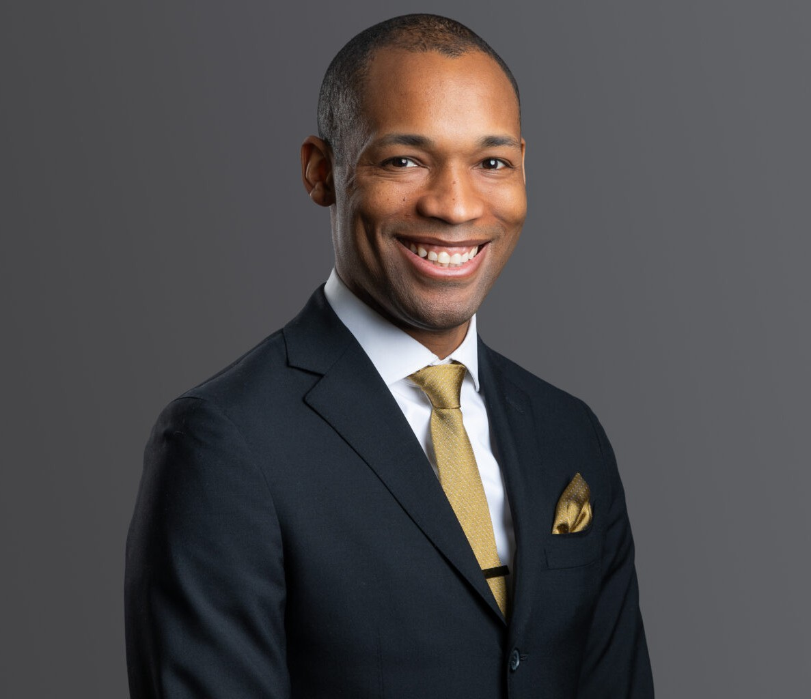

ZAKI ROBBINS
Director
Business & Finance

Denver
P: 303.813.3857 F: 303.291.3201
zrobbins@fennemorelaw.com

ZAKI ROBBINS
Zaki Robbins is a business, finance, and real estate attorney at Fennemore who counsels
companies, investors, and emerging growth clients on complex transactions and regulatory matters. He combines broad subject-matter experience with a practical, solutions-oriented approach to help clients achieve their strategic goals.
In corporate work, Zaki handles mergers and acquisitions, corporate governance, and capital raising. He structures deals, coordinates diligence, negotiates transaction documents, and manages closings. He advises boards and executives on fiduciary duties, governance
frameworks, and compliance practices. His financing experience includes debt and equity transactions for growth, recapitalizations, and investor exits.
He also represents venture capital funds and startups throughout the investment lifecycle. He negotiates term sheets and investment agreements, guides companies through seed and later financing rounds, and builds governance structures that scale. He regularly advises on investor rights, secondary transactions, and exit planning.
In renewable energy, Zaki advises developers, investors, and operators of solar, wind, and other clean power projects. His work covers power purchase agreements, project finance structures, and regulatory compliance that shapes siting, interconnection, and project economics. He supports clients from early negotiations through diligence, contracting, and closing.
Zaki’s privacy practice includes designing and implementing compliance programs, risk
assessments, policies, and governance structures under state and federal regimes. He aligns legal obligations with business operations, supports incident response, and manages vendor and data-sharing arrangements.
Committed to civic leadership, Zaki has participated in the Denver Metro Chamber Leadership Foundation’s programs and has served with organizations including the Colorado Bar
Association, the Colorado Solar and Storage Association, the Denver Preschool Program, Mullen High School, the Hampden Heights Civic Association, and Back on My Feet Denver.

EDUCATION
J.D., University of Michigan

B.A., University of Virginia

AREAS OF PRACTICE
Business & Finance Advanced Energy
Emerging Businesses & Technologies Mergers & Acquisitions
Privacy & Data Security Real Estate
Cannabis Business

AWARDS AND HONORS
Best Lawyers in America®, Real Estate Law, 2026
500 Leading U.S. Energy Lawyers, Lawdragon, 2025 5280 Magazine Top Securities Lawyer 2022 – 2024 Attorney Intel: Top 25 Attorneys of Colorado, 2024
Best Lawyers in America®, Ones to Watch, Corporate Law, 2023 – 2024; Energy Law and Mergers and Acquisitions Law, 2024
Colorado Super Lawyers Rising Star: Business/Corporate, 2023 – 2024
Law Week Colorado “Barrister’s Best” Securities Lawyer, 2023

ARTICLES AND PRESENTATIONS
Author, “Q&A: How advanced energy is vital to the U.S. meeting the projected surge in energy demand,” Denver Business Journal, March 1, 2025
Co-Author, “Nationwide Injunction Temporarily Halts Corporate Transparency Act BOIR Filing Requirements: What You Need to Know,” Fennemore Blog, December 5, 2024
Quoted, “New Treasury Reporting Rules May Be A Shock To Many Cos.,” Law360 Tax Authority, January 2024
Co-Author, “Corporate Transparency Act and Beneficial Ownership Reporting,” Firm Blog, January 2024
Co-Author, “Energize Denver: Moving toward a more sustainable Denver,” Colorado Real Estate Journal, December 2023
Co-Author, “Client Alert: Beneficial Ownership Reporting and How it Affects Business Owners,”

Firm Blog, April 2023
Author, “EVs, Supply Chains, and Infrastructure: 4 Renewable Energy Trends to Watch in 2022,”

Renewable Energy World, February 2022

PROFESSIONAL AND COMMUNITY AFFILIATIONS
American Bar Association
Colorado Bar Association, Executive Council 2019 – 2021

Colorado Bar Foundation, Bar Fellow
Colorado General Counsel Mentorship Program, 2020 – 2022
Colorado Solar and Storage Association, Board Member and Secretary Colorado Water Trust, Tributary
Denver Metro Chamber Leadership Foundation, Leadership Denver, 2023; Impact Denver, Spring 2019
Denver Preschool Program, Board Member Mullen High School, Board of Trustees
Sam Carey Bar Association

ADMISSIONS
Colorado New York

