
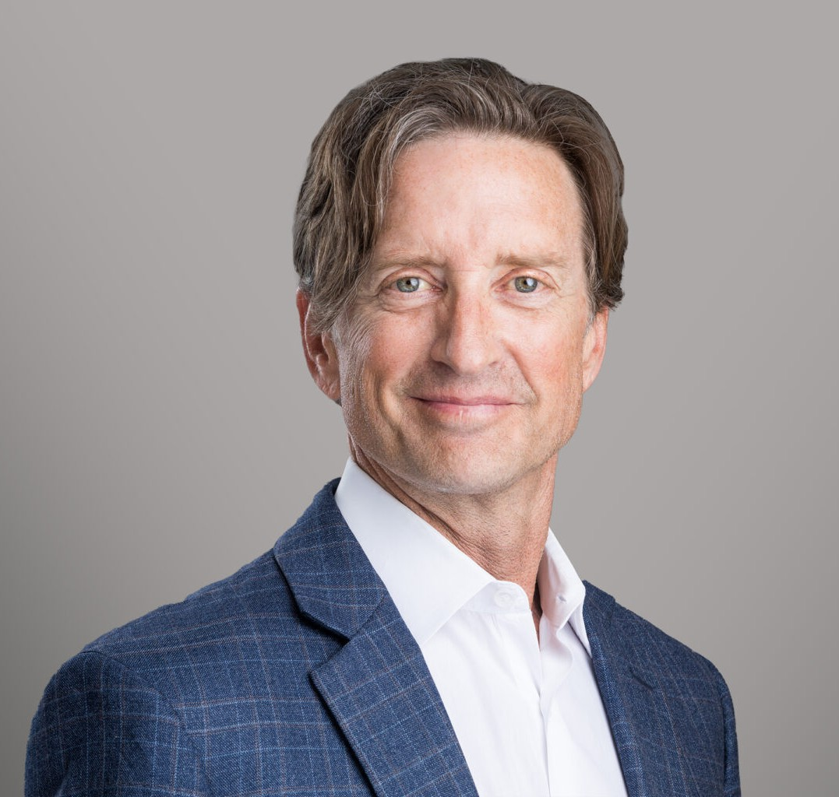
CAMERON D. BORDNER
CAMERON D. BORDNER
Director
Business Litigation
Reno
P: 775.788.2200
F: 775.786.1177
cbordner@fennemorelaw.com
Cameron (Cam) Bordner is a civil litigator in Fennemore’s Business Litigation practice group. Cam handles all types of civil litigation, including advising and representing outdoor recreation providers and ski resorts in risk management and litigation matters; representing contractors, developers and property owners in disputes related to construction law and real estate matters; and representing business owners ranging from sole proprietors to multistate corporations on matters related to general liability, contract disputes, and corporate governance. Cam is licensed to practice law in California, Nevada, and the federal court system. He handles select matters nationwide.
Cam has been involved in outdoor recreation his entire life, growing up alpine skiing and mountain biking, and later working as a professional ski patroller, river guide, ski resort risk
consultant, and Director of Risk at Heavenly Ski Resort. Ultimately, Cam went to law school with the goal of defending resorts and sports and recreation providers, which he now does. Cam remains devoted to advising and defending the outdoor recreation industry and considers it a passion, but he enjoys representing and advising clients across all industries and backgrounds.
Committed to giving back to the legal profession and the Reno/Tahoe community, Cam is a member and Past President of the Tahoe Truckee Bar Association, a Trustee of the Sierra Avalanche Center, and is on the board of directors for Sky Tavern, the oldest non-profit ski and snowboard teaching/training facility in the U.S. He is also the current Vice President of the board of directors of the Association of Ski Defense Attorneys (ASDA), an international group of attorneys recognized for their work in ski resort and recreation defense. Cam also sits on the board of Grandma’s Barn Rescue and Sanctuary, a local non-profit helping in-need animals find forever homes. Cam is a proud supporter of High Fives Foundation, Yogis for Good, and Disabled Sports USA.
When he’s not in the office, Cam enjoys skiing, cycling, music, and traveling. He also loves spending time with his wife and kids and doing projects around their mini ranch.

EDUCATION
J.D., University of the Pacific, McGeorge School of Law B.A., Fort Lewis College

Postgraduate Studies, University of Colorado at Boulder

AREAS OF PRACTICE
Business Litigation

PROFESSIONAL AND COMMUNITY ACTIVITIES
Member, Past President, Tahoe Truckee Bar Association Board of Directors, Association of Ski Defense Attorneys
Former Member of the Board of Directors, American Institute for Avalanche Research and Education (AIARE)
Member, Rotary Club of Reno
Trustee, Sierra Avalanche Center Board of Directors, Sky Tavern
Member, Washoe County Bar Association

ADMISSIONS
California Nevada
U.S. District Court District of Nevada

