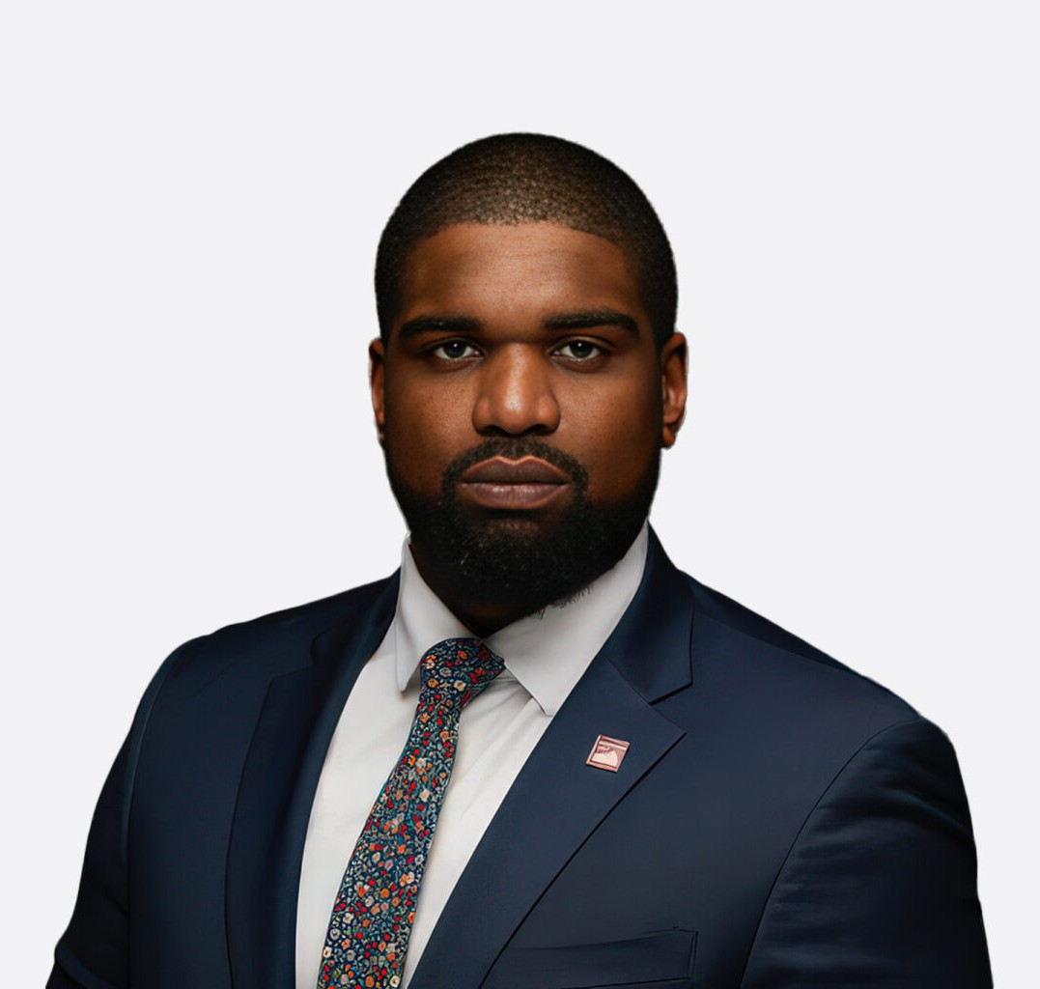

CARLTON D. FEARON
Associate
Real Estate

Phoenix
P: 602.916.5305 F: 602.916.5999
cfearon@fennemorelaw.com

CARLTON D. FEARON
Carlton Fearon is an Associate Attorney in Fennemore’s real estate practice group. He advises
investors, developers, and operators on ground leases, easements, franchise requirements, and federal land-use restrictions. He also helps clients perform title, survey, zoning, and land-use diligence for acquisitions and development projects, resolving encumbrances and compliance issues.
Prior to joining Fennemore, Carlton was a real estate associate at a national law firm, where he supported real estate aspects of M&A and fund transactions, coordinating diligence and negotiating core agreements. He also interned and clerked at other national firms, gaining experience in litigation and mediation.
Outside of the office, Carlton can be found mountain biking, golfing, playing pickleball, or enjoying poetry.

EDUCATION
J.D., Arizona State University, Sandra Day O’Connor College of Law Diverse Students Director of Business Affairs
McCarthy Fellow
Carstens Family Scholarship Anthony Lucia Scholarship
B.A., Valley City State University
All Conference Defensive End Team Captain

AREAS OF PRACTICE
Real Estate

ADMISSIONS
Arizona

California

