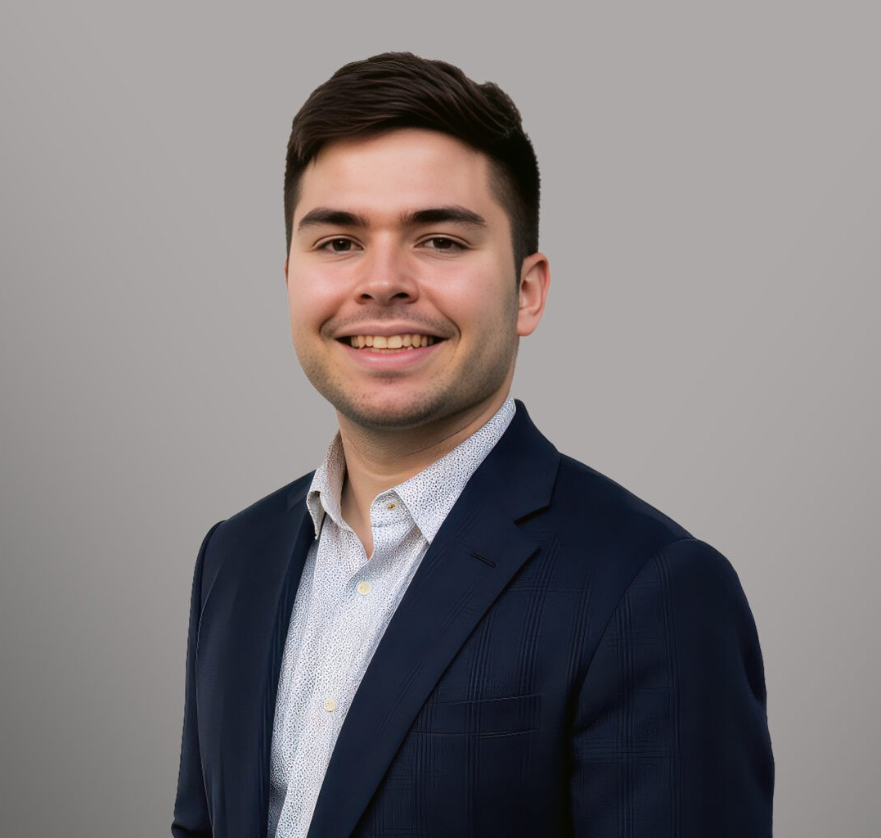

CARSON TRIGUEIRO
Associate
Business Litigation

Fresno
P: 559.446.3274
ctrigueiro@fennemorelaw.com

CARSON TRIGUEIRO
Carson Trigueiro is a business litigation attorney with experience in assisting with numerous types of both business and trust estates disputes.
Carson started his Fennemore journey as a summer associate, where he drafted numerous legal research memos and a Memo of Points and Authorities for a case proceeding to trial. Prior to joining Fennemore, Carson clerked at the Fresno City Attorney’s Office, gaining valuable experience in arbitration hearings and handling the intake process for the city’s eviction protection program. He also worked as the constituent services assistant for the City Council
President.

Carson earned his law degree from the University of Southern California Gould School of Law. He also attended the University of California, Los Angeles, and West Hills College for his undergraduate degree. There, he pitched for the West Hills College baseball team, helped to organize campus events to spread awareness and provide resources for victims of relationship
abuse, and volunteered with Central Valley Project.

EDUCATION
J.D., University of Southern California Gould School of Law
B.A., University of California, Los Angeles, magna cum laude

AREAS OF PRACTICE
Business Litigation

ADMISSIONS
California

