
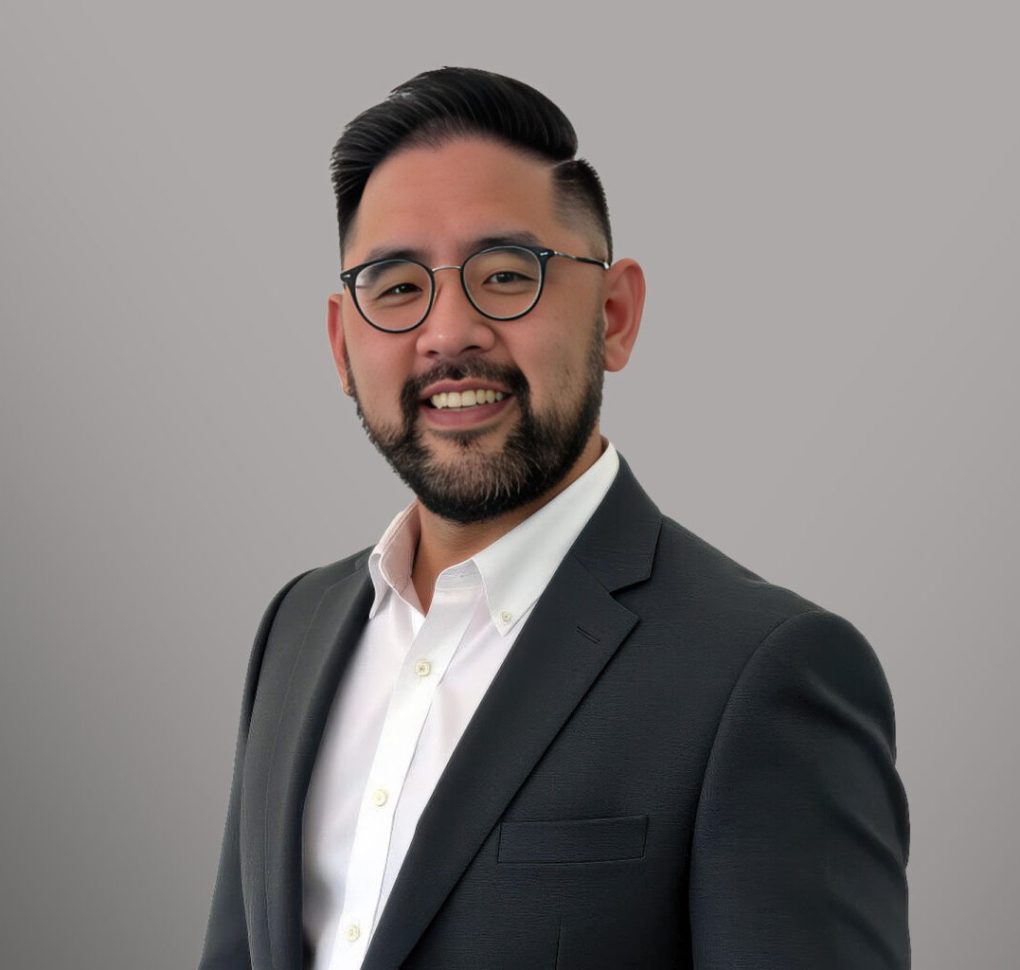
CHRISTOPHER D. HUSKEY
CHRISTOPHER D. HUSKEY
Associate
Business & Finance
Sacramento
P: 916.273.1812
F: 916.920.8608
chuskey@fennemorelaw.com
Christopher Huskey is an attorney in Fennemore’s Business & Finance practice group, where he represents clients across a broad range of industries, including logistics, healthcare, mobile home parks, restaurants, and real estate. His practice focuses on business and real estate transactions, entity formation and governance, and commercial litigation.
Before joining Fennemore, Chris practiced at a local firm, where he handled complex business transactions and litigation matters. He drafted and negotiated sale and acquisition documents, including stock and asset purchase agreements, employment agreements, and real estate purchase and lease agreements. He also advised clients on corporate governance, securities
exemptions, and tax implications, serving as outside general counsel for several small businesses.

Chris’s experience extends to representing landlords and tenants in commercial lease disputes, defending clients in construction defect and breach of contract cases, and handling various real estate and business tort matters. He has appeared in numerous hearings and has prepared motions and pleadings in both state and federal court.
Before entering private practice, Chris worked with The Foundation Aiding the Elderly, where he reviewed regulations and medical records related to skilled nursing and residential care facilities and represented clients at administrative hearings.
Chris earned his law degree from the University of California, Hastings College of the Law, and his Bachelor of Science in Business Administration from the University of Southern California. Outside of the office, he is active with the Sacramento County Bar Association and the Anthony Kennedy Inn of Court. A classically trained pianist and cellist, Chris is also a passionate cook and avid golfer.

EDUCATION
J.D., University of California, Hastings College of the Law B.S., University of Southern California

AREAS OF PRACTICE
Business & Finance

Real Estate

PROFESSIONAL AND COMMUNITY ACTIVITIES
Member, Anthony Kennedy Inn of Court Member, Sacramento County Bar Association

ADMISSIONS
California

